|  |  |  |  |  |
| --- | --- | --- | --- | --- |
| **Coursework #1** | | | | |
| **Module’s Information:** | | | | |
| Module | IBM4202 WEB PROGRAMMING WITH PHP | | | |
| Session | Jan 2021 | | | |
| Programme | BCSI & BITI | | | |
| Lecturer | **Richard Tham** | | | |
| Email: [richard.tham@newinti.edu.my](mailto:richard.tham@newinti.edu.my)  Phone: 06-798 2000 ext 2337 | | | Room: A3-F03 |
| Coursework Type | Assignment  Consist of 5 members in a group | | | |
| Percentage | 20% out of 100% | | | |
| Hand-out Date | Week 3 | | | |
| Due Date | Week 14 | | | |
| On completion of the course, students will be able to:    LO4: Display a full database driven website project. | | | | |
| **Assessment Criteria** | | **Total Marks** | **Name 1 Name 2 Name 3 Name 4 Name5** | |
| Interface design | | 20 |  | |
| Website features | | 20 |  | |
| Database Design | | 20 |  | |
| Documentation and Workshop Reflection | | 20 |  | |
| Individual Contribution | | 20 |  | |
| Total | | 100 |  | |

**Marking Rubrics For Assignment**

|  |  |  |  |  |
| --- | --- | --- | --- | --- |
| Interface design | **1-5 marks**  No interface design demonstrated | **6-10 marks**  Lacking skills on interface design, look and feel and navigation | **11-15 marks**  Needs improvement on the interface design, look and feel and navigation | **16-20 marks**  Professionally designed website with consistent look and feel and easy navigation. |
| Website features | **1-5 marks**  Poor demonstration of the crucial features | **6-10 marks**  Lacking some crucial website features | **11-15 marks**  Needs more features to be deployed | **16-20 marks**  Advanced features demonstrated |
| Database Design | **1-5 marks**  No understanding of database concepts | **6-10 marks**  Lacking understanding of database concepts | **11-15 marks**  Some basic database concepts are applied here. | **16-20 marks**  With PK, FK and normalized tables with deep understanding of database concepts |
| Documentation | **1-5 marks**  No documentation submitted | **6-10 marks**  Vague writing and satisfy 50% of the documentation requirement. | **11-15 marks**  Needs improvement and satisfy at least 60% of the documentation requirement | **16-20 marks**  Excellent writing and satisfy at least 80% of the documentation requirement |
| Individual Contribution | **1-5 marks**  No individual contribution | **6-10 marks**  Able to demo at least 1 feature individually. | **11-15 marks**  Able to demo at least 2 feature individually. | **16-20 marks**  Able to demo at least 3 feature individually. |

|  |  |  |
| --- | --- | --- |
| Name/ ID | | Signature |
| 1. Mohamed Saalim Abdulhaq Kaderdina | | Saalim |
| 1. Mareanne Ram | | Mare |
| 1. Tiew Xin Peng | | Peng |
| 1. Naeem Mamed Ali | | Naeem |
| 1. Abdulkader Abubakar Laving | | AK |
| **Description of Coursework #1:**  Refer to attached file named “Assignment”  Under the “Individual Contribution” assessment criteria, each group member must deploy at least one feature individually to be assessed for this assignment.  Arrange a 15 minutes presentation showcasing your web assignment.  Documentation Requirement:   * Cover Sheet of the assignment * Table Of Content * Table of Figures * Project Abstract * Skills and techniques used * Identify the features and function * Coding explanation * Screenshots of system * Self-reflection report * Individual tasks & functions contributed by each member * Lesson learnt * Conclusion * References   In this presentation you are expected to cover the following:  Introduction, features, code example, code logic explanation, discuss API methods and working system application) | |

**Table of Contents**

Table of Figures 10

1.0 Abstract 16

1.1 Introduction 16

1.2 Database Design 17

2.0 Skills and Techniques Used 17

2.1 PHP in-built functions 17

2.1.1 Isset function 17

2.1.2 str_shuffle 19

2.1.3 mysqli_query 19

2.1.4 mysqli_num_rows 20

2.1.5 mysqli_fetch_array 21

2.1.6 mysqli_fetch_row 21

2.1.7 mysqli_error 22

2.1.8 trim 22

2.1.9 mysqli_real_escape_string 23

2.1.10 Session_start 23

2.1.11 Session_destroy 24

2.1.12 Set cookie 24

2.1.13 Include 25

2.1.14 header 25

2.1.15 date_default_timezone_set 25

2.1.16 strtotime 26

2.1.17 date 26

2.2 User Defined functions 26

2.2.1 yourAccType 27

2.2.2 calculateMark 27

2.2.3 grade 27

2.2.4 isPass 28

2.2.5 HistoryAll 28

2.2.6 random_pass 29

2.3 Query Strings 29

2.4 Session variables 30

2.5 Cookies 30

2.6 Hidden input types 31

2.7 Scripts 31

2.8 Style 32

2.9 Required Field Validators 32

2.10 Pattern 33

3.0 Features and Functions 33

3.1 Features and functions for admin 33

3.1.1 View All Registered Accounts 34

3.1.2 Register new Teachers and Admins 34

3.1.3 View Course Taught By Teachers And Available Courses for teachers to teach 40

3.1.4 Enrol teachers to teach courses 41

3.1.5 View Records for each Student (info,courses enrolled,tests taken and marks) 42

3.1.6 View All Registered Departments, Programs and Courses 43

3.1.7 Add new Departments,programs and courses 43

3.2 Features and functions for Teacher 52

3.2.1 View Courses Where They Are Teaching 52

3.2.2 Set tests for Courses they are teaching 52

3.2.3 View All the tests set for a course 55

3.2.4 View Students enrolled in courses taught by the teacher 57

3.2.5 View tests and marks of each student enrolled in courses taught by teacher 58

3.3 Features and functions  for Student 59

3.3.1 Register an account 59

3.3.2 View courses student is enrolled in 62

3.3.3 View available tests for courses they are enrolled in 62

3.3.4 Take tests 63

3.3.5 View and Enrol in courses they are not yet enrolled 66

3.3.6 View History 66

3.4 Features and functions  for All 67

3.4.1 Login 67

3.4.2 Logout 68

3.4.3 Change Password 68

3.4.4 Reset Password 70

3.4.5 View My profile 71

3.4.6 View Graded Tests/Ranking 72

4.0 Coding Explanation 75

4.1 Common in all Pages 75

4.2 AcMan.php 77

4.3 AddCor.php 81

4.4 AddDept.php 83

4.5 AddProg.php 84

4.6 AdminHome.php 86

4.7 AdminRegNewTeach.php 90

4.8 changePass.php 92

4.9 DB.php 94

4.10 gradedTests.php 98

4.11 login.php 102

4.12 Myprofile.php 105

4.13 MyStudents.php 106

4.14 Registration.php 107

4.15 RegNewAdmin.php 109

4.16 RegTeachCor.php 112

4.17 resetPassword.php 114

4.18 Student.php 115

4.19 Student_History.php 119

4.20 Student_TakeTest.php 122

4.21 Student_Test.php 127

4.22 StudentRecords.php 128

4.23 teacherHome.php 130

4.24 TestAndMarksByCourse.php 131

4.25 uploadTest.php 133

4.26 uploadedTests.php 135

5.0 Screenshots of system 137

5.1 Admin 137

5.1.1 Home page 137

5.1.2 Graded Test page 141

5.1.3 Academic Management page 142

5.2 Teacher 146

5.2.1 Home page 147

5.2.2 Graded Test page 149

5.3 Student 150

5.3.1 Home page 150

5.3.2 Ranking page 152

5.4 All 154

5.4.1 My Profile page 154

5.4.2 Change New Password form 154

6.0 Individual Contribution and Self Reflection 155

6.1 Mohamed Saalim Individual contribution 155

6.2 Mareanne Ram Individual contribution 158

6.3 Tiew Xin Peng Individual contribution 160

6.4 Abdulkader Abubakar Laving Individual contribution 162

6.5 Naeem Mamed Ali Individual contribution 164

7.0 Workshop Reflection Report 166

7.1 Mohamed Saalim Workshop Reflection Report 166

7.2 Mareanne Ram Workshop Reflection Report 168

7.3 Tiew Xin Peng Workshop Reflection Report 169

7.4 Abdulkader Abubakar Laving Workshop Reflection Report 170

7.5 Naeem Mamed Ali Workshop Reflection Report 171

8.0 Conclusion 173

9.0 References 173

# Table of Figures

Figure 1 ERD diagram of the database design 17

Figure 2 ISSET function use 1 18

Figure 3 ISSET function use 2 18

Figure 4 ISSET function use 2 19

Figure 5 str_shuffle usage 19

Figure 6 Example of mysqli_query usage 20

Figure 7 Example of mysqli_query use 20

Figure 8 mysqli_num_rows usage 20

Figure 9 Mysqli_fetch_array usage 21

Figure 10 Mysqli_fetch_row usage 22

Figure 11 Mysqli_fetch usage 1 22

Figure 12 Mysqli_error usage 22

Figure 13 Use of trim function 23

Figure 14 Use of mysqli)real_escape_string function 23

Figure 15 Session destroy function use 24

Figure 16 Use of session destroy function 24

Figure 17 Setcookie fucntion use 24

Figure 18 Session_start function use 25

Figure 19 header function use 25

Figure 20 date_default_timezone_set use 26

Figure 21 Use of strtotime function 26

Figure 22 use of date function 26

Figure 23 User-defined function yourAccType 27

Figure 24 User defined function calculateMark 27

Figure 25 User defined function isPass 28

Figure 26 Userdefined function historyAll 29

Figure 27 User defined function random_pass 29

Figure 28 Useage of query strings 30

Figure 29 Usage of session variables 30

Figure 30 Use of cookies 31

Figure 31 Use of hidden variables 31

Figure 32 Use of scripts 32

Figure 33 use of style 32

Figure 34 use of required field validators 33

Figure 35 Use of pattern validation 33

Figure 36 Admin feature 1 34

Figure 37 Admin feature 2 35

Figure 38 Admin feature 3 35

Figure 39 Validation for inserting new records 35

Figure 40 validation for inserting new record 2 36

Figure 41 validation for inserting new record 2 36

Figure 42 Output when username exists 36

Figure 43 correct format of insertion by admin for creating new teacher account 36

Figure 44 table showing all currently registred teachers 37

Figure 45 single record display 37

Figure 46 view of all currently registred admins 37

Figure 47 When register new admin is clicked 38

Figure 48 required validation 38

Figure 49 pattern validation for password 38

Figure 50 pattern validation for phonenumber 39

Figure 51 email address pattern validation 39

Figure 52 output when a username already exists 39

Figure 53 correct format for inserting data for new admin registraton 39

Figure 54 records of currently registred admins 40

Figure 55 output when registration of new admin is a success 40

Figure 56 Display of all currently registred teachers 40

Figure 57 display of courses taught by pui khen 41

Figure 58 enrolling teacher to a course 41

Figure 59 display of all the courses taught by pui khen 41

Figure 60 display of courses taught by pui khen after enrolling him for more courses 42

Figure 61 display of all registred students 42

Figure 62 display of specific student records 42

Figure 63 Header buttons 43

Figure 64 display when academic management is clicked 43

Figure 65 View of all current departments 44

Figure 66 form for adding new departments 44

Figure 67 required field validation 44

Figure 68 adding new department process continued 45

Figure 69 display of after before department is added 45

Figure 70 display of after before department is added 46

Figure 71 new record in department table is added 46

Figure 72 View of all current programs 46

Figure 73 view after add new programs is clicked 47

Figure 74 required field validation 47

Figure 75 insertion of new program 48

Figure 76 programs table before insertion of new program 48

Figure 77 programs table after insertion of new program 49

Figure 78 the new program that is inserted 49

Figure 79 All courses table 50

Figure 80 Add more courses page 50

Figure 81 validation 50

Figure 82 data input 51

Figure 83 course page before submiting new data 51

Figure 84 course page after submiting new data 51

Figure 85 newly entred data in course table 52

Figure 86 Viewing courses where teacher is currently teaching 52

Figure 87 setting tests 52

Figure 88 test setting process 1 53

Figure 89 validation 53

Figure 90 date validation 53

Figure 91 start and end time validation 53

Figure 92 test data entry 54

Figure 93 test data entry 2 54

Figure 94 test data entry 3 55

Figure 95 successful submition of test entry 55

Figure 96 viwing all tests set process 55

Figure 97 viwing all tests set process 56

Figure 98 viwing a particular set test 56

Figure 99 viewing students enrolled for a course 57

Figure 100 who enrolled in a particular course that is taught by a teacher 57

Figure 101 process to display test and marks 58

Figure 102 when test and marks button is clicked 58

Figure 103 test and marks for another student 58

Figure 104 registration by student 59

Figure 105 registration form 59

Figure 106 validation 59

Figure 107 pattern validation for password 60

Figure 108 pattern validation for phone number 60

Figure 109 pattern validation for email 60

Figure 110 output when registration with existing username 61

Figure 111 correct insertion into registration form 61

Figure 112 successfull registration output 61

Figure 113 viewing enrolled courses 62

Figure 114 viewing available tests by course 62

Figure 115 viewing tests for IBM4204 62

Figure 116 taking a test 63

Figure 117 output when test time is passed 63

Figure 118 output when test has already been taken 63

Figure 119 taking test 64

Figure 120 timer for test 64

Figure 121 timer 64

Figure 122 output 1 on test submission 65

Figure 123 output 2 on test submissio 65

Figure 124 output when test is autosubmitted 65

Figure 125 viewing courses where student isnt enrolled 66

Figure 126 when student clicks enrol 66

Figure 127 when student clicks yes 66

Figure 128 viewing history process 66

Figure 129 History of a single student records 67

Figure 130 login form 67

Figure 131 output for invalid login attempt 68

Figure 132 successfull login 68

Figure 133 logout 68

Figure 134 my profile 68

Figure 135 when my profile page loads 69

Figure 136 change password form 69

Figure 137 error output 69

Figure 138 validation 70

Figure 139 error output 70

Figure 140 successful password change 70

Figure 141 reset password form 71

Figure 142 when userid and email dont match 71

Figure 143 output of new password 71

Figure 144 successfull password change 71

Figure 145 my profile form 72

Figure 146 admins view for graded tests 72

Figure 147 viewing graded tests process 73

Figure 148 output of the graded tests 73

Figure 149 teachers view 73

Figure 150 teachers view 2 73

Figure 151 Teachers view 3 74

Figure 152 students view 1 74

Figure 153 students view 2 74

Figure 154 Students view 3 75

Figure 155 session start 75

Figure 156 using include 75

Figure 157 checking for cookies using isset 75

Figure 158 using isset to check session variables 76

Figure 159 displaying username and accout type 76

Figure 160 function your AcType 77

Figure 161 form action for AcMan.php 77

Figure 162 Acman.php line 175 to line 179 77

Figure 163 Acman.php line 173 to line 191 78

Figure 164 Acman.php line 197 to line 198 78

Figure 165 Acman.php line 202 to line 238 79

Figure 166 Acman.php line 240to line 260 80

Figure 167 Acman.php line 262to line 284 80

Figure 168 Acman.php line 286 to line 314 81

Figure 169 AddCor.php line 153 to line 169 81

Figure 170 AddCor.php line 171 to line 203 82

Figure 171 AddCor.php line 204 to line 236 82

Figure 172 AddDept.php Line 165 to line 185 83

Figure 173 AddDept.php Line 186 to line 222 84

Figure 174 AddProg.php Line 165 to line 191 85

Figure 175 AddDept.php Line 191 to line 202 85

Figure 176 AddDept.php Line 205 to line 238 86

Figure 177 AdminHome.php line 169 to line 185 86

Figure 178 AdminHome.php line 188 to line 220 87

Figure 179 AdminHome.php line 221 to line 247 88

Figure 180 AdminHome.php line 253 88

Figure 181 AdminHome.php line 258 to line 293 89

Figure 182 AdminHome.php line 295 to line 320 89

Figure 183 AdminRegNewTeach.php Line 166 to line 192 90

Figure 184 AdminRegNewTeach.php Line 198 to line 203 90

Figure 185 AdminRegNewTeach.php Line 205 to line 239 91

Figure 186 AdminRegNewTeach.php Line 242 to line 278 91

Figure 187 AdminRegNewTeach.php Line 254 92

Figure 188 AdminRegNewTeach.php Line 266 92

Figure 189 AdminRegNewTeach.php Line 269 to line 275 92

Figure 190 AdminRegNewTeach.php Line 277 to line 285 92

Figure 191 changePass.php line 126 to line 149 93

Figure 192 changePass.php Line 150 to line 190 93

Figure 193 DB.php line 2 to line 4 94

Figure 194 DB.php line 5 94

Figure 195 DB.php line 7 to line 13 95

Figure 196 DB.php line 15 to line 42 95

Figure 197 DB.php line 44 to line 73 96

Figure 198 DB.php line 73 to line 114 97

Figure 199 DB.php line 116 to line 132 98

Figure 200 DB.php line 134 to line 148 98

Figure 201 gradedTests.php Line 211 to line 254 99

Figure 202 gradedTests.php Line 301 to line 331 99

Figure 203 gradedTests.php Line 323 to line 324 100

Figure 204 gradedTests.php calculatmark function 100

Figure 205 gradedTests.php Line 332 to line 355 100

Figure 206 gradedTests.php Line 356 to line 377 101

Figure 207 gradedTests.php Line 379 to line 383 101

Figure 208 gradedTests.php Line 384 to line 431 102

Figure 209 login.php line 107 to line 125 103

Figure 210 login.php line 127 103

Figure 211 login.php line 130 to line 158 103

Figure 212 login.php line 159 to line 186 104

Figure 213 login.php line 187 to line 204 104

Figure 214 Myprofile.php line 111 to line 114 105

Figure 215 Myprofile.php line 118 to line 135 105

Figure 216 Myprofile.php line 136 to line 149 105

Figure 217 Myprofile.php line 152 106

Figure 218 MyStudents.php line 1 form action 106

Figure 219 Myprofile.php line 158to line 162 106

Figure 220 Myprofile.php line 207 to line 234 106

Figure 221 Registration.php line 113 to line 150 107

Figure 222 Registration.php line 152to line 174 108

Figure 223 Registration.php line 176 to line 210 108

Figure 224 Registration.php line 211 to line 226 109

Figure 225 RegNewAdmin.php line 146 to line 150 109

Figure 226 RegNewAdmin.php line 151 to line 191 110

Figure 227 RegNewAdmin.php line 235 to line 274 110

Figure 228 RegNewAdmin.php line 203 to line 232 111

Figure 229 RegNewAdmin.php line 196 to line 202 111

Figure 230 RegteachCor.php Line 199 to line 235 112

Figure 231 RegteachCor.php Line 237 to line 248 112

Figure 232 RegteachCor.php Line 249 to line 255 112

Figure 233 RegteachCor.php Line 256 to line 276 113

Figure 234 RegteachCor.php Line 181 to line 197 113

Figure 235 RegteachCor.php Line 281 114

Figure 236 RegteachCor.php Line 177 to line 180 114

Figure 237 resetPassword.php line 99 to line 113 114

Figure 238 resetPassword.php line 115 to line 138 114

Figure 239 resetPassword.php line 139 to line 145 115

Figure 240 Student.php line 199 to line 210 115

Figure 241 Student.php line 218 to line 241 116

Figure 242 Student.php line 243 to line 250 116

Figure 243 Student.php line 275 to line 277 116

Figure 244 Student.php line 278 to line 298 117

Figure 245 Student.php line 299 to line 325 117

Figure 246 Student.php line 251 to line 256 118

Figure 247 else if statement for $_REQUEST ['yes'] 118

Figure 248 Student_History.php line line 198 to line 199 119

Figure 249 query to get all test ID in Sudent_History.php 119

Figure 250 Student_History.php line line 201 to line 203 119

Figure 251 Student_History.php line line 219 to line 224 119

Figure 252 Student_History.php line line 255 to line 279 120

Figure 253 function calculatemark in Student_History.php 120

Figure 254 Student_History.php line line 385 to line 432 121

Figure 255 Student_History.php line line 434 to line 444 121

Figure 256 Student_History.php line line 289 to line 343 function HistoryAll 122

Figure 257 Student_TakeTest.php line 3 122

Figure 258 Student_TakeTest.php line 143 122

Figure 259 Student_TakeTest.php line 179 to line 185 123

Figure 260 Student_TakeTest.php line 186 to line 195 123

Figure 261 Student_TakeTest.php line 194 to line 203 123

Figure 262 Student_TakeTest.php line 204 to line 208 123

Figure 263 Student_TakeTest.php line 209 to line 213 124

Figure 264 Student_TakeTest.php line 214 to line 220 124

Figure 265 Student_TakeTest.php line 221 to line 225 124

Figure 266 Student_TakeTest.php line 226 to line 278 125

Figure 267 Student_TakeTest.php isset 283 and after submit is clicked 126

Figure 268 Student_TakeTest.php line 342 to line 356 (script to show live timer for test) 127

Figure 269 Student_Test.php line 2 128

Figure 270 Student_Test.php line 182 to line 205 128

Figure 271 StudentRecords.php line 1 129

Figure 272 Student_Test.php line 185 to line 195 129

Figure 273 Student_Test.php line 206 to line 227 129

Figure 274 Student_Test.php line 260 to line 267 130

Figure 275 Student_Test.php line 268 to line 309 130

Figure 276 teacherHome.php line 169 to line 208 131

Figure 277 teacherHome.php line 212 to line 235 131

Figure 278 TestAndMarksByCourse.php line 203 to line 214 132

Figure 279 TestAndMarksByCourse.php line 215 to line 222 132

Figure 280 TestAndMarksByCourse.php line 223 to line 276 133

Figure 281 uploadTest.php form action 133

Figure 282 uploadTest.php line 189 to line 212 134

Figure 283 uploadTest.php line 216 to line 255 134

Figure 284 uploadTest.php line 257 to line 295 135

Figure 285 uploadedTests.php Line 223 to line 261 136

Figure 286 uploadedTests.php Line 262 to line 293 136

Figure 287 Admin Home Page 137

Figure 288 Student records page 138

Figure 289 Courses taught by teacher page 139

Figure 290 Register new teacher page 140

Figure 291 Register new admin page 141

Figure 292 graded tests page 141

Figure 293 records of test page 142

Figure 294 Academic department page 143

Figure 295 Add department page 144

Figure 296 Add program page 145

Figure 297 Add Course page 146

Figure 298 Teacher Home Page 147

Figure 299 Set Test page 147

Figure 300 List of students enrolled in course page 148

Figure 301 Tests and amrks by student page 148

Figure 302 Uplaoded tests page 149

Figure 303 Graded tests page 149

Figure 304 records for test page 150

Figure 305 Student Home page 150

Figure 306 Available test page 151

Figure 307 Take test page 151

Figure 308 enroll to course page 152

Figure 309 History page 152

Figure 310 Ranking page 152

Figure 311 Records for test page 153

Figure 312 set test page 153

Figure 313 Set questions page 153

Figure 314 My profile page 154

Figure 315 change password page 154

Figure 316 registration page 155

# 1.0 Abstract

## 1.1 Introduction

The task for this assignment was to design and construct an Automated online examination system. The System requirements as provided by the coursework specification was that there are 3 main types of users, admins, teachers, and students each with their own tasks as specified tasks.

We decided to implement all the required tasks and add additional functionality to allow for ease of use and management of the system. Our System will allow admin to register new teachers and new admins. Admins can view all registered accounts information. Admins can also view all graded tests of students and view the students ranking. Admins can also add departments, programs, and courses after which they can choose to enroll teachers to teach specific courses which would allow teachers to set and view tests for the courses that they are enrolled in.

Teachers cannot create accounts; however, they can set and view tests for courses that they are teaching. They can also view students enrolled into the courses that are taught by them. Teachers can view the graded tests and rankings for each student.

Students can register into the system using the registration page. Once registered they can enroll for available courses and sit for tests if any tests have been created. Each test has a date, start time and end time and therefore students can only sit for tests within that specified time-period for each test which is set by the teacher when they create the test.

All users, regardless of account type, can view and update their profile details by going to my profile page. They can also choose to change their password. If a user is not logged in, they can click reset if they have forgotten their password. They can enter their username and password and if it matches in the database, they will be provided with a randomly generated password.

Additional functionality is talked in more details in Section 3.0 of this report.

## 1.2 Database Design

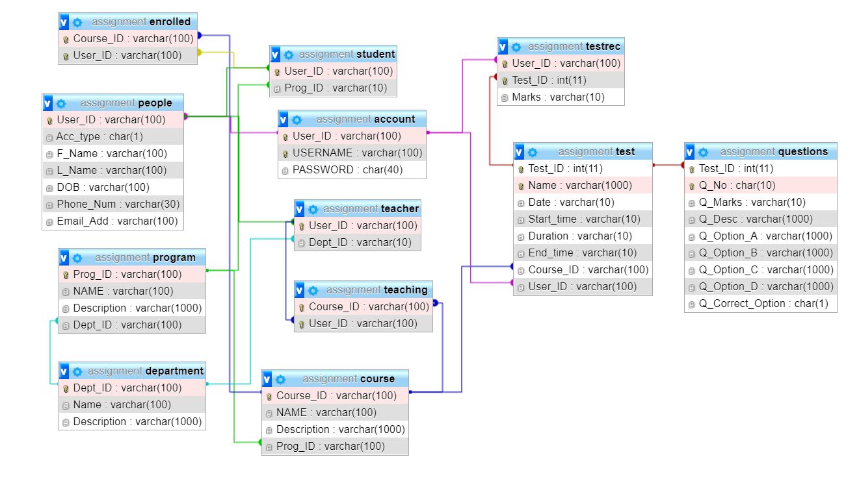

Figure ERD diagram of the database design

# 2.0 Skills and Techniques Used

## 2.1 PHP in-built functions

A function in php is a block or piece of code that is used to perform a specific task. Predefined functions in php that are available in the installation package are known as built in functions. There are many different categories to classify the many different built in functions such as string and numeric functions.

### 2.1.1 Isset function

This is an in-built function of php which is used to check whether a variable exists and that it is not null. It does this by checking whether the variable has been declared/ that the variable has been set. A variation on the isset function is the !isset function which is used to check whether a variable is not set. The isset function has been used multiple times in this project such as:

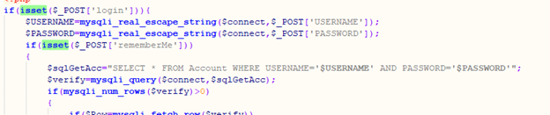

Figure ISSET function use 1

In the example above the isset function has been used in login.php. It has been used in the above example to check whether the $_POST variable named ‘login’ has been set. This is used to check whether the login button was clicked which will help to insert the username and password into the sql database without any special characters.

It has been used again to check whether the variable $_POST named ‘rememberMe’ has been set. This is used to check whether the checkbox remember me has been selected which will then help to achieve the goal of keeping the user logged in even after they close the browser and re-open it.

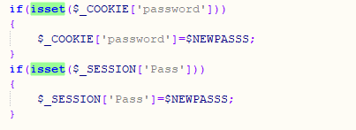

Figure ISSET function use 2

Here is another example of the isset function being used in the changePass.php. It has been used to check whether the variable $_COOKIE named ‘password’ has been set. This is used to check whether a cookie has been set with the name ‘password’ which will then help to achieve the task of changing the user’s password.

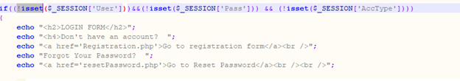

Figure ISSET function use 2

This is an example of an !isset function from login.php. It is used to check that the variable $_SESSION named ‘user’, ‘pass’ and ‘AccType’ is not set this helps to then display the login form for the user to login.

### 2.1.2 str_shuffle

This is an in-built function which is used to shuffle every character found in a string to get a random assortment of characters. It has only been used once in resetPassword.php.

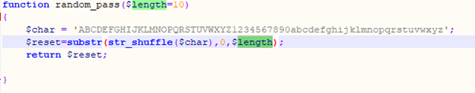

Figure str_shuffle usage

In the example above the str_shuffle function is being used to get a random string of characters from the variable $char of length 10 which is gotten from the variable $length with the use of the function substr. This is used to generate a random password for the user.

### 2.1.3 mysqli_query

This is an in-built function that is used to execute different types of sql queries such as insert, select update and delete.  It has been used in multiple times in this project such as:



Figure Example of mysqli_query usage

In the example above the mysqli_query function has been used in login.php. mysqli_query is used to execute a select query through the variable $sqlGetAcc. This is used to get the information from the sql database which would help in setting the session and cookies.

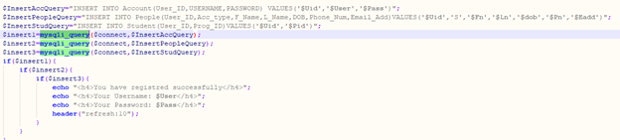

Figure Example of mysqli_query use

In the example above the mysqli_query function has been used in registration.php. It is used to execute an insert query through the variables $InsertAccQuery, $InsertPeopleQuery and $InsertStudQuery. This is used to insert data into the tables Account, People and Student respectively in the sql database. This would help in adding the information the user has put into the registration form thus registering the user.

### 2.1.4 mysqli_num_rows

This is an in-built function that is usually used to check whether there is any data in the database. It does this by returning the number of rows that are there in the result set. A connection to the database is necessary to use this function.



Figure mysqli_num_rows usage

The example above is from changePass.php. It is used to check whether the number of rows in the account table are more than 0 through using the variable $verify. This is used to find out whether the account table has any data in it. It is then used to achieve the task of changing the password.

### 2.1.5 mysqli_fetch_array

mysqli_fetch_array is an in-built function used to display a row from the result set that is used to fetch rows from a table in sql database and stores that information in an array.

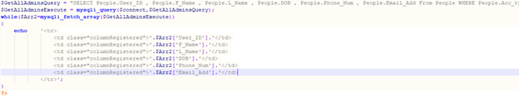

Figure : mysqli_fetch_array function

This example is taken from RegNewAdmin.php. mysqli_fetch_array is used to fetch the rows from the people table in the database through the variable $GetAllAdminsExecute. The array is then stored in the variable $Arr2 which is then used to display all the information.

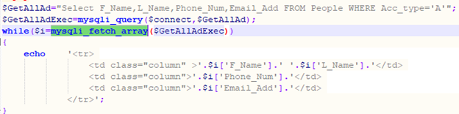

Figure Mysqli_fetch_array usage

This example is taken from Registration.php. mysqli_fetch_array is used to fetch the rows from the sql database through the variable $GetAllAdExec. The array is then stored in the variable $i which is then used to display all the information.

### 2.1.6 mysqli_fetch_row

This is an in-built function of php that is used to fetch a single row from a result set. It is returned as an enumerated array.

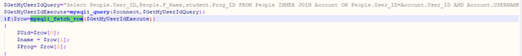

Figure Mysqli_fetch_row usage

The example above has been taken from Student.php. It is used to fetch a single row from the sql database through the variable $GetMyUserIdExecute. The row is then stored in the variable $row which is then used to display all the information.

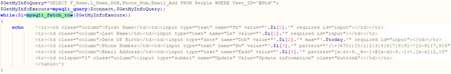

Figure Mysqli_fetch usage 1

This example is taken from MyProfile.php. It is used to fetch a single row from the sql database through the variable $GetMyInfoExecute. The row is then stored into the variable $I which is then used to display the information.

### 2.1.7 mysqli_error

This is an in-built function used to return errors when the most recent mysql function call fails.

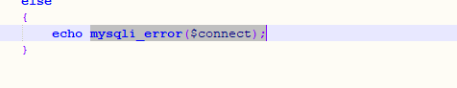

Figure Mysqli_error usage

This example is from StudentRecords.php. mysqli_error is used here to return an error in the event the function call fails.

### 2.1.8 trim

This function removes predefined characters and whitespace from each side of the string.

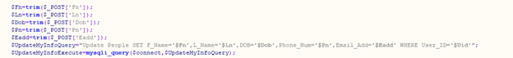

Figure Use of trim function

This example is from Myprofile.php. The trim function is used here to remove the white spaces and predefined characters from the string in the variable $_POST named ‘Fn’, ‘Ln’,’Dob’,’Pn’ and ‘Eadd’. This is used to ensure only the desired data is taken without the whitespaces and the predefined characters.

### 2.1.9 mysqli_real_escape_string

This function is used to create a string that is usable in a sql statement by having the given string encoded to an escaped sql string while taking into consideration the character set of the connection currently being used.

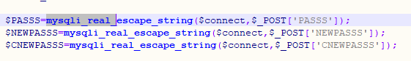

Figure Use of mysqli)real_escape_string function

The example above is taken from changePass.php. mysqli_real_escape_string is used here to ensure that no special characters are included when taking the string from the variable $_POST named ‘PASSS’, ‘NEWPASSS’ and ‘CNEWPASSS’ which is then inserted into the variables $PASSS, $NEWPASSS and $CNEWPASSS respectively.

### 2.1.10 Session_start

This is an in-built function that is used to create or resume a session. It does this through a session identifier that is passed through POST of GET requests or through cookies.

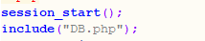

Figure session start

This example is from changePass.php. The session_start function is used to allow the user to use session variables such as $_SESSION.

### 2.1.11 Session_destroy

This function is used to destroy the current session variables associated however this does not unset cookie variables. This means that it is used to delete the session variables. In our case we have used it to log out a user from the system.

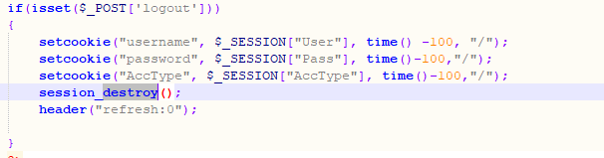

Figure Session destroy function usage

The example above is taken from gradedTests.php. It is used to destroy the session after the logout button has been clicked.

### 2.1.12 Set cookie

This function is used to set a cookie that can be accessed when the page is loaded the next time.

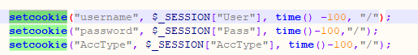

Figure Setcookie fucntion use

The example above is taken from gradedTests.php. It is used to set cookies with the names “username”, ”password” and “AccType” along with the time until they are destroyed which is in negative. The negative time function causes the cookies to be destroyed.

### 2.1.13 Include

The include statement is used for taking all text/code that is there in specified files and creates a copy of that into the file where the include statement is being used.

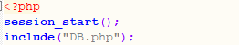

Figure Session_start function use

This example is from gradedTests.php. The include statement is used to include code from DB.php. This allows gradedTests.php to use the code from DB.php.

### 2.1.14 header

The header function is used to send a raw http. Location headers are used to redirect the user to another page.



Figure header function use

The example above is taken from gradedTests.php. The header function is used to redirect the user to login.php when the sessions are not set.

### 2.1.15 date_default_timezone_set

This function is used to set the default time zone that would be used by all date/time functions.



Figure date_default_timezone_set use

This example is from Myprofile.php. The date_default_timezone_set is used to set the default time zone to Asia/kuala lumpur which will allow all other date/time functions such as the date function to use. This is to ensure that all date/time functions have the correct time relating to the correct time zone.

### 2.1.16 strtotime

This is a built-in function in php which is used to change from English textual date-time to a Unix timestamp. These functions accept string parameters in English which represents the description of date-time. As an example, the word “now” in this function is the current date and time.

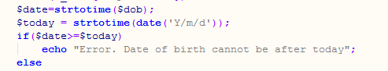

Figure Use of strtotime function

### 2.1.17 date

The date function was used on Myprofile.php with the finality of retrieve the date in the date format accepted by date time interface.



Figure use of date function

## 2.2 User Defined functions

These are functions that are created by us the users. They are not pre-defined in php, however are created by us. They generally begin with the word function followed by the function name and parameter. They contain curly brackets inside which the function is defined.

### 2.2.1 yourAccType

This function is almost used in all of our pages, it was created to check the user account type that is logged into our program, and they could be either: Admin, Student and Teacher. We used this function on AcMan.php So we could know which account is logged in our system.

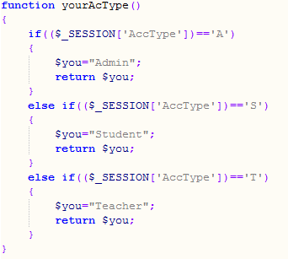

Figure User-defined function yourAccType

### 2.2.2 calculateMark

This function was used on gradedTests.php with the purpose of calculating the students test percentage.

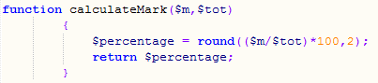

Figure User defined function calculateMark

### 2.2.3 grade

grade function was also used on gradedTests.php, with the purpose of retrieving test percentage and assigning a grade for it. As an example, if students have above 90% he is assigned with grade A+.

### 2.2.4 isPass

This function on gradedTests.php with the purpose of retrieving students' grades  and declaring if a student passes or fails. As an example if a student's grade is C-, D or F The system assumes that student fails otherwise the student passes.

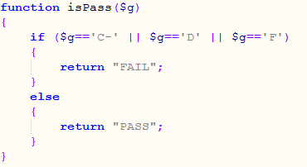

Figure User defined function isPass

### 2.2.5 HistoryAll

This function was created with the finality of displaying student history information, this function was used to retrieve the test id, name , the curse ID, the date that the tests were taken, the marks, student grade and declaration if a student passes or fails . This function was used on Student_history.php

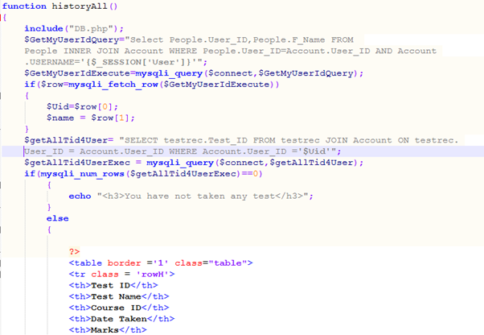

Figure Userdefined function historyAll

The query used is a SELECT query that contains JOIN to get records from multiple tables in this case getting records from people table and account table where the user_id’s match.

### 2.2.6 random_pass

This function is used when a user is trying to reset his password. When the  user reset his password the system gives the user a random one after the user validates that he is the account owner, after that ,this random password  is assigned to his user ID, after that user can enter on his account, and change it . We can find this function on resetPassword.php

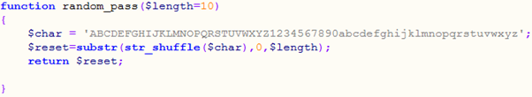

Figure User defined function random_pass

## 2.3 Query Strings

Query string  is  part of a uniform resource locator also known as (URL) which assigns values to specific parameters, a query string includes fields added to a base URL by a Web browser. This query string is found on uploadedTest.php and is used to send to that page on click the course id, test id and test name. We use query strings to allow us to pass data from one page to another.



Figure Useage of query strings

## 2.4 Session variables

Sessions are used to store information, it stores information on the client side and also on the server used, sessions creates files on a temporary directory on the server where  the resisted session variables and values are stored. The information stored will be available on all pages on the site, during that visit. A session ends when the user leaves the site or when the user closes the browser. An example of where he used sessions is on our Login.php page.

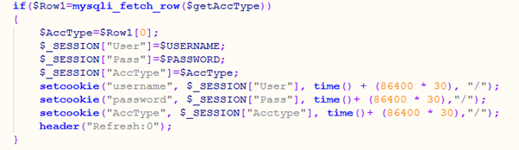

Figure Usage of session variables

## 2.5 Cookies

Cookies are also used to store information but it only stores information on client-side and not on server. Cookies are text files stored and they usually are name, age ,phone number, email and others, the browser stores this information for future use. And next time that browser sends a request to the server it sends  this cookie information to the server and the server uses that data to identify the user. On our Login.php page we set our cookies for 30 days.



Figure Use of cookies

## 2.6 Hidden input types

The < input type= “hidden”> defines a hidden input field, the hidden input fields let the web developers include data that cannot be seen or modified by users when a form is submitted. Used on uploadTest.php. We use hidden input typs when we wish to save data without having the need to show this data to the user.

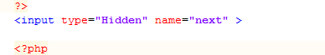

Figure Use of hidden variables

## 2.7 Scripts

The HTML <script > is used to define  client side script (javascript), the <script> either contains script statements, or it points to an external scripts file through the src attribute. Common uses for JavaScript are form validation, dynamic changes of content and image manipulation.We can find it on uploadTest.php

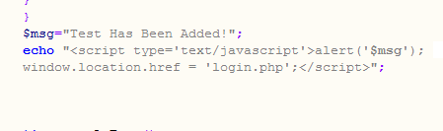

Figure Use of scripts

## 2.8 Style

We used styles when we were designing our program interfaces, we used styles to choose background color, text align, font-size, tables size and style. We used styles to make the program well designed and easy to understand. One example of where we used styles is on page greater.php

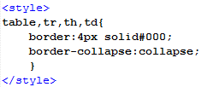

Figure use of style

## 2.9 Required Field Validators

Required input validators are used to make an input control required, it will show an error/ message if the user leaves input control empty. In other words if these fields are left empty the  user will not be able to submit the form.We can see on the screenshot below that User Id and Username are required to be filed. These functions were used on Registration.php. We used required field validation in order to let the user know that some fields all compulsory to be filled.

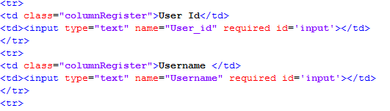

Figure use of required field validators

## 2.10 Pattern

The Pattern attribute specifies a regular expression the <input> elements value is checked against the form submission. Patterns can work with the following input types : text, dates, phone number , email and password. We used patterns because were  required to have an @ in order to have a valid email, the phone number  was required to have 9 numbers and has +60 in front and we use patterns also to insert password while doing the registration, so user should know that Password must contain at least 8 digits, 1 of them in number and other one on uppercase letter. We can see the patterns used bellow.



Figure Use of pattern validation

# 3.0 Features and Functions

## 3.1 Features and functions for admin

### 3.1.1 View All Registered Accounts

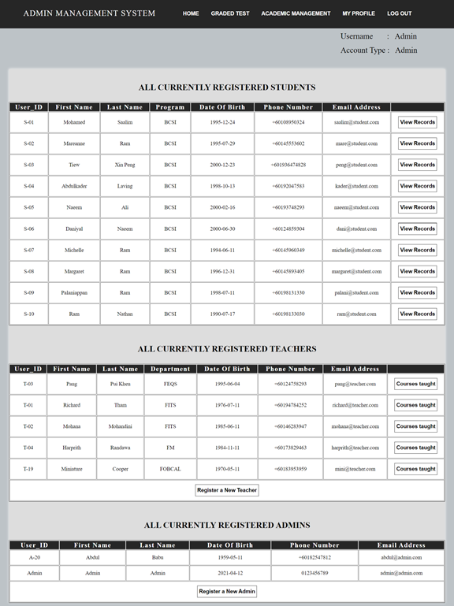

Figure Admin feature 1

Three tables “All currently registered students”, “All currently registered teachers” and “All currently registered admins” would appear in the home page of the online examination system after the admin has logged in successfully. These three tables allow admin to view all the registered accounts.

### 3.1.2 Register new Teachers and Admins

#### 3.1.2.1 Register new teachers

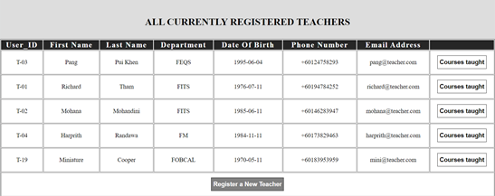

Figure Admin feature 2

Admin must click the button “Register a new teacher” which is placed at bottom of the table “All currently registered teachers”.

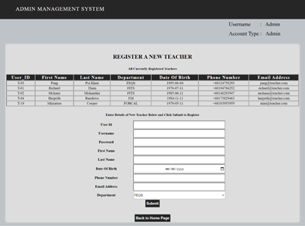

Figure Admin feature 3

“Register a new teacher page” allows the admin to register a new teacher. A table which has listed information of registered teachers is placed at the top of this page. Before the “Submit” button is clicked, admin must make sure that all the text fields are inserted.

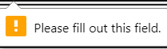

Figure Validation for inserting new records

This message would appear if the admin clicked on the “Submit” button without inserting values for all required fields.

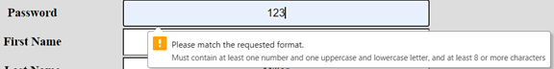

Figure validation for inserting new record 2

This message appears when the admin has inserted the password in the wrong format. Admin must create an appropriate password for the teacher according to the requirement as shown in the message above.

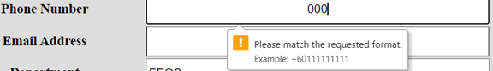

Figure validation for inserting new record 2

This message appears when the admin has inserted the phone number in the wrong format. Admin must insert an appropriate phone number for the teacher according to the requirement as shown in the message above.



Figure Output when username exists

This message appears if the admin has registered a teacher by using the information which is currently existing in the database.

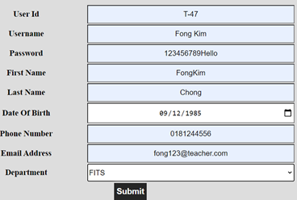

Figure correct format of insertion by admin for creating new teacher account

The image above is showing the fields that are inserted by admin by using the correct format.

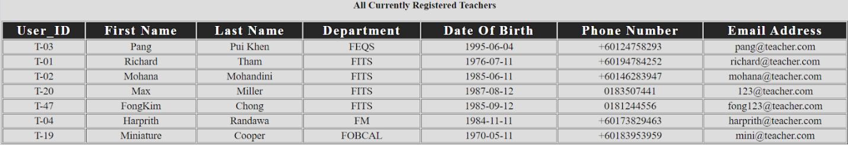

Figure table showing all currently registred teachers

The image above is showing the current records of the “All currently registered teachers” table.



Figure single record display

The image above shows one of the records from table “All currently registered teachers”. After the “Submit” button is clicked, the new teacher which is registered by admin will be inserted to this table.

#### 3.1.2.2 Register new admin

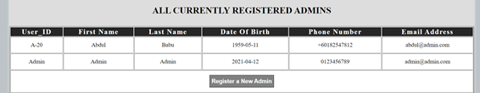

Figure view of all currently registred admins

As we mentioned there is a button “Register a new admin” is placed at bottom of the table “All currently registered admins. Admin must click on it to register a new admin.

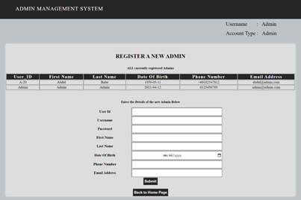

Figure When register new admin is clicked

“Register a new teacher page” allows the admin to register a new admin. A table which has listed information of registered admins is placed at the top of this page. Before the “Submit” button is clicked, admin must make sure that all the text fields are inserted.



Figure required validation

This message would appear if the admin clicked on the “Submit” button without inserting values for all required fields.



Figure pattern validation for password

This message appears when the admin has inserted the password in the wrong format. Admin must create an appropriate password for the new admin according to the requirement as shown in the message above.

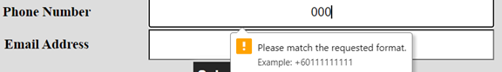

Figure pattern validation for phonenumber

This message appears when the admin has inserted the phone number in the wrong format. Admin must insert an appropriate phone number for the new admin according to the requirement as shown in the message above.

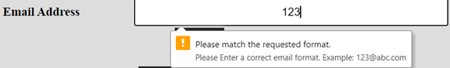

Figure email address pattern validation

This message appears when the admin has inserted the email address in the wrong format. Admin must insert an appropriate email address for the new admin according to the requirement as shown in the message above.



Figure output when a username already exists

This message appears if the admin has registered a new admin by using the information which is currently existing in the database.

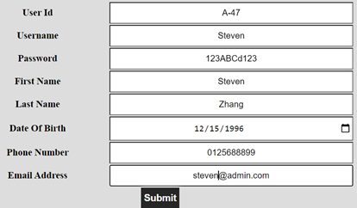

Figure correct format for inserting data for new admin registraton

The image above is showing the fields that are inserted by admin by using the correct format.

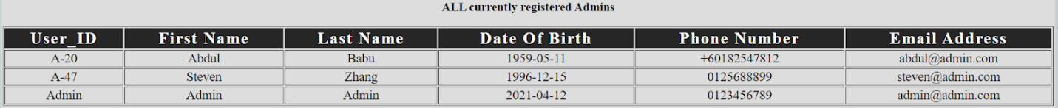

Figure records of currently registred admins

The image above is showing the current records of the “All currently registered admins” table.



The image above shows one of the records from table “All currently registered admins”. After the “Submit” button is clicked, the new admin which is registered by admin will be inserted to this table.

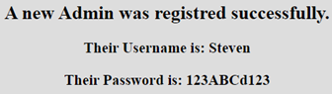

Figure output when registration of new admin is a success

This message appears when the admin has successfully registered a new admin.

### 3.1.3 View Course Taught By Teachers And Available Courses for teachers to teach

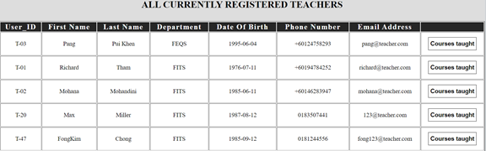

Figure Display of all currently registred teachers

Admin must click the button “Courses taught” on any rows to view the courses taught by a particular teacher and available courses for a teacher to teach.

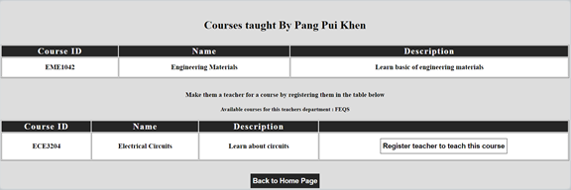

Figure display of courses taught by pui khen

This page allows the admin to view the courses taught by a teacher and courses that are available for a teacher to teach according to the department of teacher.

### 3.1.4 Enrol teachers to teach courses

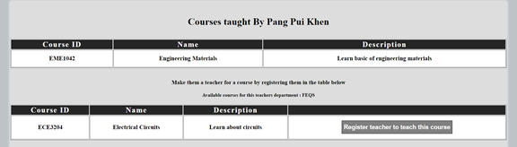

Figure enrolling teacher to a course

As we noticed there is a button “Register teacher to teach this course” displayed along with the course in the table “Available courses for this teacher”. Admin must click on this button to enroll teachers to teach courses.

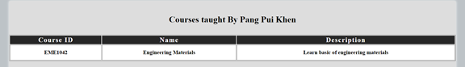

Figure display of all the courses taught by pui khen

The image above is showing the table of courses taught by a teacher before the button “Register teacher to teach this course” is clicked.

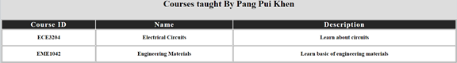

Figure display of courses taught by pui khen after enrolling him for more courses

The image above is showing the table of courses taught by a teacher after the button “Register teacher to teach this course” is clicked.

### 3.1.5 View Records for each Student (info,courses enrolled,tests taken and marks)

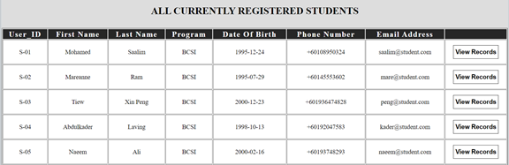

Figure display of all registred students

Admin must click the button “View records” on any rows to view all the information of a student.

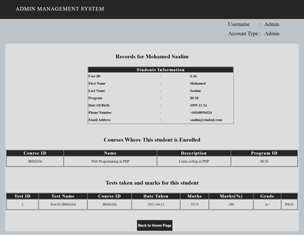

Figure display of specific student records

This page allows the admin to view all the information of students, such as personal information, courses enrolled, tests taken and marks of students.

### 3.1.6 View All Registered Departments, Programs and Courses



Figure Header buttons

In order to view all registered departments, programs and courses, admin must click on the tab “Academic management”.

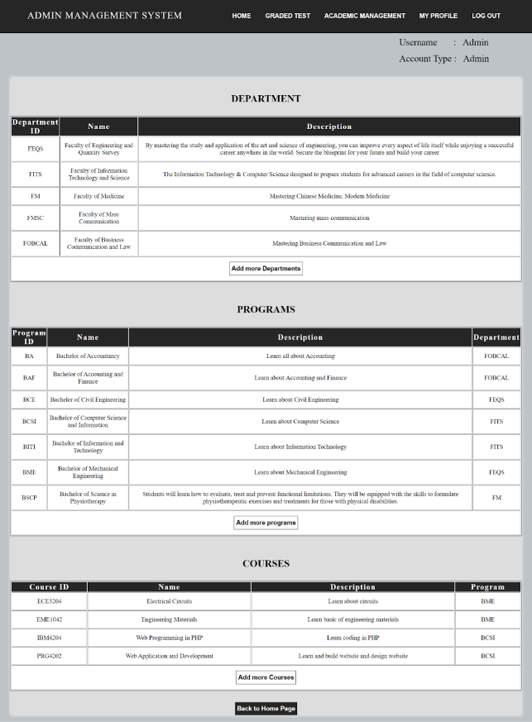

Figure display when academic management is clicked

Three tables “Departments”, “Programs” and “Courses” would appear in the home page of the online examination system after the admin has logged in successfully. These three tables allow the admin to view all the records of departments, programs and courses.

### 3.1.7 Add new Departments,programs and courses

#### 3.1.7.1 Add new department

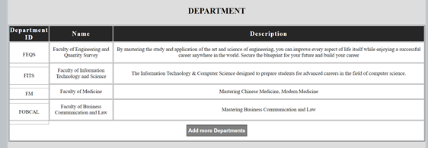

Figure View of all current departments

As we noticed there is a button “Add new departments” is placed at the bottom of the department table, admins must click on it to add departments.

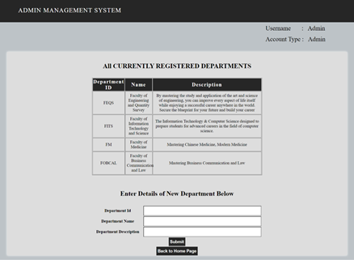

Figure form for adding new departments

“Add more departments page” allows the admin to register a new department. A table which has listed information of registered departments is placed at the top of this page. Before the “Submit” button is clicked, admins must make sure that all the text fields are inserted.

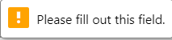

Figure required field validation

This message would appear if the admin clicked on the “Submit” button without inserting values for all required fields.

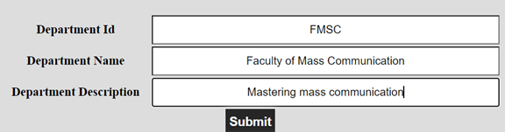

Figure adding new department process continued

The image above is showing the fields that are inserted by admin by using the correct format.

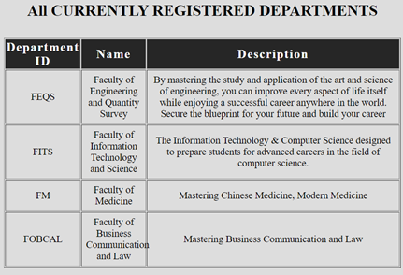

Figure display of after before department is added

The image above is showing the current records of the “All currently registered departments” table before the “Submit” button is clicked.

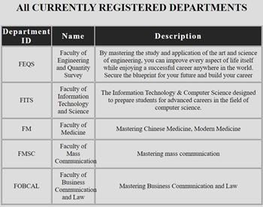

Figure display of after before department is added

The image above is showing the records of the “All currently registered departments” table after the “Submit” button is clicked.

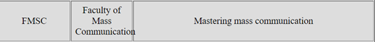

Figure new record in department table is added

The image above shows one of the records from table “All currently registered departments”. After the “Submit” button is clicked, the new department which is registered by admin will be inserted to this table.

#### 3.1.7.2 Add new program

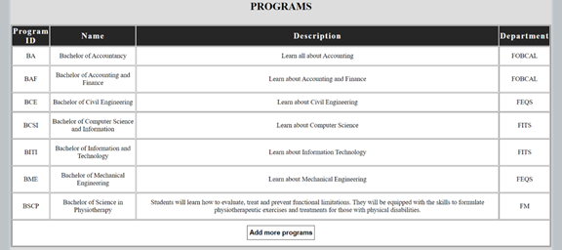

Figure View of all current programs

As we noticed there is a button “Add new programs” is placed at the bottom of the programs table, admin must click on it to add programs.

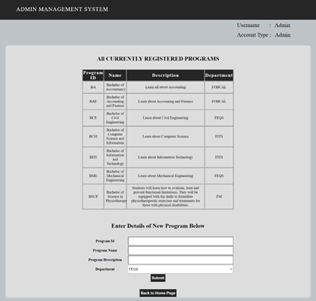

Figure view after add new programs is clicked

“Add more programs page” allows the admin to register a new program. A table which has listed information of registered programs is placed at the top of this page. Before the “Submit” button is clicked, admin must make sure that all the text fields are inserted.



Figure required field validation

This message would appear if the admin clicked on the “Submit” button without inserting values for all required fields.

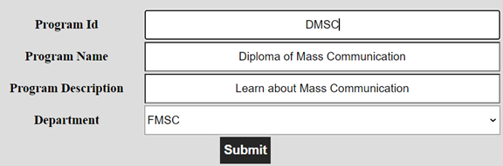

Figure insertion of new program

The image above is showing the fields that are inserted by admin by using the correct format.

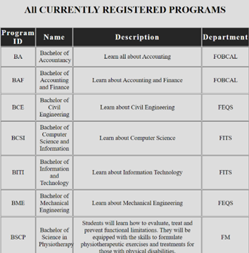

Figure programs table before insertion of new program

The image above is showing the current records of the “All currently registered programs” table before the “Submit” button is clicked.

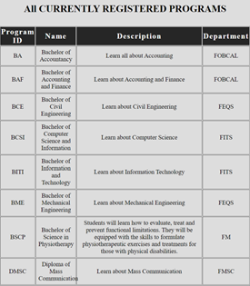

Figure programs table after insertion of new program

The image above is showing the records of the “All currently registered programs” table after the “Submit” button is clicked.

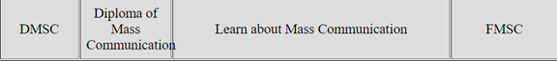

Figure the new program that is inserted

The image above shows one of the records from table “All currently registered programs”. After the “Submit” button is clicked, the new program which is registered by admin will be inserted to this table.

#### 3.1.7.3 Add new course

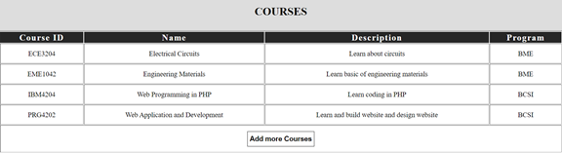

Figure All courses table

As we noticed there is a button “Add new courses” that is placed at the bottom of the courses table, admin must click on it to add courses.

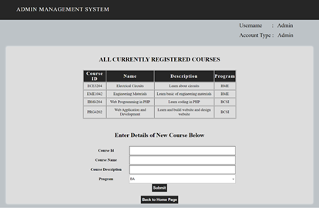

Figure Add more courses page

“Add more courses page” allows the admin to register a new course. A table which has listed information of registered courses is placed at the top of this page. Before the “Submit” button is clicked, admin must make sure that all the text fields are inserted.



Figure validation

This message would appear if the admin clicked on the “Submit” button without inserting values for all required fields.

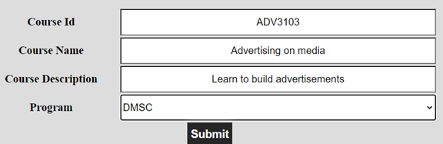

Figure data input

The image above is showing the fields that are inserted by admin by using the correct format.

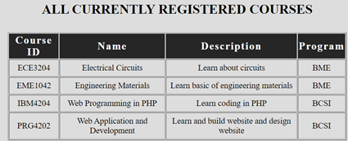

Figure course page before submiting new data

The image above is showing the current records of the “All currently registered courses” table before the “Submit” button is clicked.

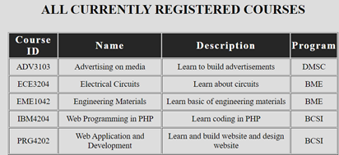

Figure course page after submiting new data

The image above is showing the records of the “All currently registered courses” table after the “Submit” button is clicked.



Figure newly entred data in course table

The image above shows one of the records from table “All currently registered courses”. After the “Submit” button is clicked, the new course which is registered by admin will be inserted to this table.

## 3.2 Features and functions for Teacher

### 3.2.1 View Courses Where They Are Teaching

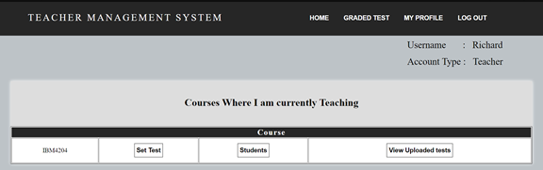

Figure Viewing courses where teacher is currently teaching

Teachers are able to view the courses that they are currently teaching on the home page after they have successfully logged into the online examination system via the login form.

### 3.2.2 Set tests for Courses they are teaching

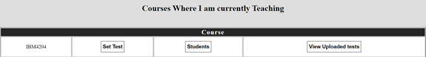

Figure setting tests

For setting up the tests for the course, teachers must click on the button “Set test”.

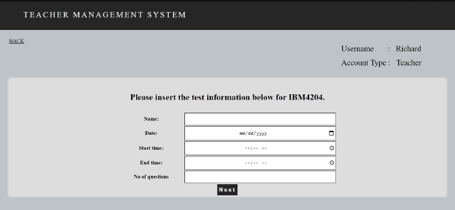

Figure test setting process 1

The page “Set test information” allows teachers to insert the test information for courses, before the “Next” button is clicked, teachers must make sure that all the required text fields are inserted with values.

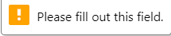

Figure validation

This message appears when the teacher clicked on the “Next” button without inserting all the required fields.

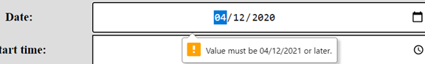

Figure date validation

This message appears when teachers have inserted a date that is lower than “today”.



Figure start and end time validation

This message appears if the teacher has inserted the start time for the test that is greater than the end time for the test.

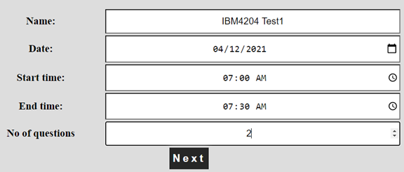

Figure test data entry

The image above is showing the fields that are inserted by the teacher by using the correct format.

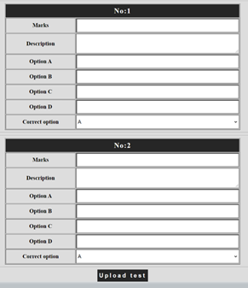

Figure test data entry 2

System shows tables (number of tables depending on the number of questions) for the teacher to set questions for the test.

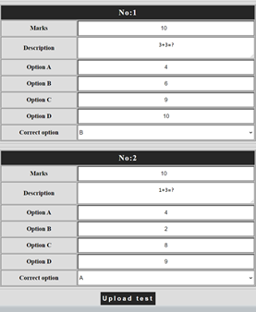

Figure test data entry 3

Teachers can click on the “Upload test” button to submit a test after they have inserted the details for each question.

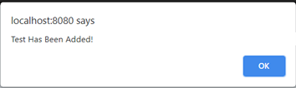

Figure successful submition of test entry

This message shows up when teachers have successfully created a test.

### 3.2.3 View All the tests set for a course

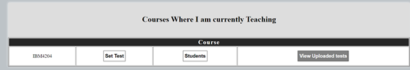

Figure viwing all tests set process

The button “View upload tests” allows the teacher to view all the tests set for a course if it is clicked.

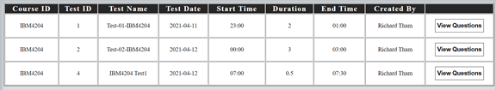

Figure viwing all tests set process

Teachers will be directed to this table after they have clicked the button “View upload tests” in the previous step, this page allows teachers to view all the tests set for a particular course. As we noticed there is a button called “View questions”, which is enabling a teacher to view the questions that were created for each test before.

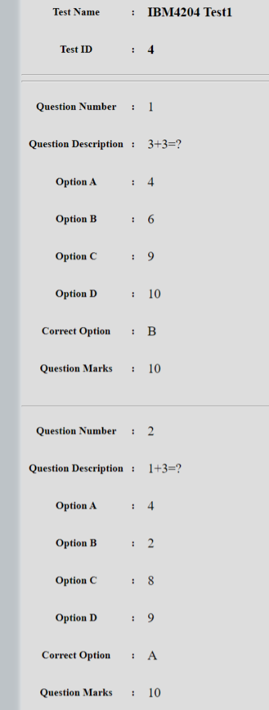

Figure viwing a particular set test

The image above is showing the details of questions of a test that is selected, this appears after the button “View Questions” is clicked.

### 3.2.4 View Students enrolled in courses taught by the teacher

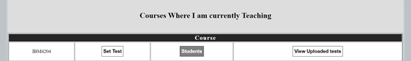

Figure viewing students enrolled for a course

The button “Students” in the table “Courses where I am currently teaching” on the homepage  allows the teachers to view all the students enrolled in the course which are taught by them if it is clicked.

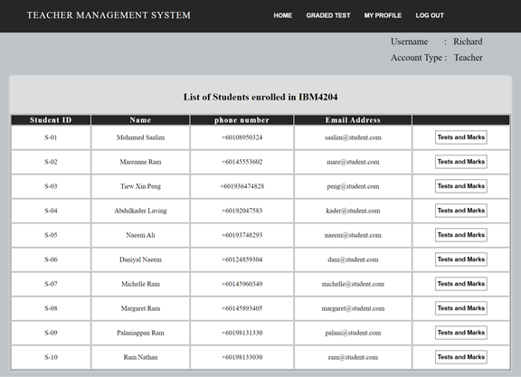

Figure who enrolled in a particular course that is taught by a teacher

The image above is showing the list of students who enrolled in a particular course that is taught by a teacher after the button “Students” in the previous page is clicked.

### 3.2.5 View tests and marks of each student enrolled in courses taught by teacher

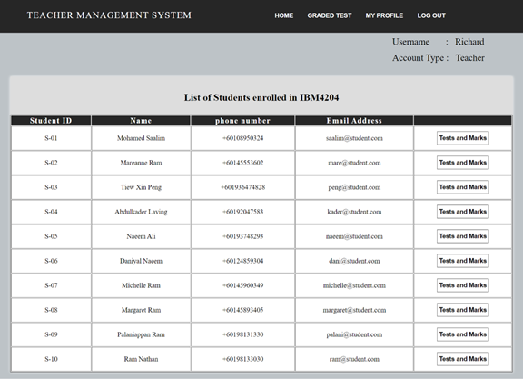

Figure process to display test and marks

As we can see, there is a button “Test and marks” available in all rows, teachers are allowed to view tests and marks of each student enrolled in courses which are taught by them if it is clicked.

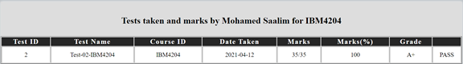

Figure when test and marks button is clicked

The image above is showing the test taken and marks of a student who is currently taking the course “IBM4204”.

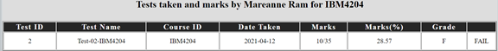

Figure test and marks for another student

The image above is showing the test taken and marks of another student who is currently taking the course “IBM4204”.

## 3.3 Features and functions  for Student

### 3.3.1 Register an account

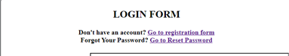

Figure registration by student

Students must click on the link “Go to registration form” in the login page to navigate to the registration form.

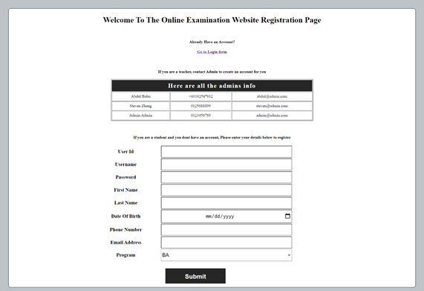

Figure registration form

Registration form is where students are allowed to create an account if they do not have an existing account. When registering an account, the text fields “User Id”, “Username”, “Password”, “First name”, “Last name”, “Date of birth”, “Phone number”, “Email address” are compulsory for students to fill-in before they click on the button “Submit”. There is a hyperlink “Go to login form”, students can click the link to navigate to the login form after they have created an account.

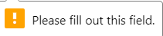

Figure validation

This message appears if students clicked on the “Submit” button without inserting all the required fields.

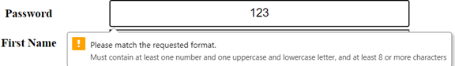

Figure pattern validation for password

This message appears when students have inserted the wrong format for the field “Password”. Students must create an appropriate password according to the requirement as shown in the message above.

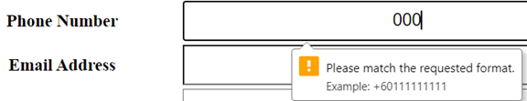

Figure pattern validation for phone number

This message appears when students have inserted the wrong format for the field “Phone number”. Students must insert an appropriate phone number according to the requirement as shown in the message above.

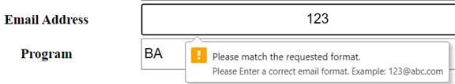

Figure pattern validation for email

This message appears when students have inserted the wrong format for the field “Email address”. Students must insert an appropriate email address according to the requirement as shown in the message above.



Figure output when registration with existing username

This message appears if the username or user Id inserted by students are existing in the database.

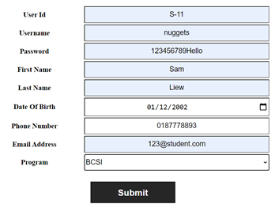

Figure correct insertion into registration form

Image above shows the fields that are inserted by using the correct format.

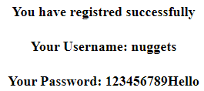

Figure successfull registration output

This message appears when students have created an account successfully.

### 3.3.2 View courses student is enrolled in

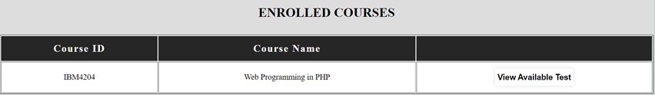

Figure viewing enrolled courses

The table “Enrolled courses” will be displayed in the homepage if students have successfully logged in via the login form. This table allows students to view the courses they have enrolled.

### 3.3.3 View available tests for courses they are enrolled in



Figure viewing available tests by course

As we noticed there is a button “View available test”, it allows students to view all the available tests from a course if it is clicked.

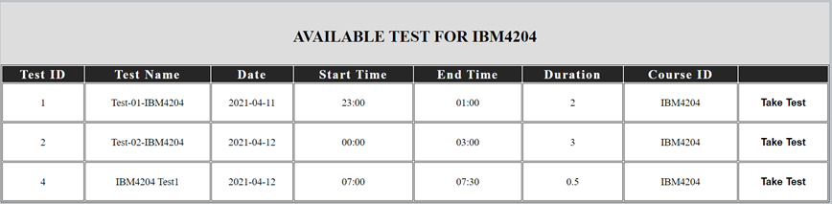

Figure viewing tests for IBM4204

Students will be directed to this page after clicking the button “View available test” in the previous page. This page allows students to view the available tests of a particular course.

### 3.3.4 Take tests

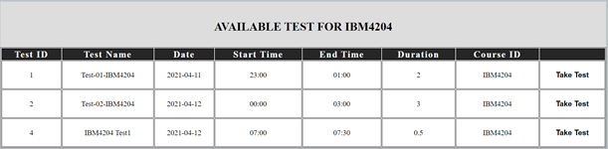

Figure taking a test

Students must click on the button “Take test” in order to sit for a test.



Figure output when test time is passed

This message appears if students have selected overdue tests.



Figure output when test has already been taken

This message appears if students have selected a test that was taken by them before.

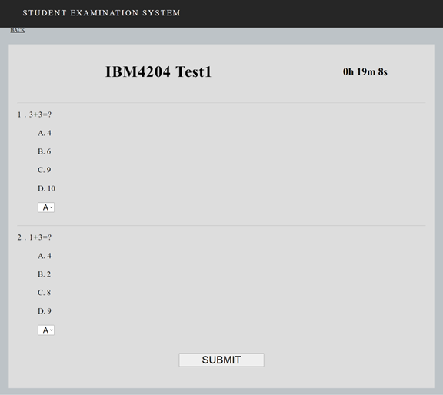

Figure taking test

Students will be able to sit for a test if they have selected the test that is still available.



Figure timer for test

Countdown timer is created for the online examination system for ensuring the students finish the test within the time range.

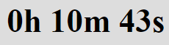

Figure timer

The remaining time of the test decreases automatically as the time passes.

Students may click the “Submit” button after they have finished answering for the questions.

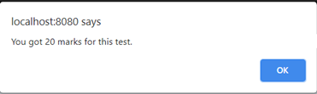

Figure output 1 on test submission

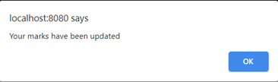

Figure output 2 on test submissio

These two messages will be displayed if a test is submitted by students.

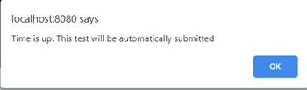

Figure output when test is autosubmitted

This message appears if students have reached the end time of the test but still yet to submit the test.

### 3.3.5 View and Enrol in courses they are not yet enrolled

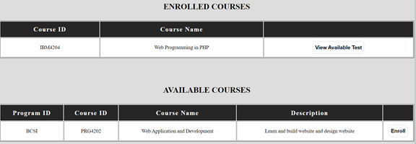

Figure viewing courses where student isnt enrolled

The table “Available courses” shows the courses that are available for a student to enroll. There is a button “Enroll”, it allows students to enroll themselves to a particular course if it is clicked.

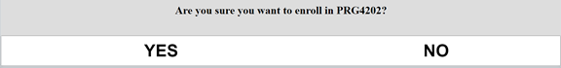

Figure when student clicks enrol

This message appears after the “Enroll” button is clicked.

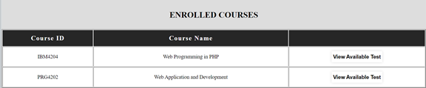

Figure when student clicks yes

Table “Enrolled courses” is updated if the students click “Yes”.

### 3.3.6 View History



Figure viewing history process

Students can click on the tab “History” to view the record of test that have already taken before.

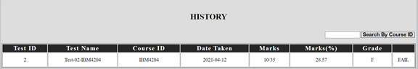

Figure History of a single student records

Image above shows the test history of a student.

## 3.4 Features and functions  for All

### 3.4.1 Login

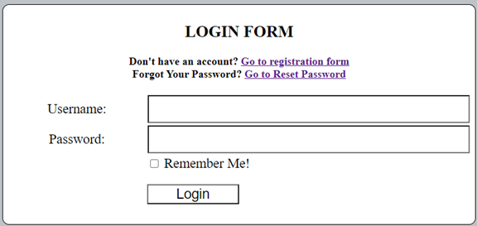

Figure login form

Login form is a page where allows all types of user to log into the online examination system. When navigating to this form, users must fill in the two compulsory fields by entering their username and password. Two hyperlinks “Go to registration form”, “Go to reset password” are placed above the text fields, which are enabling the users to select which action they are likely to perform among these two choices. Users can navigate to registration form to create a new account if they don’t have an existing account. If users have forgotten their password, they are allowed to reset their password by navigating to the reset password form. The checkbox “Remember me!” is created to enhance the convenience which enables users to pass the login process directly while navigating again to the login page even if they have closed their browser. There is another button “Login” placed at the bottom center of login form, it is allowing the user to click on it to continue with the login process.



Figure output for invalid login attempt

The image above is showing the error message after the “Login” button is clicked. The message above would appear in two cases, in which the user has inserted their username and password that do not match, or the user left either one of the two compulsory fields as blank.

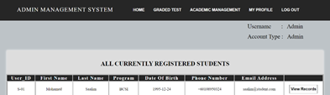

Figure successfull login

Users are allowed to navigate other pages in the online examination system  if they have logged in by using the correct username and password via login form.

### 3.4.2 Logout



Figure logout

Logout button appears in the navigation tab of the online examination system, which allows users to log out from the online examination system.

Session of users will be terminated if they have clicked on the button “Logout”. After the logout button is clicked, the user will be redirected to the initial status (login form) of the system.

### 3.4.3 Change Password



Figure my profile

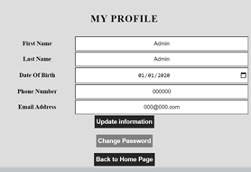

Figure when my profile page loads

Users need to perform the following tasks to navigate to the change password form:

1. Login to the system via login form.

2. Click on the tab “My profile”.

3. Click the button “Change password”.

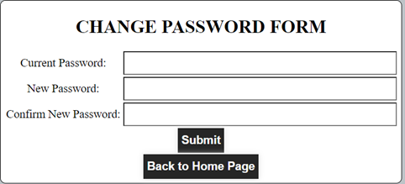

Figure change password form

Change password form allows users to change their password in case that they feel that their current password is not secure enough. Before they click on the button “Submit”, users must enter the three fields “Current password”, “New password” and “Confirm new password”.



Figure error output

The image above shows an error message after the “Submit” button is clicked. This message would appear if the users have inserted the current password that does not match with their actual current password which is existing in the database.

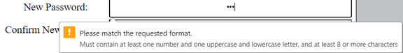

Figure validation

This message appears when users have inserted the wrong format for the field “New password”. Users must create an appropriate new password according to the requirement as shown in the message above.



Figure error output

This message appears when users have inserted the same numbers for the new password and current password.

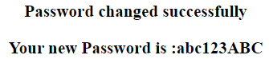

Figure successful password change

This message appears when users have changed their password successfully. This occurs when users have inserted valid values for the fields “Current password”, “New password” and “Confirm new password”.

### 3.4.4 Reset Password

Users need to perform the following tasks to navigate to the reset password form:

1. Go to login form.

2. Click on the link “Go to registration form”.

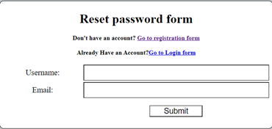

Figure reset password form

Reset password form is where the users are allowed to reset their password in case that they have forgotten their password. Before users click on the “Submit” button, they are required to insert the two compulsory fields “Username” and “Email” for verification.



Figure when userid and email dont match

This message appears when users have entered the user ID and email that does not match or both the user ID and email are not existing in the database.

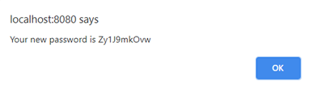

Figure output of new password

This pop-up message appears and displays the new password for users If they have successfully reset their password by inserting the correct username and email.



Figure successfull password change

This message appears when users have reset their password successfully.

### 3.4.5 View My profile

Users need to perform the following tasks to navigate to My profile:

1. Login to the system via login form.

2. Click on the tab “My profile”.

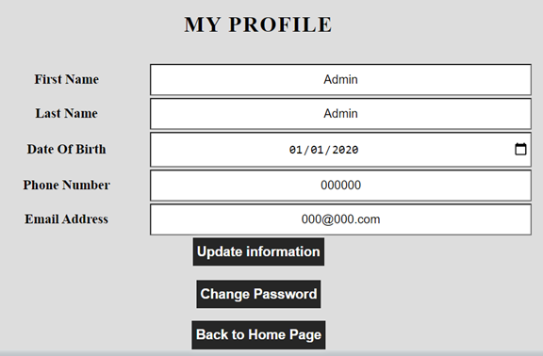

Figure my profile form

My profile is where users can view and make modifications to their personal information. All available fields are editable for users. There are three buttons “Update information”, “Change password”, “Back to home page” placed under the text fields, user can select any action to perform depending on their preferences, for example, if they wish to update their personal information, they must click on the button “Update information” after they have made changes to their profile, users are allowed to change their password by clicking on the “Change password” button to navigate to the change password form, on the other hand, they can click on the button “Back to home page” to return to the home page of online examination system.

This page keeps the same validation to ensure that data entered into the database is the same as when user is initially registering to keep the flow of the data throughout the system the same and in the correct order.

### 3.4.6 View Graded Tests/Ranking

#### 3.4.6.1 Admin’s view



Figure admins view for graded tests

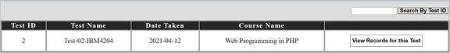

Figure viewing graded tests process

Admin need to perform the following tasks to view graded tests/ranking:

1. Login to the system via login form.

2. Click on the tab “Graded test”.

3. Click on the button “View records for this test”.

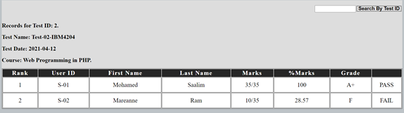

Figure output of the graded tests

Admin can view records of graded tests after performing the tasks as mentioned above.

#### 3.4.6.2 Teacher’s view



Figure teachers view

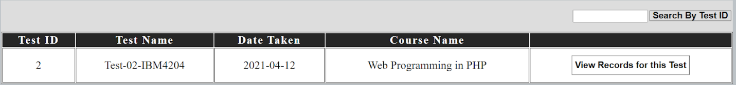

Figure teachers view 2

Teacher need to perform the following tasks to view graded tests/ranking:

1. Login to the system via login form.

2. Click on the tab “Graded test”.

3. Click on the button “View records for this test”.

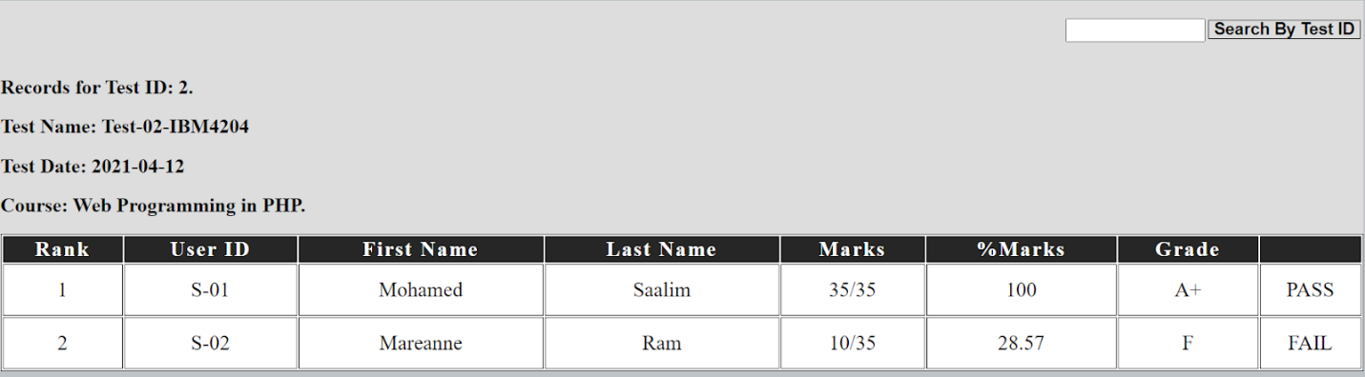

Figure Teachers view 3

Teachers can view records of graded tests after performing the tasks as mentioned above.

#### 3.4.6.1 Student’s view



Figure students view 1

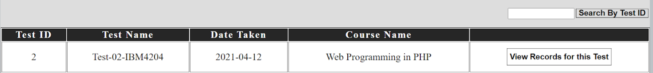

Figure students view 2

Student need to perform the following tasks to view graded tests/ranking:

1. Login to the system via login form.

2. Click on the tab “Ranking”.

3. Click on the button “View records for this test”.

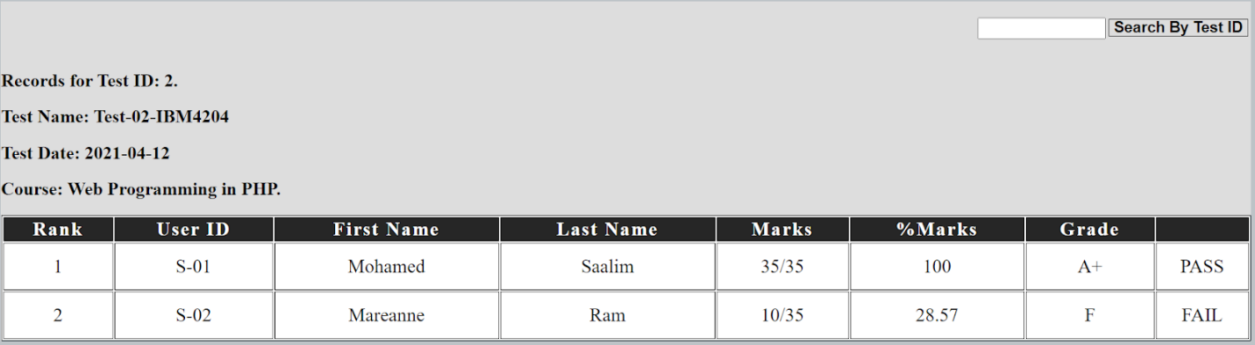

Figure Students view 3

Students can view records of graded tests after performing the tasks as mentioned above.

# 4.0 Coding Explanation

## 4.1 Common in all Pages



Figure session start

We implement session_start() function to start a session. This will then create a session that is used to store information in session variables across multiple pages. This function is also used and implemented in all the pages.



Figure using include

The include function as above enables the system to use the variables in DB.php such as $connect which is used for query execution and database connection. This function is also used and implemented in all the pages.

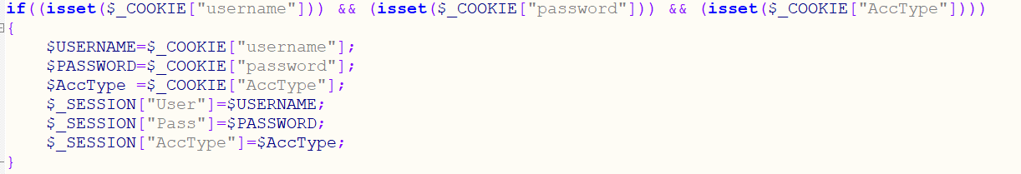

Figure checking for cookies using isset

The next function if((isset($_COOKIE["username"])) && (isset($_COOKIE["password"])) && (isset($_COOKIE["AccType"]))) is used to check if there is a cookie variable that exists. If it does exist it will save the cookie value to variables and store those variables to session variables as username, password and acctype. This will allow users to come back to his page even if they close the web browser only if they clicked on the remember me checkbox while logging in.



Figure using isset to check session variables

The next function is the if((isset($_SESSION["User"])) && (isset($_SESSION["pass"])) && (isset($_SESSION["AccType"]))). This will check if there a not session variables for username,password and AccType, if non exist, the user will be redirected to the login page and will be shown the login allows the user to login into the system.

Figure displaying username and accout type

This line of code above is used to fetch the session variable ‘User’ which is passed to the function youAccType() below which will then output the username and account type of the user to the screen.

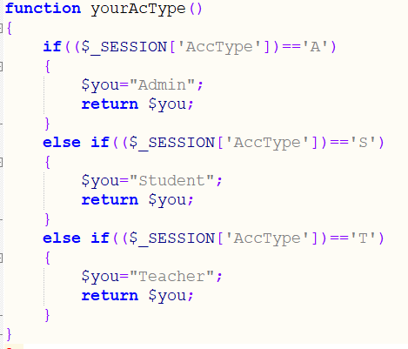

Figure function your AcType

This function is used in all the pages.

## 4.2 AcMan.php

This file is used to give admins the ability to view all departments, programs and courses that are registered in the database. It also allows the admins to be directed to other pages such as AddDept.php, AddCor.php and AddProg.php



Figure form action for AcMan.php

Line 1 shows the form action = $_SERVER[‘PHP_SELF’] and method post making the page submit data to itself.

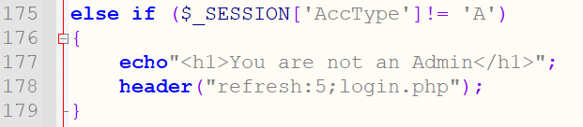

Figure Acman.php line 175 to line 179

From line 175 to 179, is an if function that will echo a message to users that they are not admin if the session variable ‘AccType’ is not equal to A then refreshes the header to login.php therefore preventing any user that is not an admin from accessing this page.

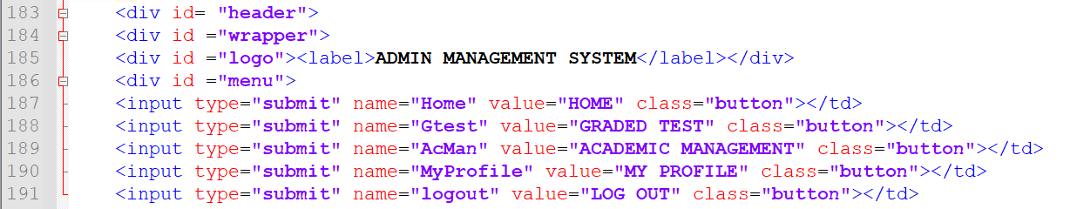

Figure Acman.php line 173 to line 191

From line 183 to 191, The code will create a label to display Admin Management System and will create all the buttons where the Admin can click.



Figure Acman.php line 197 to line 198

Line 197 and 198 are used to fetch the session variable ‘User’ which is passed to a function yourAccType which will then output the username and account type of the user to the screen.

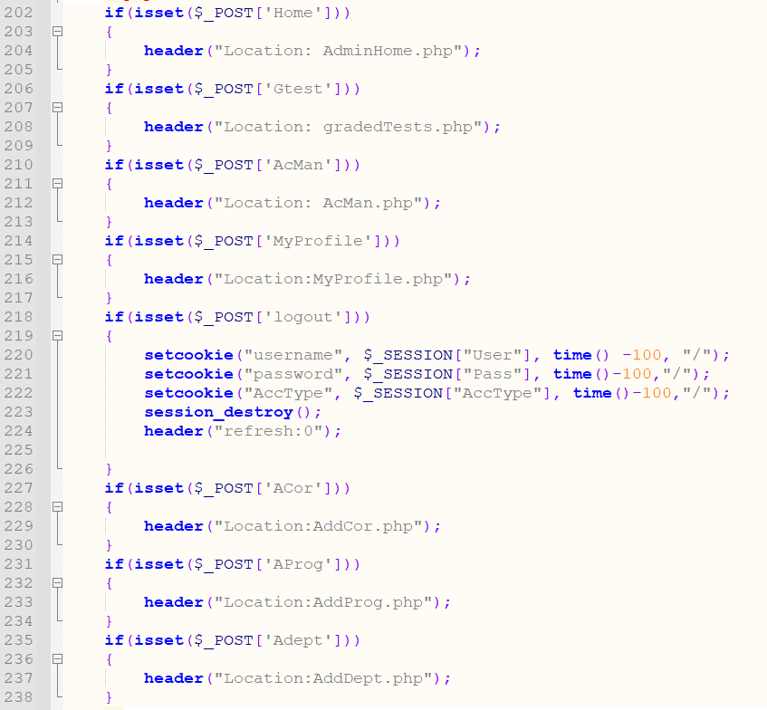

Figure Acman.php line 202 to line 238

From line 202 to line 238 are isset functions that are used to check if a certain submit button has been clicked. For example line 202 to line 205 checks if a button with the name ‘Home’ has been clicked. If it has been clicked, the header location will change to AdminHome.php. The rest of the isset functions work in a similar way. On line 218 to line 226, the isset function uses $_POST to check if an input type of submit with the name ‘logout’ has been clicked. If it has been clicked, the setcookie functions are used to create cookies with negative time which will cause deletion of those cookies. The session_destroy function will delete all session variables and the header will be refreshed. Since there are no session variables, the isset functions that check for session variables will be invoked thus causing the page to be redirected to login.php.

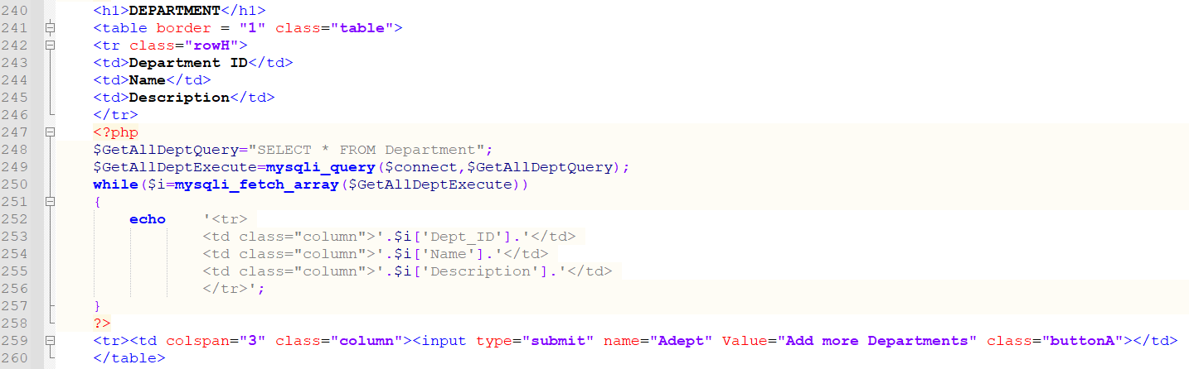

Figure Acman.php line 240to line 260

From line 240 to line 246 the code is used to create a table with columns in which the first row has department id, name and description. These are used as table headers in this case. On line 248 a select statement is saved into a variable called getAllDeptQuery and on line 249, the variable GetAllDeptExecute is used to execute the select statement using the mysqli_query function. The while loop on line 250 is used to fetch each line as an array from the database by executing the select statement and putting the data received into each row in the table. It is getting all the departments and putting the data into the table. Line 259 is creating a submit input type with the name Adept that will be used to redirect users to AddDept.php when it is clicked using the isset function on line 235.

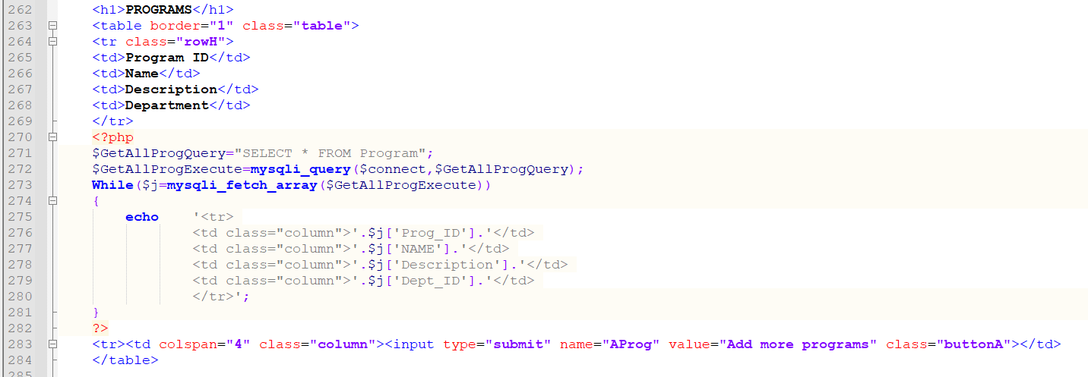

Figure Acman.php line 262to line 284

Line 262 to line 284 work in a similar way as line 240 to line 259. However, instead of getting all the departments, they are now getting all the programs from the database and saving the data into a table and the input type submit named AProg will direct users to AddProg.php page using the isset function on line 231

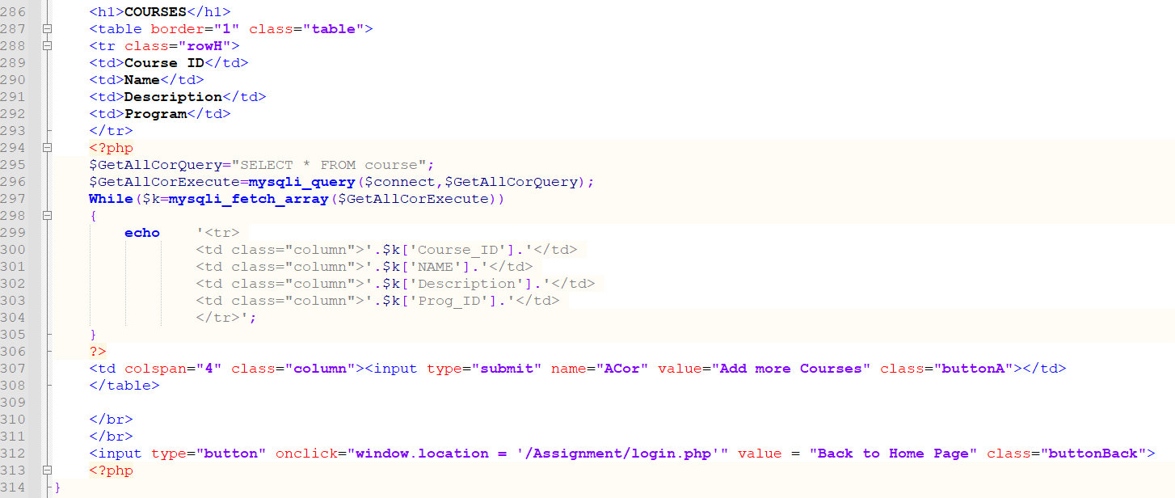

Figure Acman.php line 286 to line 314

Line 286 to line 312 work in the same way as line 262 to line 284. However, instead of getting the programs from the database, it is now getting all the courses from the database and displaying the information in a table and the input type of submit with the name Acor will direct users to AddCor.php using the isset function on line 227. The button on line 312 will direct users to login.php using window.location method. However, since the session variables are already set, the login page will then login the user and direct them to the AdminHome.php page.

## 4.3 AddCor.php

This file allows admins to add new courses to the database.

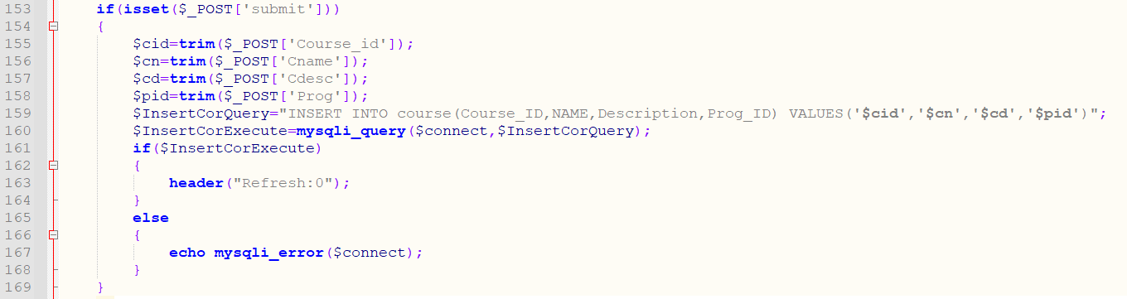

Figure AddCor.php line 153 to line 169

Line 153 to line 169 is an isset function that is used to check if the input type of submit with the name submit has been clicked. If clicked, it will gather data from the form in the page and save it to variables. Example , it will get the data inside the input of type text called Course_id using _POST and it will then use the trim function to get rid of the leading and trailing spaces and will then save it to a variable called $cid. It will do the same from line 156 to 158. It will then update the database by executing the insert query and will refresh the page using header(refresh:0). The 0 represents the time in seconds after which the page will be refreshed. The if statement will check if the database has been updated successfully and the else statement will display the error if an error occurs using the mysqli_error function.

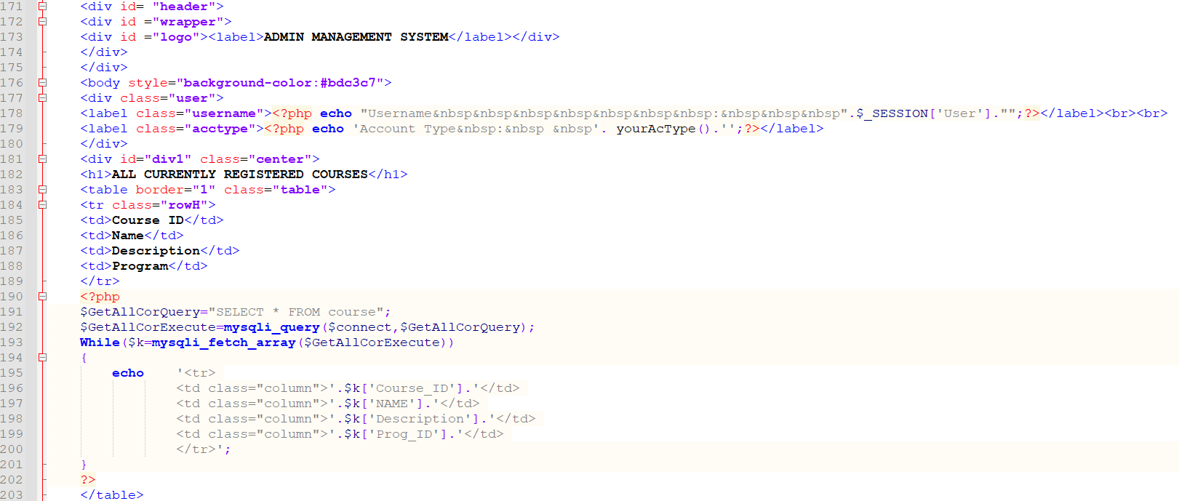

Figure AddCor.php line 171 to line 203

Line 171 to line 203 will function in the same way as on AcMan.php displaying all the currently registered courses saved in the database in a table.

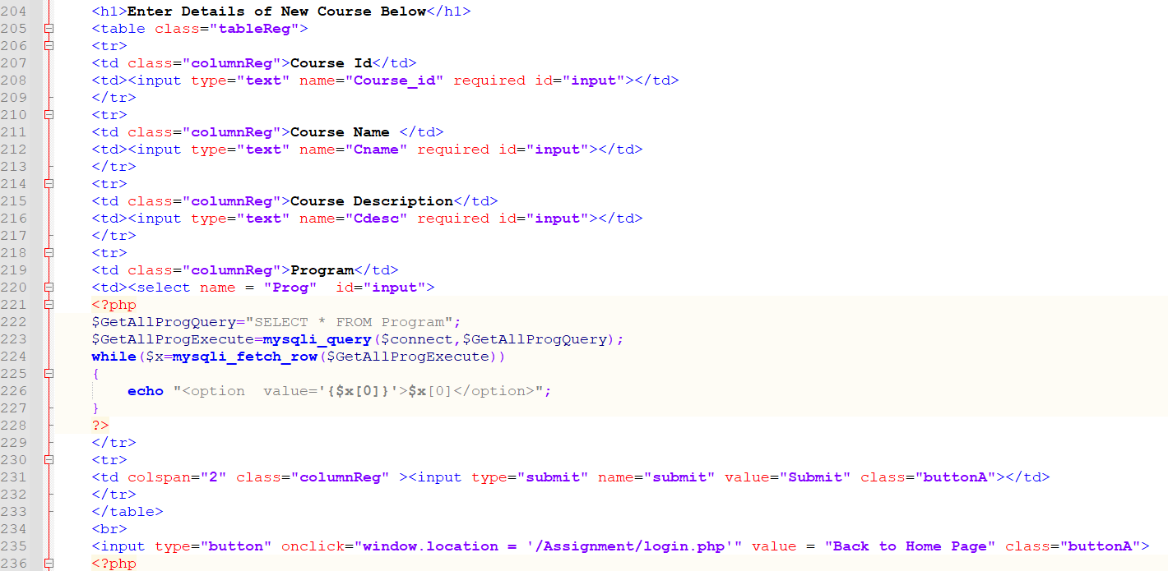

Figure AddCor.php line 204 to line 236

Line 204 to line 236 is a form that will allow an admin to enter the information for a new course. Line 219 to line 227 is used to display a drop down list of all the current programs in the database using the select query and mysqli_query function along with the <select> and <option>. The while loop is used to loop through each row using mysqli_fetch_row function and display each row as an option for the <select>. The form also contains required field validators that prevent the users submitting an empty form.

## 4.4 AddDept.php

This file allows admins to view all the departments in the database and also allows them to add more departments. It functions in a similar way to the AddCor.php page apart from not having any <select> or options since there are no foreign keys in the department table.

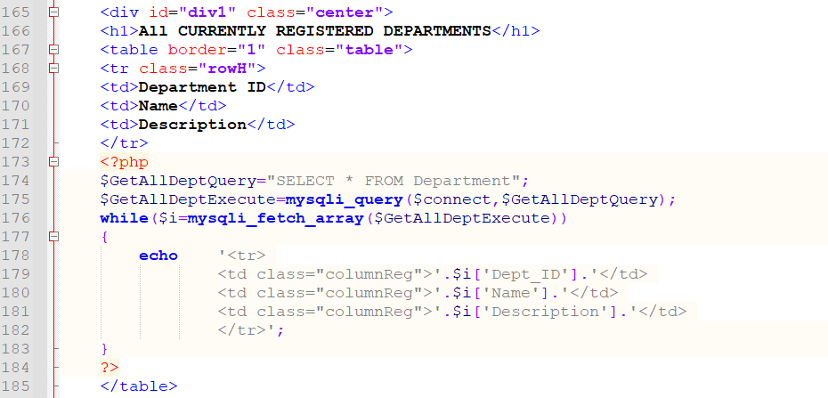

Figure AddDept.php Line 165 to line 185

Line 165 to line 185 is used to display all the departments in the database by department id, name and description using a query and executing the query by using my sqli_query. The while loop along with mysqli_fetch_array is used to fetch each row from the database as an array with the keys as the column names and the echo is used to display each row into a row in the table column by column.

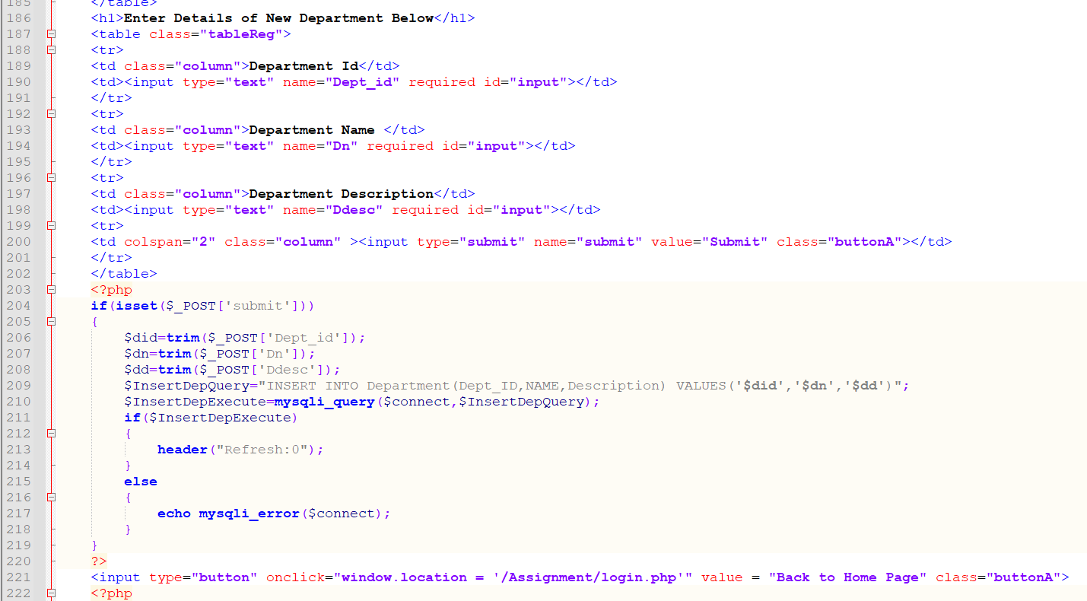

Figure AddDept.php Line 186 to line 222

Line 186 to line 202 is a form that allows users to enter data into input types of text that contain required field validators preventing submission of empty data.

The isset submit is used to check if the submit button is clicked and uses the INSERT query to insert data in the database using the mysqli_query and the if statement is used to check if the insertion is done then refresh the header else show the error using mysqli_error.

## 4.5 AddProg.php

This file allows admins to add more programs to the database. It works in a similar way to AddCor.php. Apart from the fact that instead of displaying a drop down of all the program id’s, it displays a drop down of all the department ids in the <select> and <option> part of the file since the department ids are used as foreign keys, we used a select to make sure that the department ids entered will be as received from the database to minimize errors during data entry.

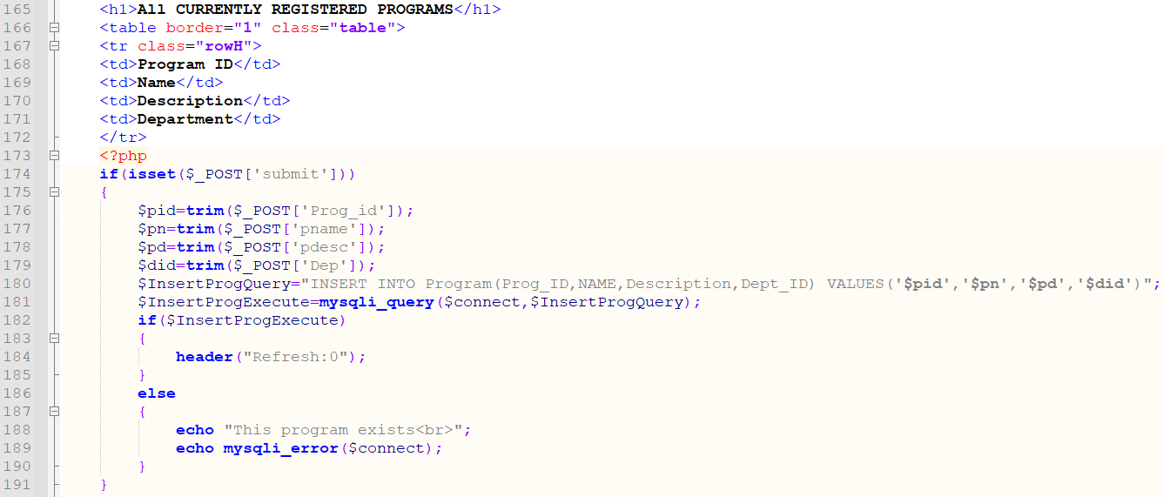

Figure AddProg.php Line 165 to line 191

The isset function on line 174 is used to check if the submit button is pressed. When pressed it will save the data from the form and update the database by executing the insert query.

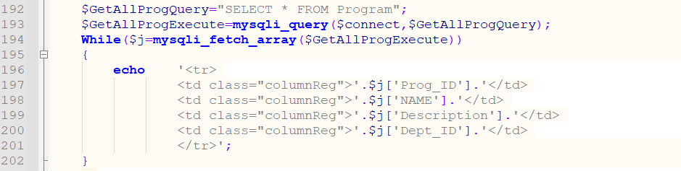

Figure AddDept.php Line 191 to line 202

Line 192 to line 202 is used to display all the programs from the database using the Select statement with the mysqli_query. The while loop used mysqli_fetch_array to get all the rows from the program table as an array and we then display them into a table.

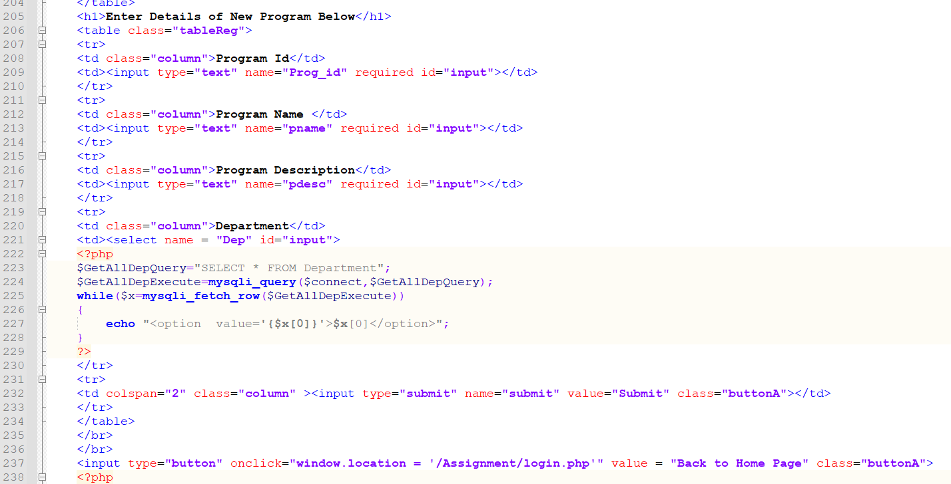

Figure AddDept.php Line 205 to line 238

Line 205 to 237 is the form allowing data entry. Line 221 to line 229 is used to display all the departments in a drop down list.

## 4.6 AdminHome.php

This file acts as the home page for the admins. When the page loads, they can view all students, teachers and admins that have registered accounts with the system.

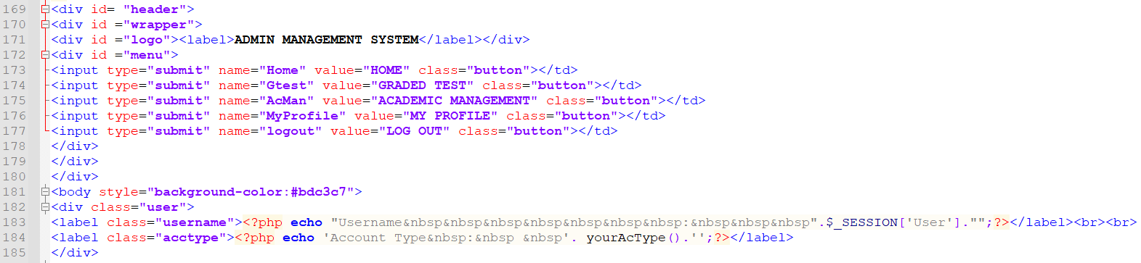

Figure AdminHome.php line 169 to line 185

Line 168 to 185 is used to create buttons of type submit that will be used along with isset functions and header functions to direct the user to the appropriate page.

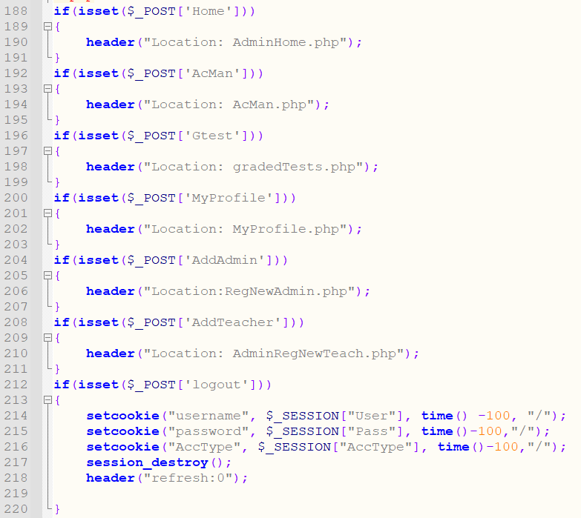

Figure AdminHome.php line 188 to line 220

Line 188 to line 220 are isset functions that check if the appropriate submit button is clicked using $_POST and the button name inside square brackets, they then direct users to the appropriate page. The only different button is the logout button which when clicked sets cookies to negative timers thus deleting them and uses session destroy and header refresh to delete all session variables and send the user to the login page.

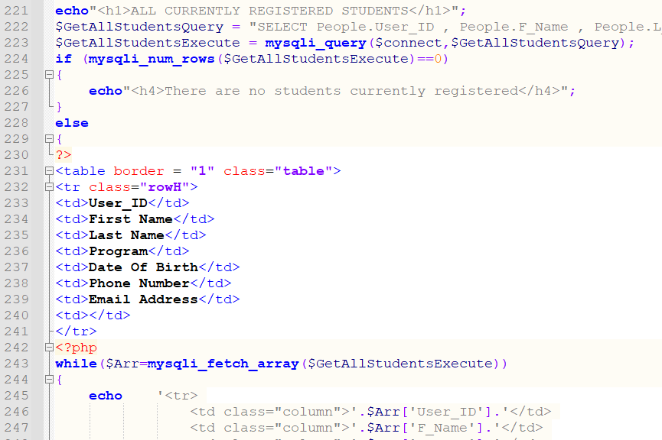

Figure AdminHome.php line 221 to line 247

From line 221 onwards, the code is displaying all the currently registered students as seen from the database in a table. It uses an if statement to check if there are no records then it will show that there are no students in the database else it uses a while loop along with mysqli_fetch_array to displaythe students information in a table.



Figure AdminHome.php line 253

Line 253 is used to create a button that will direct the user to Student Records page using a query string called UID that will store the students User_id and send it as a query string to the StudentRecords.php page. The value of the query string is decided by the value of the $Arr[‘User_ID’] as received on each row from the database thus allowing the creatio of dynamic buttons that will create query strings dynamically.

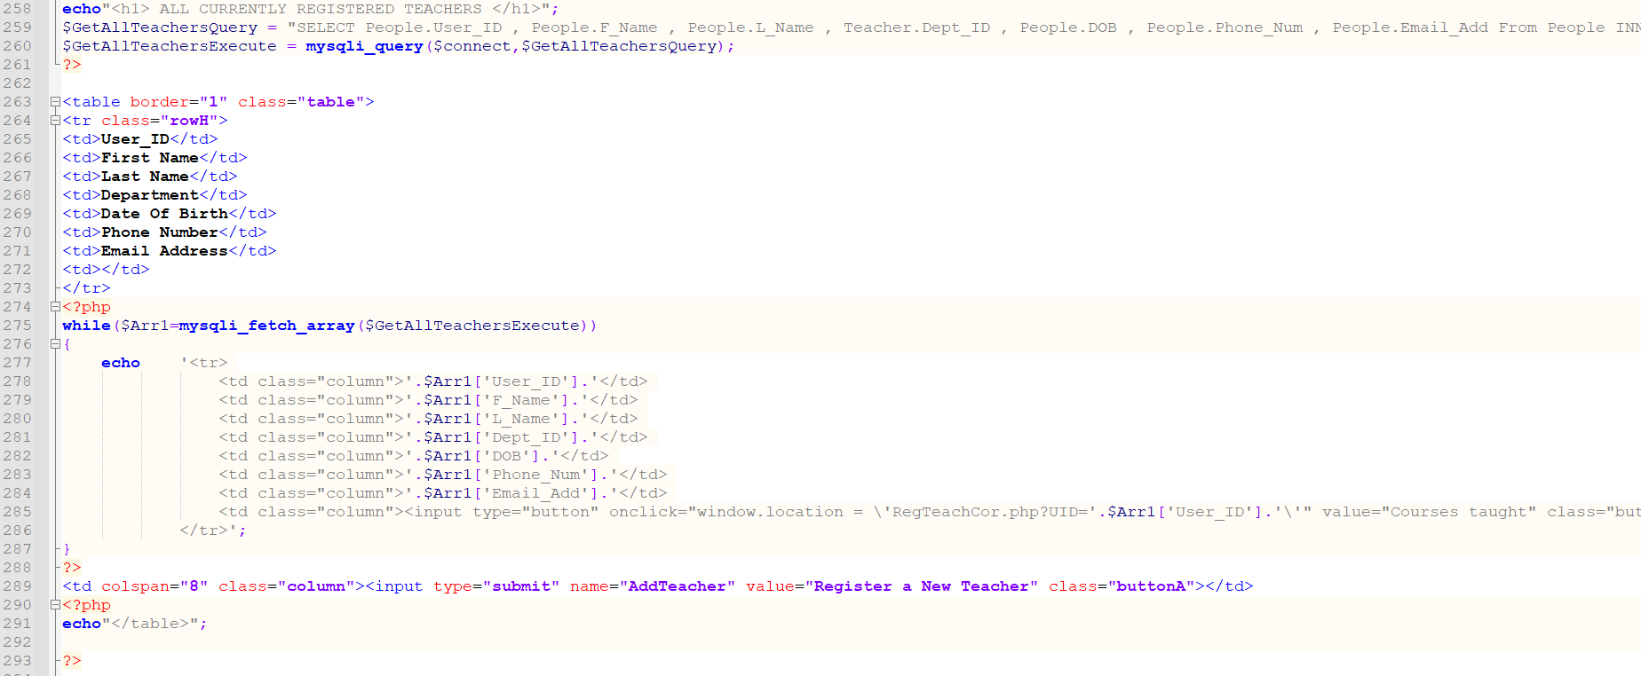

Figure AdminHome.php line 258 to line 293

Line 258 to line 293 work in a similar fashion as explained above. The only difference is that it now displays all the teachers registered in the database and the button created on line 285 directs the user to RegTeachCor.php with a query string called UID that has the value of the teachers user id for each row.

The submit button on line 289 is used to direct the user to AdminRegNewTeach.php using isset and header functions. The isset is used to check if the submit input type with name AddTeacher is clicked. If it is clicked it directs the user to AdminRegNewTeach.php using the header function.

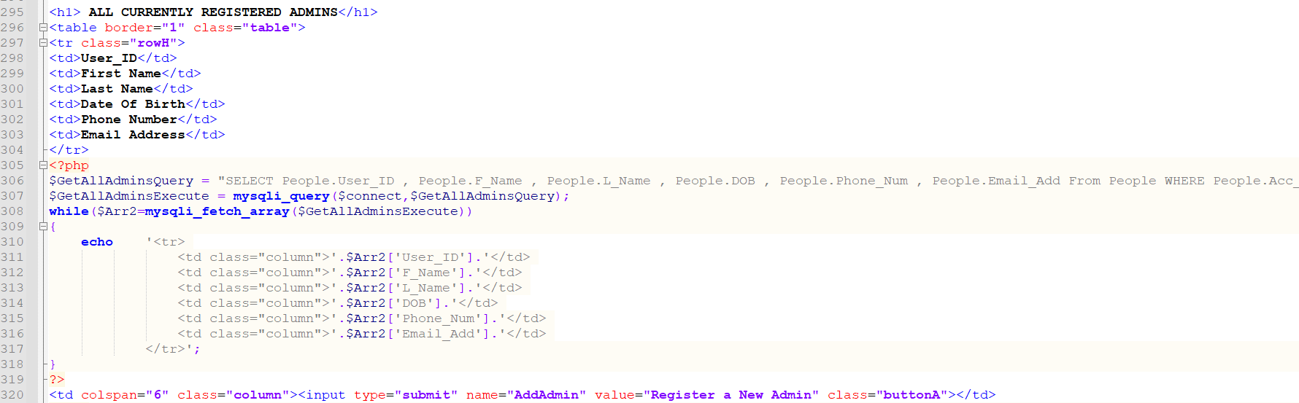

Figure AdminHome.php line 295 to line 320

Line 295 to line 320 is used to display all the currently registered admins from the database and it also creates a submit input type on line 320 which uses isset functions to check if the button with the name AddAdmin is clicked. If it is clicked, it will direct user to RegNewAdmin.php using the header function inside the isset function.

## 4.7 AdminRegNewTeach.php

This file allows admins to register new teachers into the system.

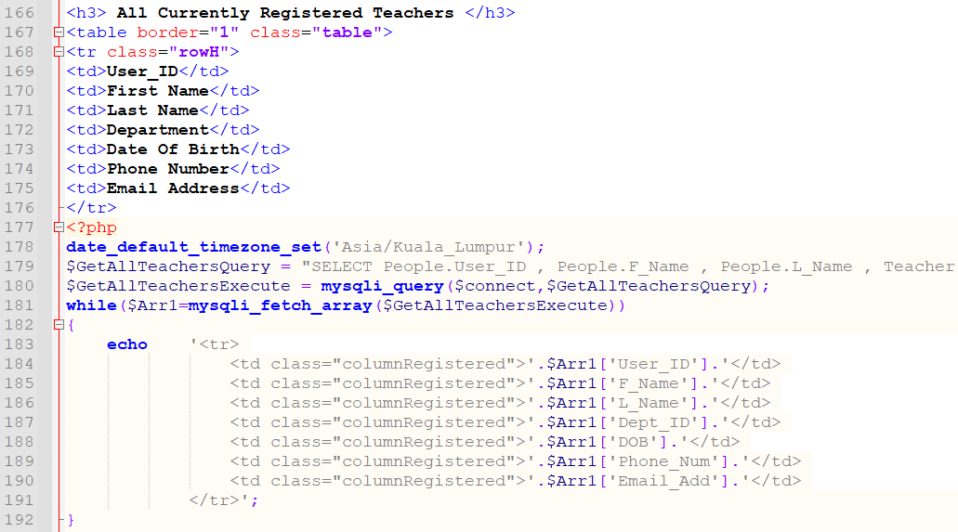

Figure AdminRegNewTeach.php Line 166 to line 192

Line 166 to line 192 uses a query and a while loop to display all the teachers from the database into a table. The query is created as a string and saved to a variable called $GetAllTeachersQuery as seen on line 179. The execution of the query is then saved into a variable called $GetAllTeachersExecute using mysqli_query. The while loop on line 181 is used to fetch each row from the database into an array with keys as the column names. It is then displayed in a table from line 183 to line 191.

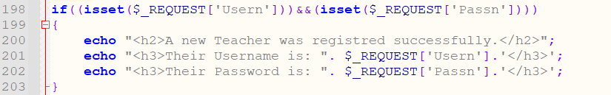

Figure AdminRegNewTeach.php Line 198 to line 203

Line 198 is an isset function that checks if the query string Usern and Passn exist. If they exist, it will print out a message saying a new teacher has been registered and it will output their username and their password. This function will be executed only when the query strings exists when the page loads.

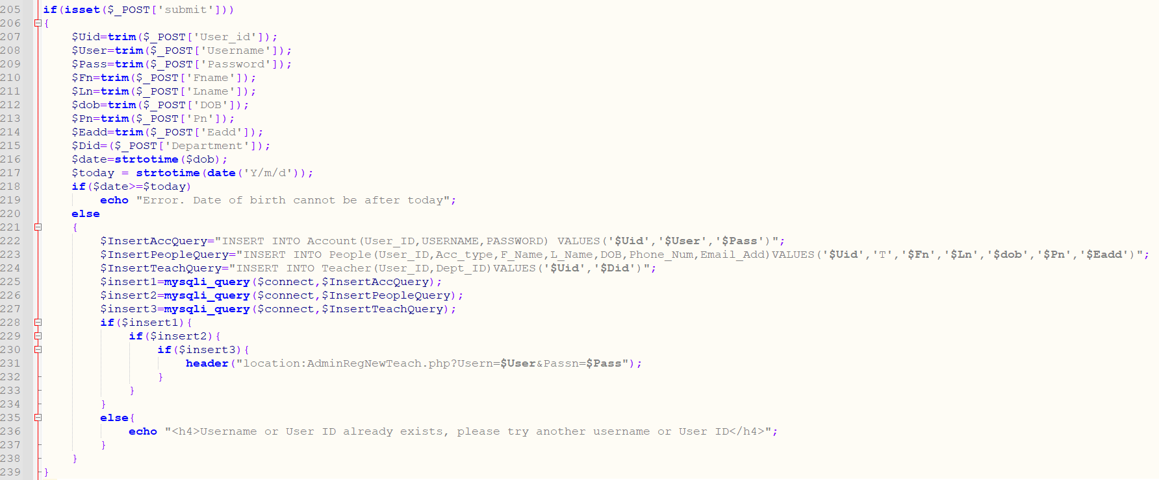

Figure AdminRegNewTeach.php Line 205 to line 239

Line 205 to line 239 is an isset function that will take all the data from the form that starts on line 242. It will save this data to variables as seen on line 207 to line 215. Line 216 converts the variable $dob to total number of seconds for that date and saves to a variable called $date. Line 217 converts the current date to seconds using strtotime. The if statement on line 218 is then used as validation to prevent the date of bitch of the teacher from beaing equal to or more than todays date. The else on line 220 is executed if the validation is passed. Line 222 to line 224 creates three different strings to be used as query’s to enter data into the database since the information for the teacher is separated into three different tables which are all related using the user Id. The strings are converted to executable cureies and saved as variables from line 225 to line 227. The ifs then insert the data into the tables accordingly linking them with the user id.

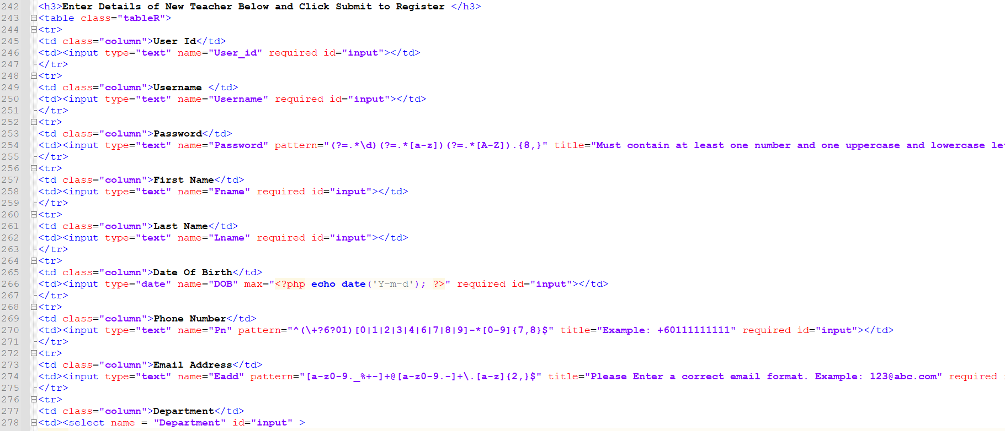

Figure AdminRegNewTeach.php Line 242 to line 278

Line 242 onwards is a form that allows the admin to enter the teachers data that he or she wishes to create an account for. All the fields have required field validators which prevent submission if any field is empty.



Figure AdminRegNewTeach.php Line 254

Line 254 has pattern condition which must be met to allow the form to be submitted. The pattern in this case is for the password which only allows submission of the form when the password field is at least 8 characters long, contains 1 number and one uppercase letter and 1 lowercase letter.



Figure AdminRegNewTeach.php Line 266

Line 266 prevents the user from entering any date beyond the current date using max.



Figure AdminRegNewTeach.php Line 269 to line 275

Line 270 contains a pattern validation that only allows Malaysian phone numbers to be entered and line 274 contains a pattern validation that only allows valid email addresses to be entered.

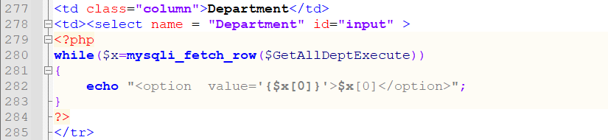

Figure AdminRegNewTeach.php Line 277 to line 285

Since the Admin has to add teachers based on department, we use a <select> with a query to get all the departments from the database and display them in a drop down list to allow the admin to select the department he wishes for the teacher to be a part of.

## 4.8 changePass.php

This file is accessible by all user types. It is used to allow users to change their password by entering their current password, new password and confirmation of the new password.

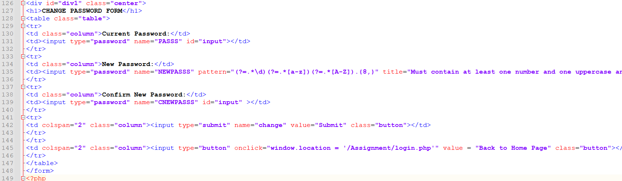

Figure changePass.php line 126 to line 149

Line 126 to line 145 creates a form to allow the user to change their password. The user is required to enter their current password, new password and confirmation of the new password. It also contains pattern validation to ensure password entered has at least 8characters, one uppercase letter and one number.

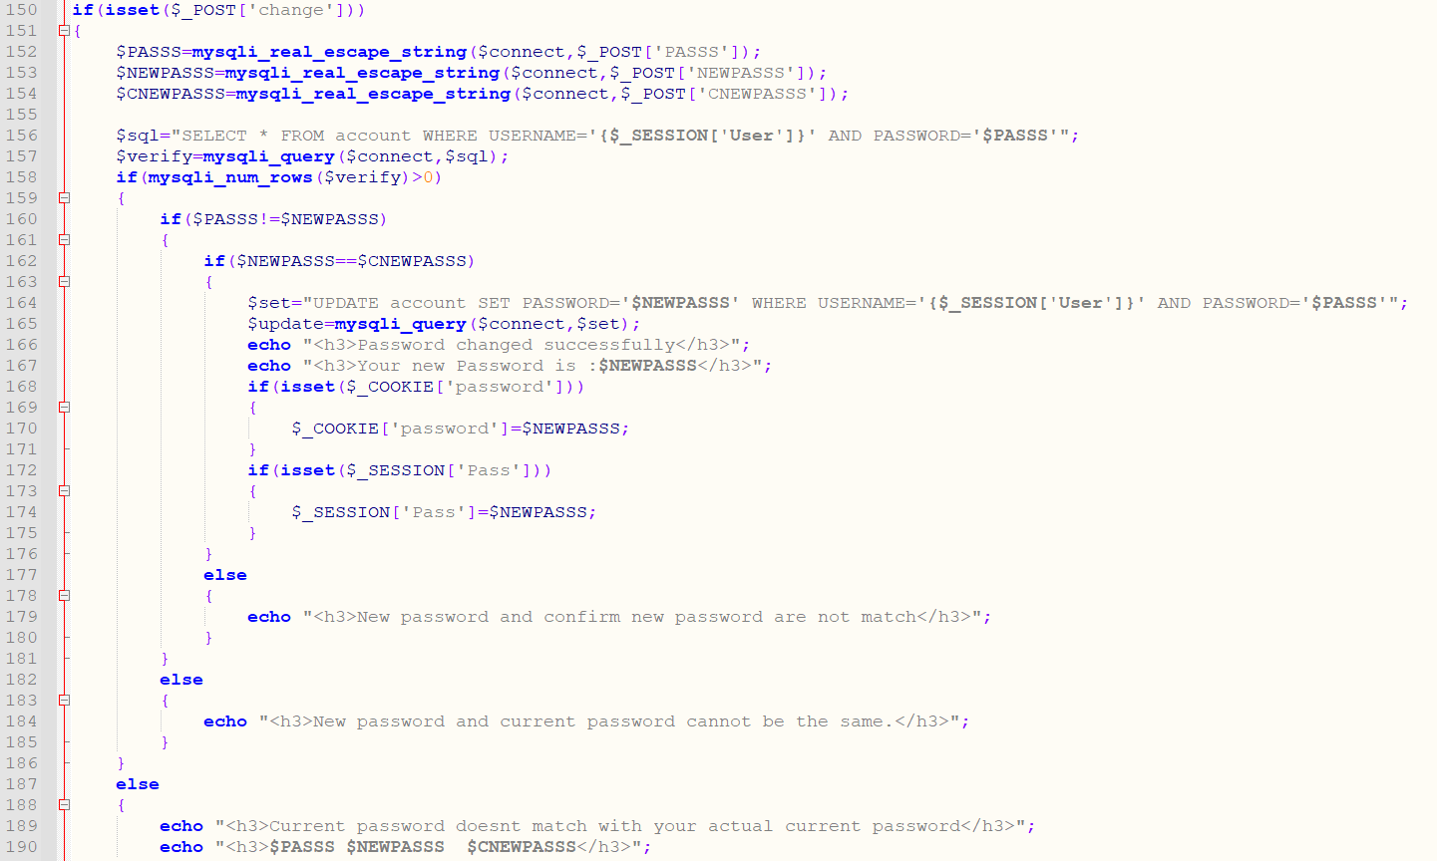

Figure changePass.php Line 150 to line 190

The isset function on line 150 is used to check if the user clicked on the submit input type called change. If they clicked on it, the data from the form is saved into variables as seen on line 152 to line 154. It then uses a query to validate if the old password matches with the current user. The username is gotten from the session variable with the name ‘User’ that is created when a user logs into the system. The if statement on line 158 is used to perform this validation. The next validation is used to ensure that the new password and the old password are not the same using the if statement on line 160. The next validation is to make sure that the new password and the confirmed new password match using the if statement on line 162. If all these validations pass, the system will use an update query to update the database with the users new password. The if statement on line 168 is then used to check if a cookie variable called password exists. If it exists it will change the cookie variable to the new password. The if statement on line 172 will check if a session variable called pass exists. If it does, it will change the value of the variable to the new password. We do this to ensure that the system is up to date regarding the cookies and session variables. Since we create cookie variables when a user logs in if they have clicked the remember me button and we also create session variables when the user logs in.

## 4.9 DB.php

This file is used to create a connection with the database and it is also used to create the tables of the database.

Fields with Primary key are defined in the table as the primary key. If the primary key has to fields inside, it means that both fields combined function as the primary key.

Fields inside the foreign key brackets are the foreign keys that link to other tables inside the references brackets.

NOT NULL fields cannot beleft null when filling the database with data.

AUTO INCREMENT fields will automatically increment their values with every new data entry



Figure DB.php line 2 to line 4

Line 2 is used to create a connection with the server. Line 3 is used to create the database with the name assignment. Line 4 is used to execute the database creation query.



Figure DB.php line 5

Line 5 uses the function mysqli_select_db to select the database.

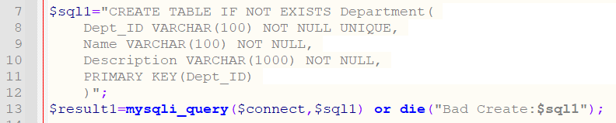

Figure DB.php line 7 to line 13

Line 7 to line 13 is used to create a table in the database called department if it doesn’t exist with the primary key as the Dept_ID field.

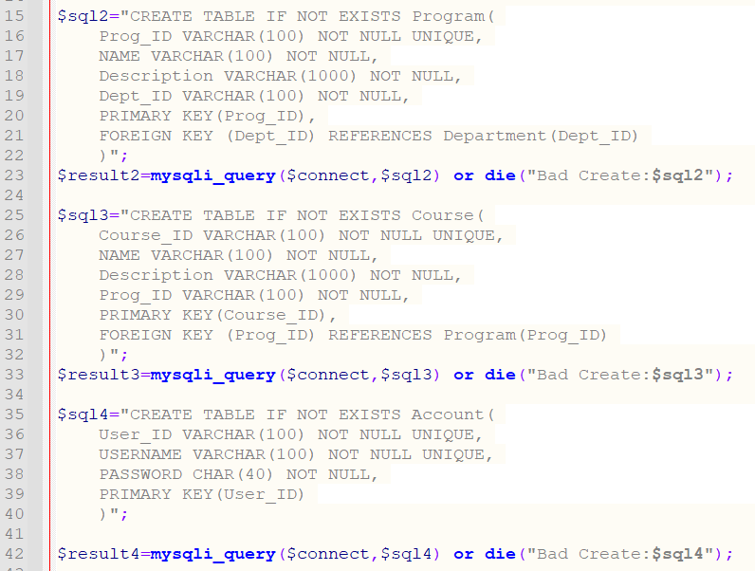

Figure DB.php line 15 to line 42

Line 15 to line 42 is used to create more tables in the database if they don’t exist namely; Program, Course and Account.

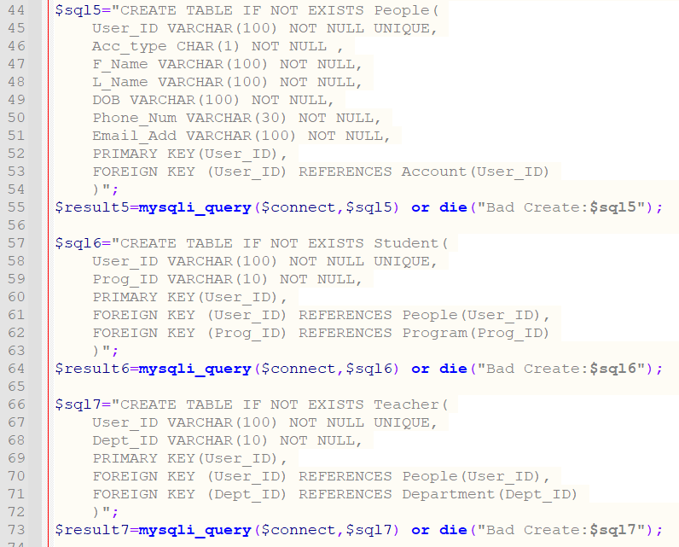

Figure DB.php line 44 to line 73

Line 44 to line 73 is used to create tables in the database if they don’t exist. Namely; People, Student and Teacher.

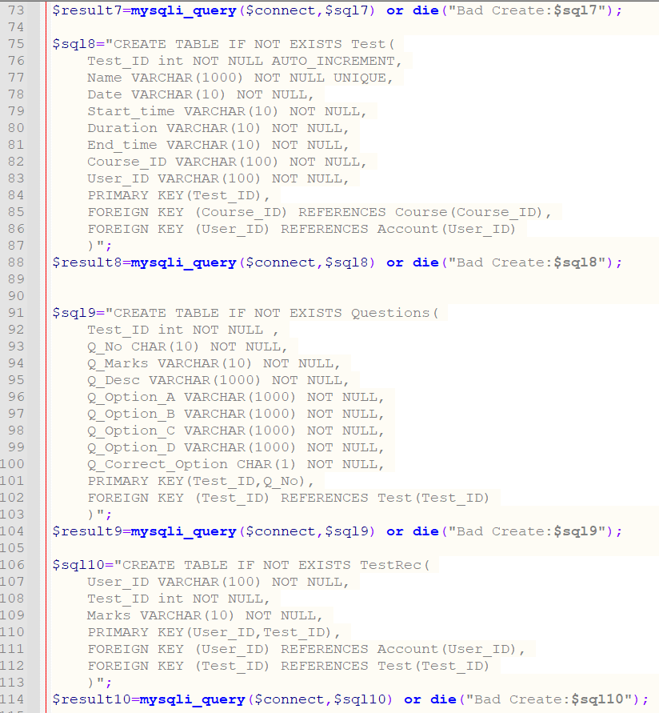

Figure DB.php line 73 to line 114

Line 73 to line 114 is used to create tables in the database namely; Test, Questions and TestRec.

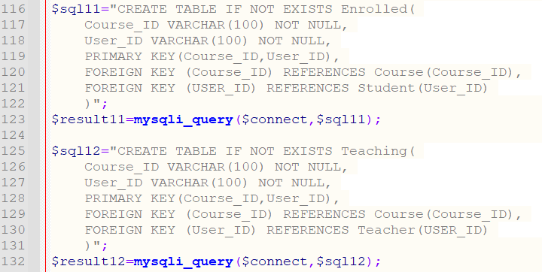

Figure DB.php line 116 to line 132

Line 116 to line 132 to used to create tables in the database namely enrolled and teaching.

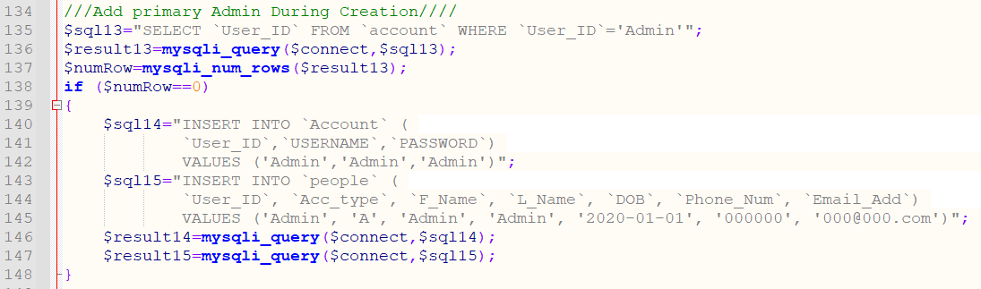

Figure DB.php line 134 to line 148

Line 134 to line 148 is used to create a default admin account if it doesn’t exist. The Default account can be used to log into the database.

## 4.10 gradedTests.php

This file allows users to view all the grades for each test and the ranking of all the students who have taken tests. It also allows users to search by test id to view the ranking for the test Id that they have searched.

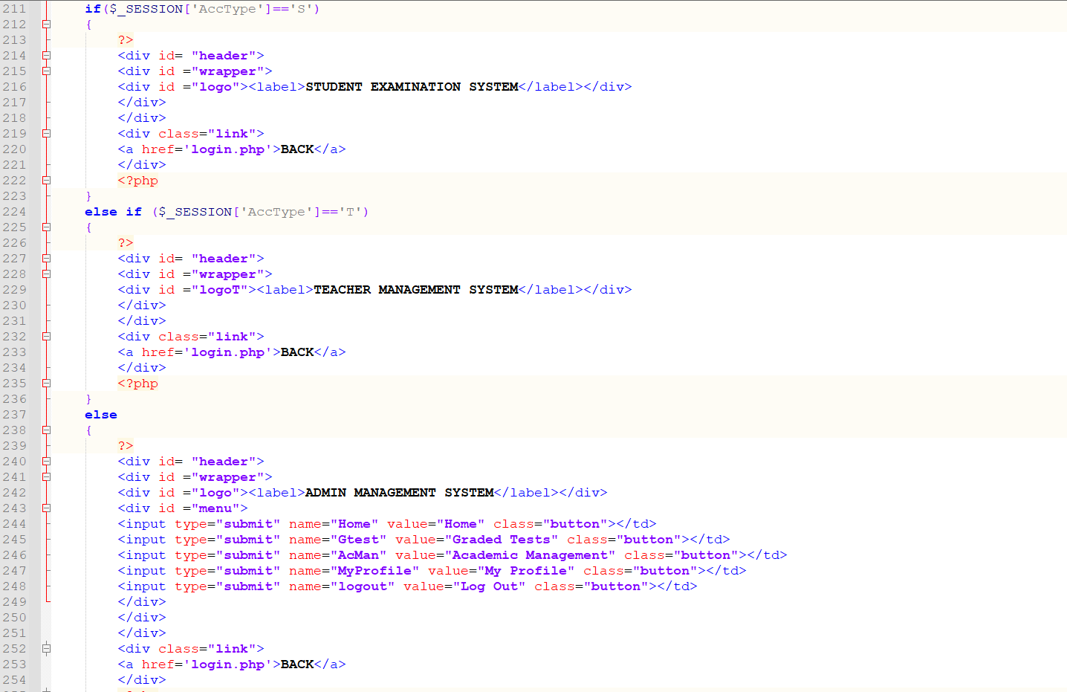

Figure gradedTests.php Line 211 to line 254

Line 211 to line 254 is used to identify which user type has opened this page by checking the $_SESSION[‘Acctype’]. If the user type is student, the header displayed will be STUDENT EXAMINATION SYSTEM, if the user type is teacher, it will display a header of TEACHER MANAGEMENT SYSTEM. If the user is an Admin, the header displayed will be ADMIN MANAGEMENT SYSTEM.

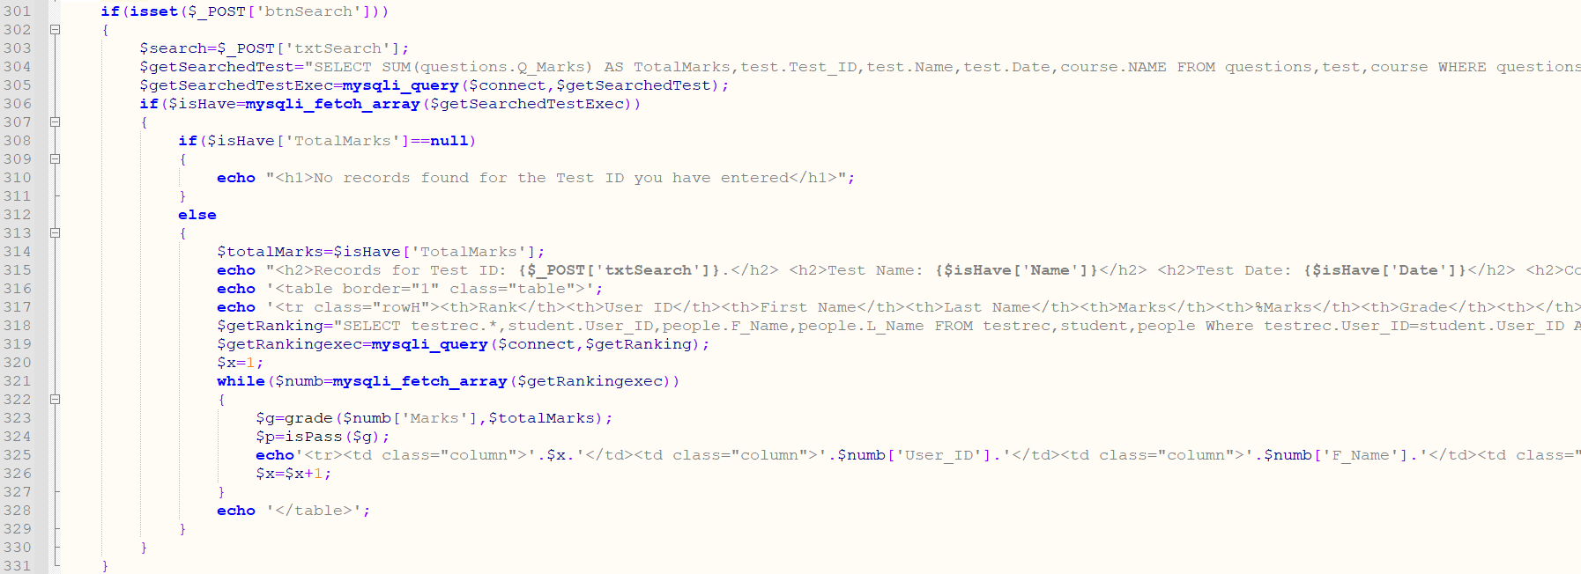

Figure gradedTests.php Line 301 to line 331

Line 301 to line 331 is used to check if the btnSearch button of type submit has been clicked. If it has been clicked, this if () will be triggered. It will then save the text entered in the search bar into a variable and pass that variable into a string used as a query. The query is used to find if the test has been taken by checking testRec table in the database. The if statement on line 306 is used to check if the query returns any results, if it returns null values, it means the test id does not exist in the database and would therefore echo out line 310. If a test id exists, it will then display all the records in the database table testRec where the test id is the one searched for using $POST[‘txtSearch’] in the string for the SELECT query. It will create a query that will display all the rows. Each row is the results of one student. The query also has ORDER BY testrec.Marks DESC which will order all the results in descending order by the value of the marks.



Figure gradedTests.php Line 323 to line 324

Line 323 uses a function grade() to calculate the grade of the students and line 324 uses a function to find out if the student passed or failed the test.



Figure gradedTests.php calculatmark function

We also use the function calculatemark() to calculate the total Marks for the test in percentage.

The while loop on line 321 to line 327 is used to display the results for each row.

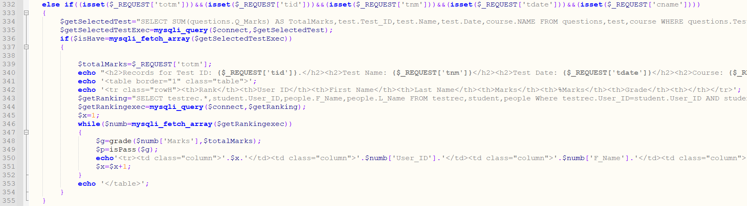

Figure gradedTests.php Line 332 to line 355

Line 332 to line 355 is triggered when a user clicks on the tests table that is displayed by default. This else statement checks if the query strings totm,tid,tnm,tdate and cname are set. Using the if isset($_REQUEST[]). The functionality is the same as when search button is clicked, the only difference is that the test id is received from the query string that is created when the user clicks on view records from the default table displayed when the page loads.

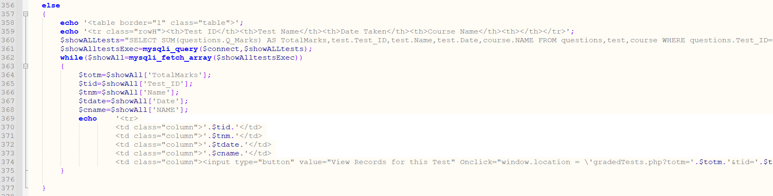

Figure gradedTests.php Line 356 to line 377

Line 356 to line 377 is the default table that is displayed when the page loads. This page displays all the tests that have been taken by checking the testRec table to find unique test ids. These tests are then displayed by the use of a query that contains multiple joins to get the data for the tests from multiple tables. The test information is displayed along with a button. The button when clicked reloads the page adding multiple query strings that trigger the ele if statement on line 332.

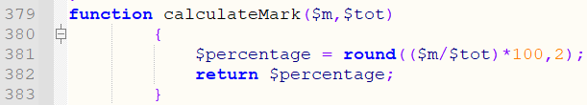

Figure gradedTests.php Line 379 to line 383

Line 379 to line 383 is a function that accepts two arguments and uses them to calculate the percentage value rounded to two decimal places and returns the percentage value.

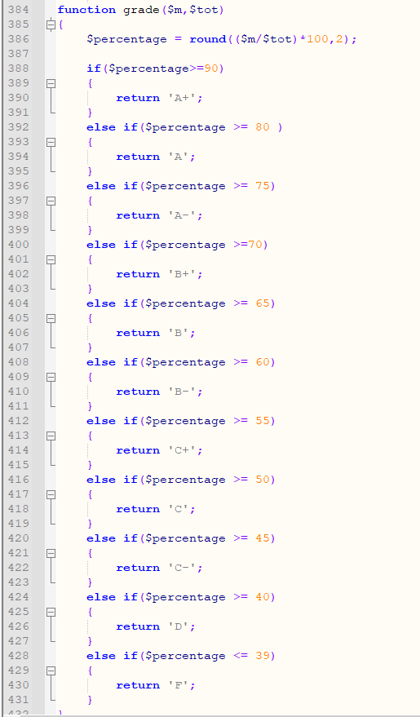

Figure gradedTests.php Line 384 to line 431

The function on line 384 is used to calculate the grade by accepting 2 arguments and using them to calculate the percentage which is then used to return the Grade.

## 4.11 login.php

This file is used to allow users to log into the system with a valid username and password.

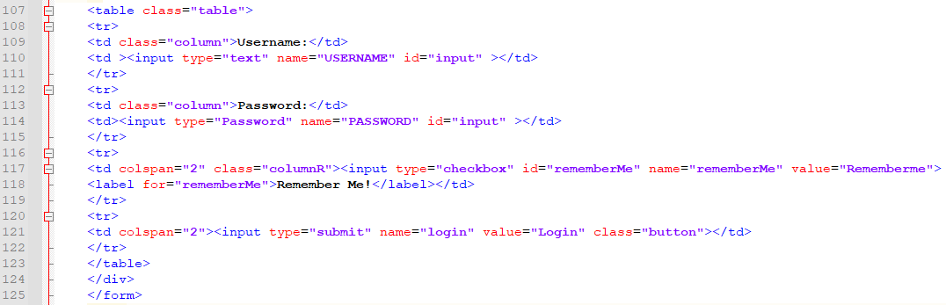

Figure login.php line 107 to line 125

Line 107 to line 125 is a form that allows users to enter their username and password. It also contains a checkbox that allows users to remain logged in by creating cookies.



Figure login.php line 127

Line 127 is an if isset function that checks to see if a user has clicked the login button.

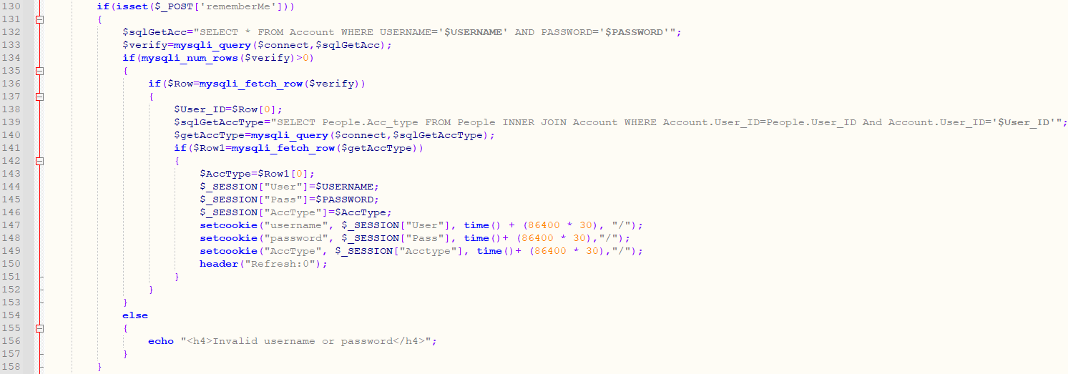

Figure login.php line 130 to line 158

Line 130 to line 158 is an if isset function that checks to see if the user clicked on the remember me checkbox. It will be triggered if the user clicked on remember me checkbox. Line 134 checks the database to see if the username and password match and return more than one row which signifies that the account exists in the account table. Line 136 is used to get the account type of the user from the people table in the database. Line 144 to line 146 then create session variables that save the username password and account type to session variables ‘User’, ‘Pass’ And ‘AccType’ respectively.Line 147 to line 149 set cookies using the setcookie function saving the username, password and account type as the cookie values. It then refreshes the header. Which would trigger the final else on line 189 which is discussed later below.

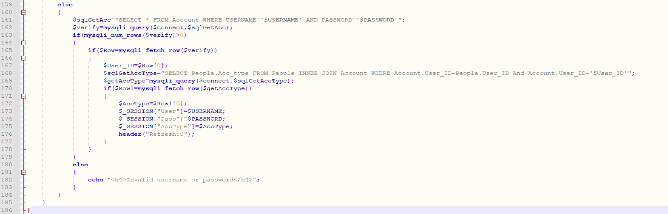

Figure login.php line 159 to line 186

Line 159 to line 186 performs the same functions as line 130 to line 130 discussed above however, it will only be triggered when the user does not click on the remember me button. The main difference is that here, we will not create any cookie variables, this will cause the user to be logged out of the system I they close their browser.

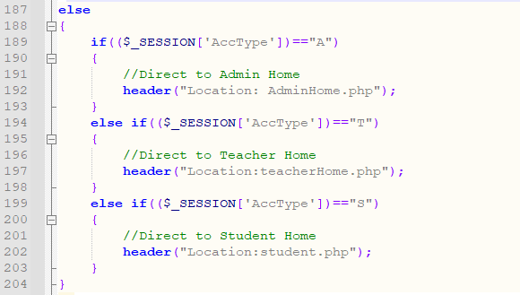

Figure login.php line 187 to line 204

Line 187 is an else statement that will be triggered if Session variables User, Pass and AccType exist. Line 189 to line 203 will check if the $_SESSION variable is A, it will direct the user to the AdminHome.php, if it is T it will direct the user to the teacherHome.php and if the variable is S it will direct the user to student.php.

## 4.12 Myprofile.php

This file is used to allow users to edit their profile information and update the database accordingly. It also contains a button that will direct the users to the changePass.php file where they can change their password in the database.



Figure Myprofile.php line 111 to line 114

Lin 111 to line 114 checks to see if the query string up is set. If it is set it will display the echo on line 113.

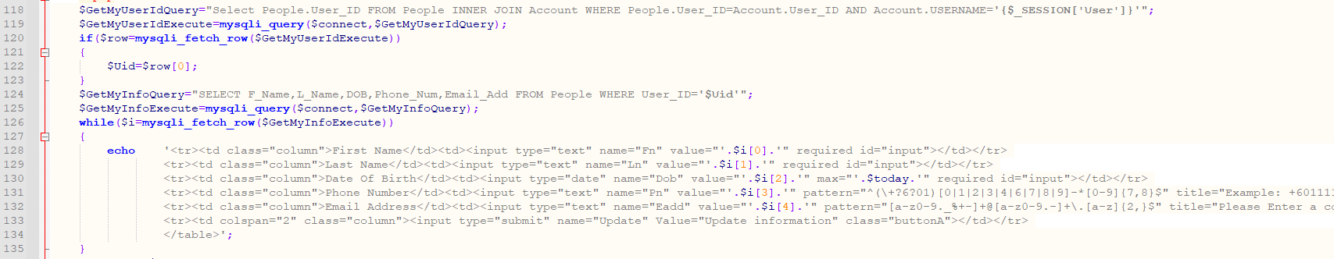

Figure Myprofile.php line 118 to line 135

Line 118 to line 135 is used to create a form that will display the user their current information in textboxes which they can choose to edit and click on the update button.

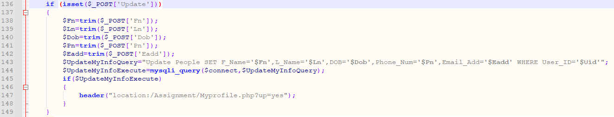

Figure Myprofile.php line 136 to line 149

Line 136 to line 149 is triggered when the user clicks on the update button. The file saves the user information from the form into variables by first trimming the leading and trailing spaces using trim function and then updates the database with the information they entered. If the update is successful, the header will add a query string called up with a value yes. Which is checked in the isset function on line 111 which would then output a success message.



Figure Myprofile.php line 152

Line 152 creates a button which would direct users to the changePass.php file where they can change their password.

## 4.13 MyStudents.php



Figure MyStudents.php line 1 form action

Line 1 shows the form action which is php self which means the form will post to itself on submit. The form also hasquery strings UID and cid which are used to identify the user who has reached this page and the course id as sent from the teacherHome.php.

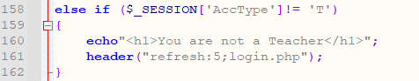

Figure Myprofile.php line 158to line 162

The else if statement on line 158 is used to make sure that only teachers can access this page.

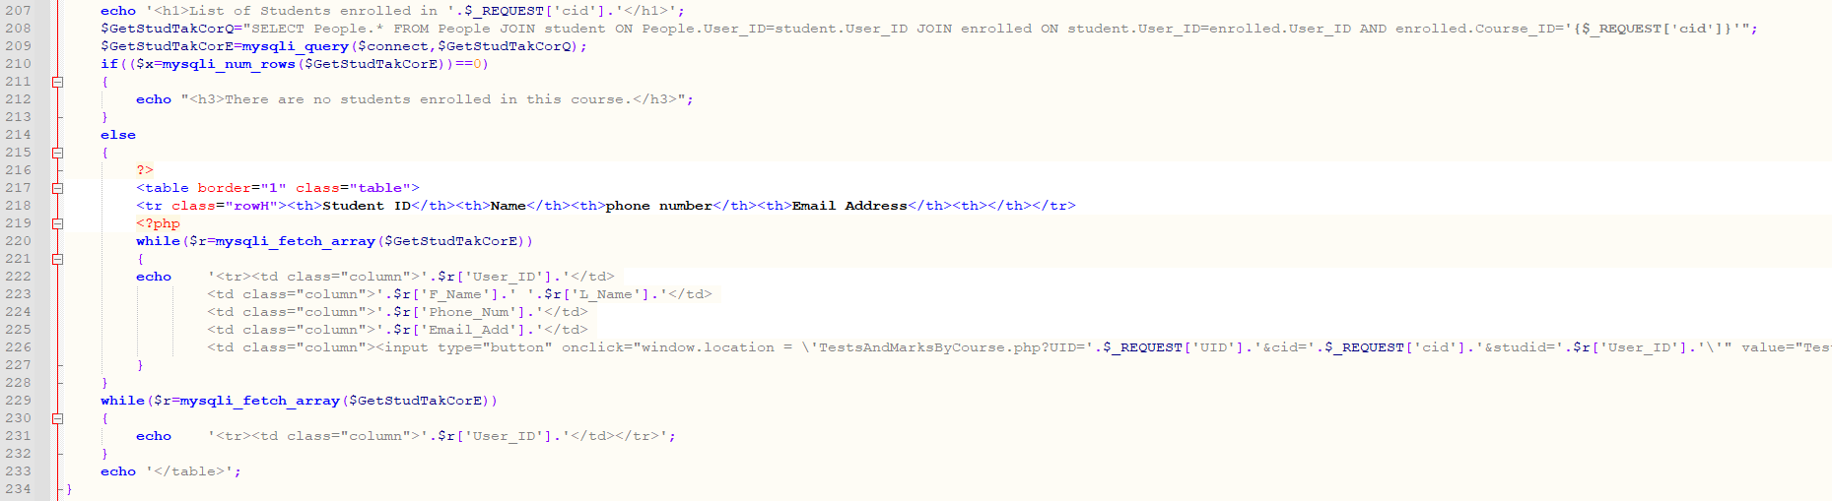

Figure Myprofile.php line 207 to line 234

Line 207 to line 234 is used to display all the students that are enrolled in the course with the id as received from the query string. If there are no students enrolled, the if statement on line 210 will be triggered echoing the text on line 212. If there are students enrolled it will display all the students row by row in a table using the while loop on line 220. Line 226 creates a button with an onclick function that will redirect the user to TestsAndMarksByCourse.php sending query strings along with the window.location change. The query strings sent are the User id, the course id and the student id.

## 4.14 Registration.php

This file allows students to register into the system and create accounts.

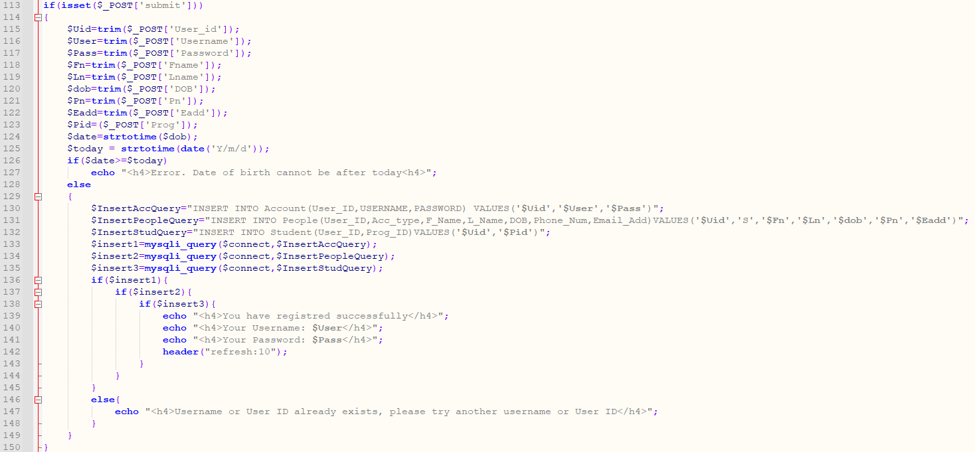

Figure Registration.php line 113 to line 150

Line 113 to line 150 is used to gather all the data entered into the form and save it to variables. Line 126 validates the date of birth to make sure it is no passed todays date. If the date is valid, it will insert the students information into the database. If the database insertion is successful, it will display the username and password to the user using the echo on line 139 to line 141. It will then refresh the page after 10 seconds using the header(refresh:10) function on line 142.

The else on line 146 will be triggered if the username already exists in the database.

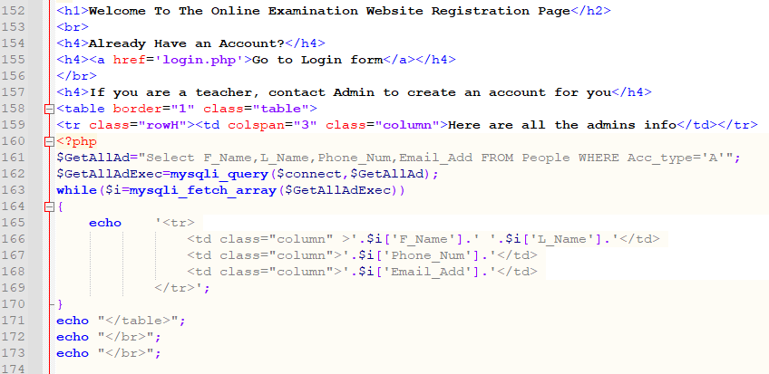

Figure Registration.php line 152to line 174

Line 152 to line 174 is used to display a welcome message. Line 154 creates an a href link to direct users to login page incase they already have an account. Line 157 informs the user that if they are a teacher they can contact admins to create an account for them. Line 161 to line 171 displays all the admins registered in the system will their details to allow users to contact the admins via phone or email if they so desire.

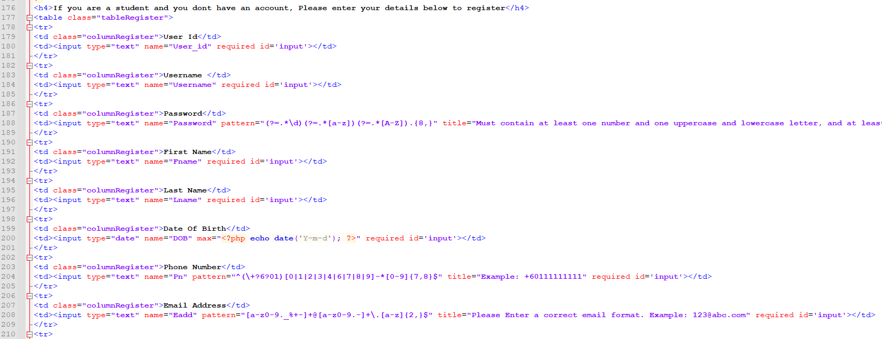

Figure Registration.php line 176 to line 210

Line 176 to line 210 is a form that allows students to enter their information. The form contains required field validators and pattern validators similar to the adminRegNewTeach.php file.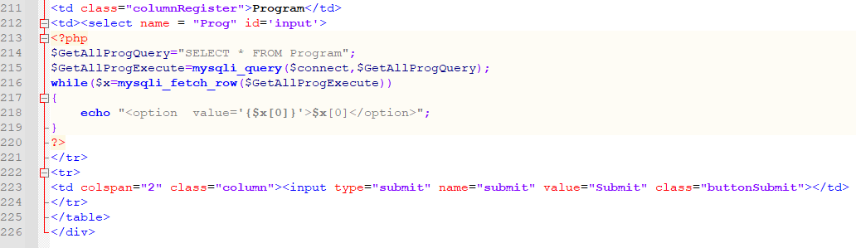

Figure Registration.php line 211 to line 226

Line 211 to line 220 creates a drop down list to allow students to choose their program. The drop down lists receives it information from the database using a query and a while loop to display all the program ids in the drop down list.

Line 223 creates a submit input type that allows users to submit their information to the form which triggers the isset function on line 113 whose functionality is discussed above.

## 4.15 RegNewAdmin.php

This file is used to allow Admin to register new admin to the system and for the system to store the new admin’s information to the account table and people table created in DB.php

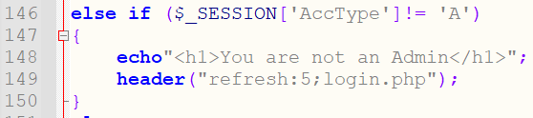

Figure RegNewAdmin.php line 146 to line 150

From line 146 to 150, the code checks that if the ‘AccType’ not equal to ‘A’ meaning that if the user is not an Admin, therefore the following message will be displayed as above, and the system will refresh after 5 seconds. This will not allow any other users apart from the Admin to access the page. This code is applied to all the pages in Admin Management System.

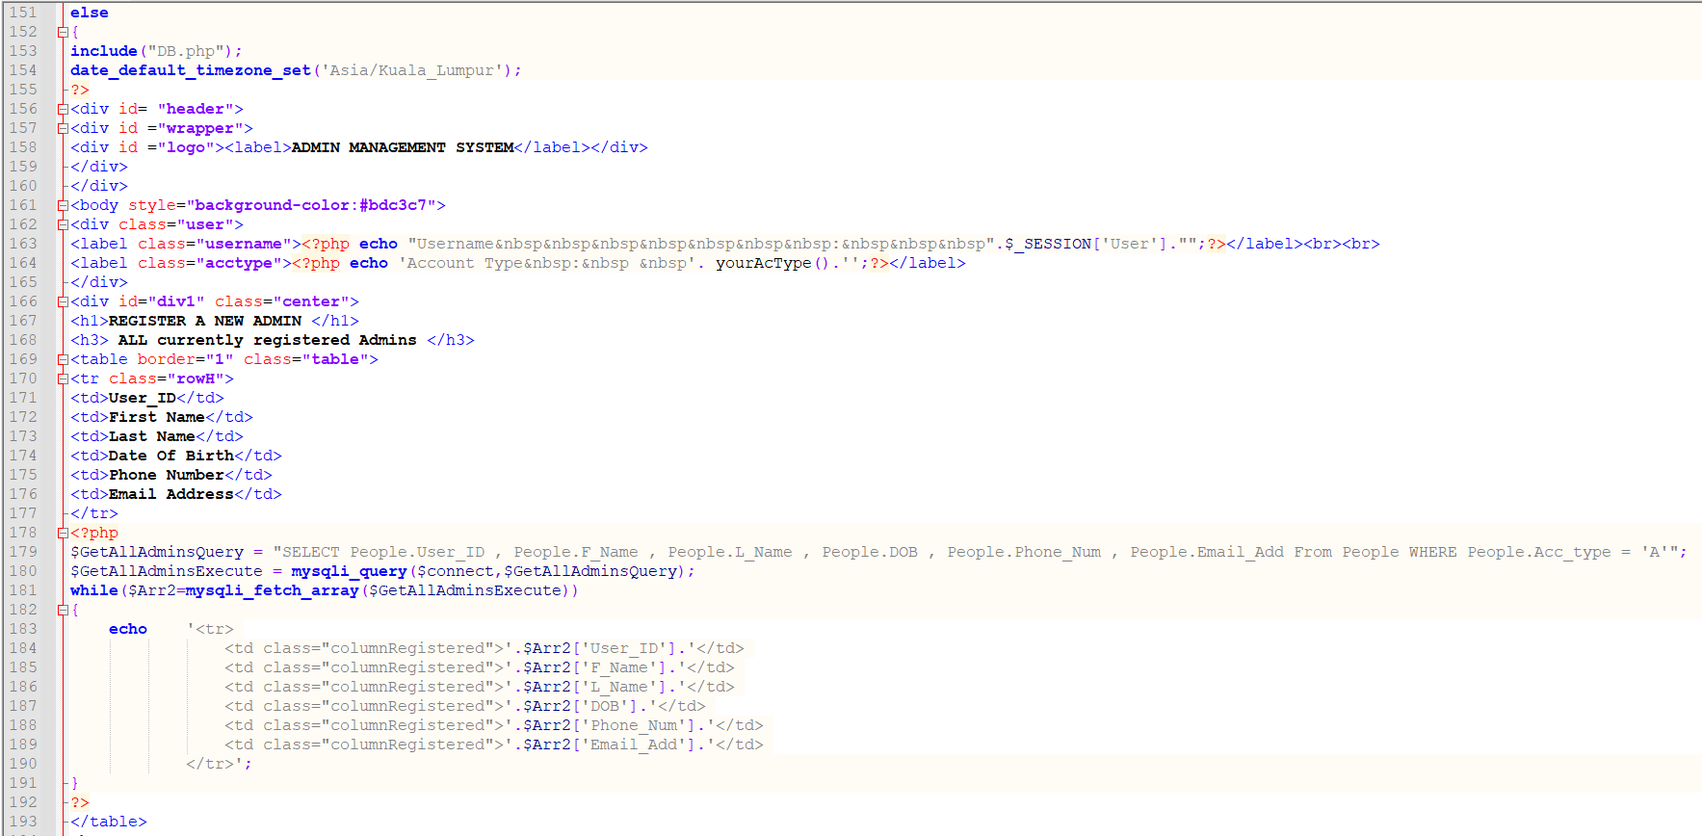

Figure RegNewAdmin.php line 151 to line 191

The else statement as shown above will be triggered when a session variable for user and password exists. will then proceed to display all currently registered Admins. In line 179, the code gets the data from the database using the SELECT statement and is saved as a string to a variable. At line 180, the mysqli_query function performs a check against the database from the variable which has a string in it. At line 181-193, the function mysqli_fetch_array then fetch the data (PHP mysqli fetch_array() Function, 2021) from the database, and it outputted to a table using while loop. This method is commonly used in all the pages.

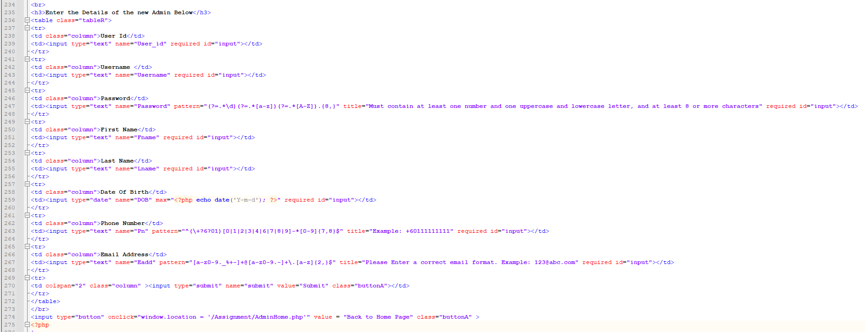

Figure RegNewAdmin.php line 235 to line 274

From line 235-274, the code is used to display the form to register and enter details of the new admin.

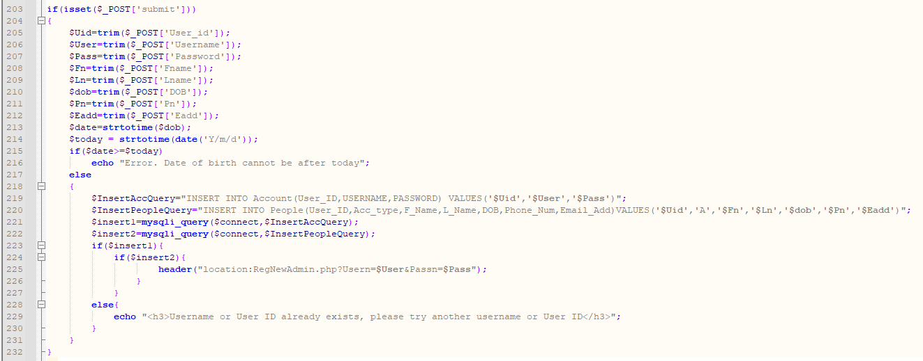

Figure RegNewAdmin.php line 203 to line 232

All input has their own validation using the required function and if the submit button is clicked the if (isset($_POST[‘submit’])) on line 203-232 will be triggered. It will then save all the form information into variables doing necessary validation using isset functions for each input type. The trim function as show above is to get rid of all leading and trailing spaces. We then use an INSERT query on line 219 to insert the form data into the database.

The if statement on line 223 will check if insertion was successful and will then refresh the page whilst sending 2 query string Usern and Passn. The isset function in line 196 as shown below will be triggered to check the variable Usern and Passn exist and if it does exist the following messages will be displayed as shown in line 198-200.

The else statement on line 228 will be triggered only when the username or user id entered by the user exist in the database.

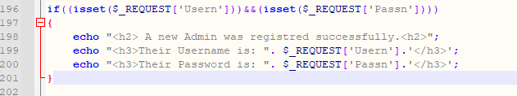

Figure RegNewAdmin.php line 196 to line 202

## 4.16 RegTeachCor.php

This page allows Admin to enrol teachers to teach courses for their respective department. Admin is redirected to this page when Courses Taught is clicked from Admin Home and a query string $Uid which is the User ID is sent to this page and is used to collect data from the database.

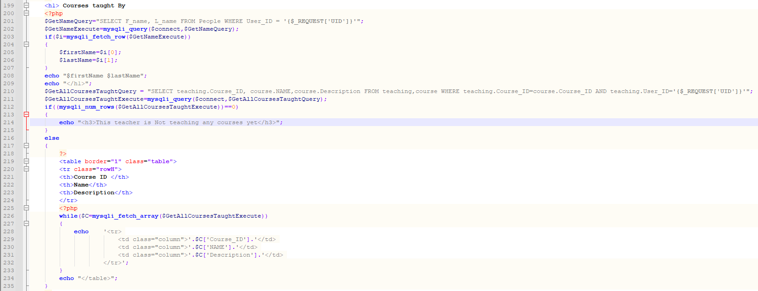

Figure RegteachCor.php Line 199 to line 235

The following code from line 199 - 235 as shown above is used to display all the courses that are currently taught by the teacher. In line 210, in the SELECT statement the $_REQUEST[‘Uid’] is used to get the value of the query string which is the User ID.

The if statement in line 212, is checking if there is any data for the requested query string and if there is not the message in line 214 is displayed. If there is, the else statement in line 216 will be triggered and the function mysqli_fetch_array will fetch the data and is outputted in the table using the while loop in line 226-235.

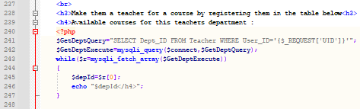

Figure RegteachCor.php Line 237 to line 248

The code in line 243, will fetch the data from the query with the requested query string which is the User ID to display the department id for that User ID.

Figure RegteachCor.php Line 249 to line 255



In line 249, the SELECT statement is used to select the data from table in the database with the variable and query string that is highlighted in red above. The if statement performs a check if there is any available courses that have yet to be taught by the teacher. If there is none, the following messages in line 253-254 is displayed. If there is any course that have yet to be taught by the teacher, the else statement will be triggered as shown below.

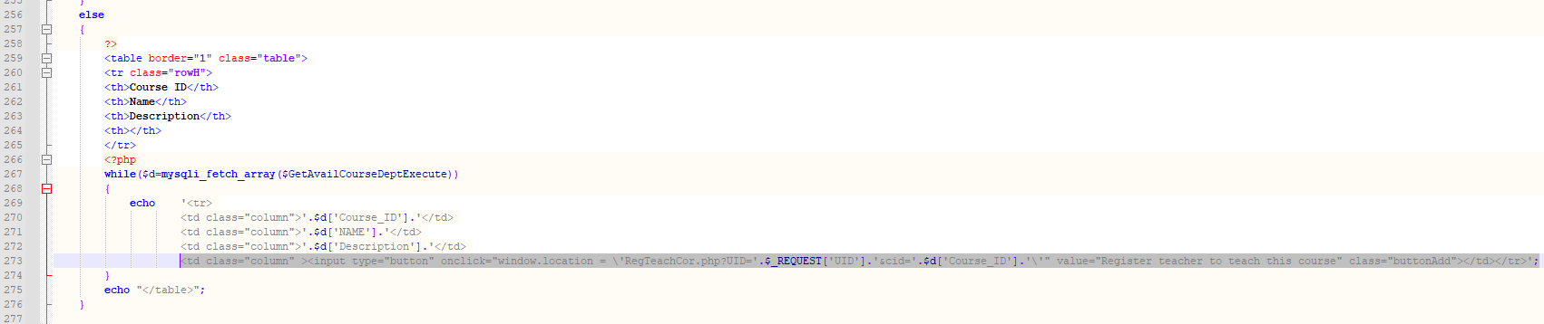

Figure RegteachCor.php Line 256 to line 276

The else statement as show above in line 256 will show all the courses that have not been taught by the teacher. If the button Register teacher to teach this course is clicked, the query string $Uid which is the user id and $cid which is the coursed ID will be sent to the same page. The isset function as shown below in line 181, will then be triggered and perform a check whether $_REQUEST[‘cid’] exist. If exist, the insert($sql) is performed to insert the data into the database. If the insertion is successful, the following messages on line 189 will be displayed and the page will reload. If the insertion is unsuccessful an error message will be displayed using mysqli_error() function as shown below on line 194.

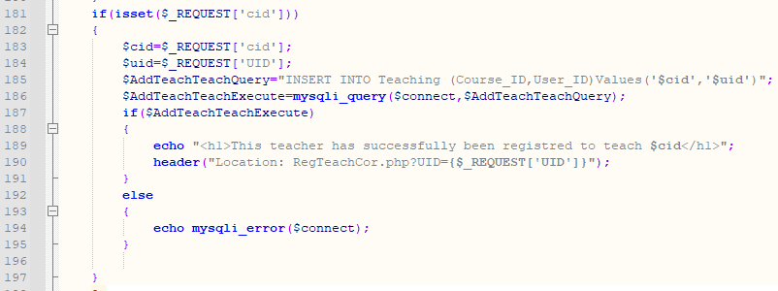

Figure RegteachCor.php Line 181 to line 197



Figure RegteachCor.php Line 281

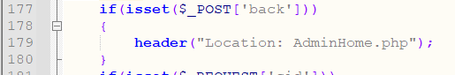

Figure RegteachCor.php Line 177 to line 180

The isset function above in line 177, uses $_POST to check if an input type of submit with the name ‘back’ has been clicked. When clicked, the user will be redirected to home page using the header function.

## 4.17 resetPassword.php

This page allows all users to reset their password and acts as a forget password page when user must enter their username and email to reset their password.

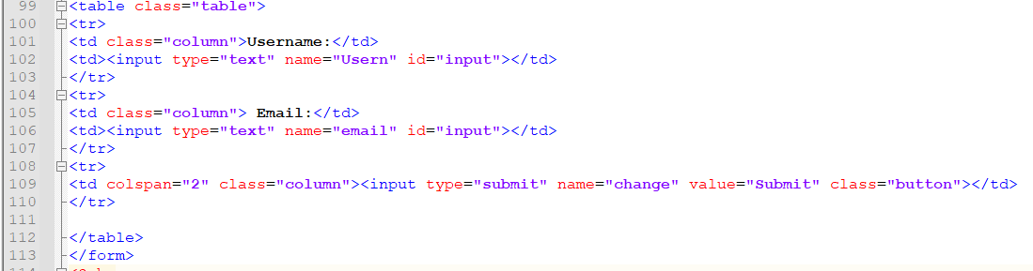

Figure resetPassword.php line 99 to line 113

The form above from line 99-113 is displayed to the user to enter their username and email.

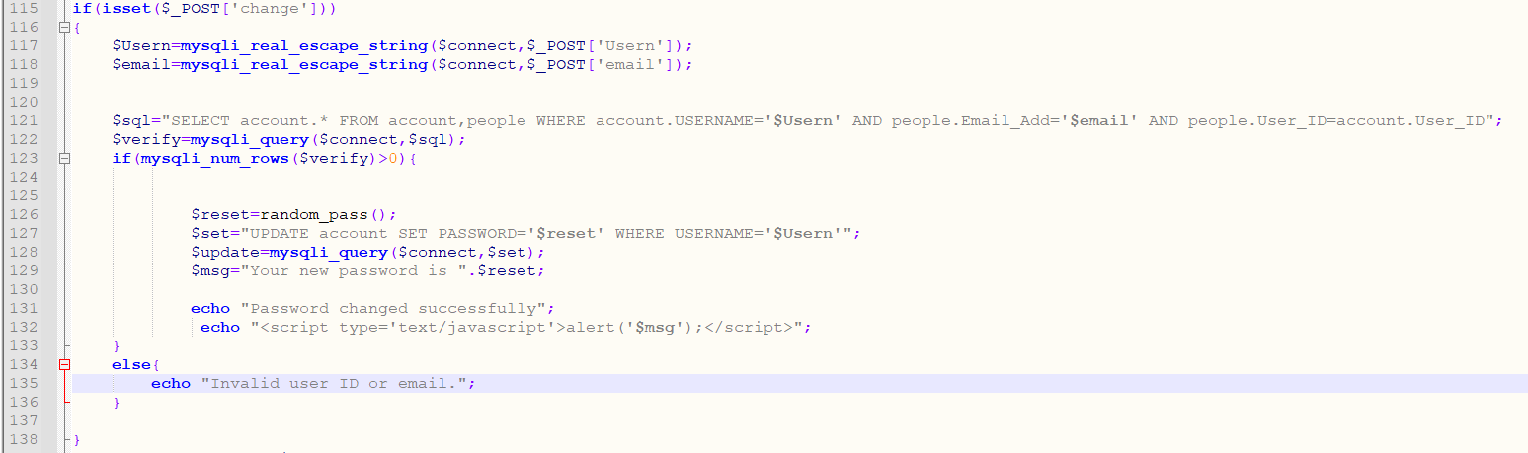

Figure resetPassword.php line 115 to line 138

Once the submit button is clicked on line 109, the isset function on line 115 uses $_POST to check if an input type of submit with the name ‘change’ has been clicked. If it is clicked, it will perform the necessary checks to verify if the username and email does exist in the system. The function mysqli_real_escape_string is used to escapes special characters in a string (PHP mysqli real_escape_string() Function, 2021). The if statement will check if verification is successful and if it is successful the UPDATE statement will be performed to update the new password which used a random_pass() function as shown below on line 139-145 to generate a random 10-digit password for the user. The random 10-digit password is displayed using an alert message in the script.

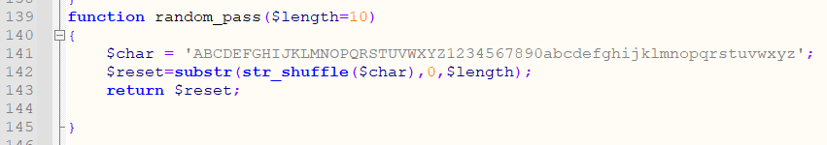

Figure resetPassword.php line 139 to line 145

The function above is to generate a 10-digit password using the str_shuffle that shuffles the character and digit.

## 4.18 Student.php

This page allows students to view the course that they have enrolled in and view all the available the courses for each students program that they have yet to enrolled in.

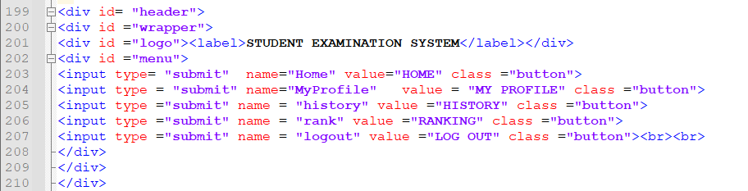

Figure Student.php line 199 to line 210

As seen above, the label Student Examination System will be shown and the button that are available for the student to click.

.

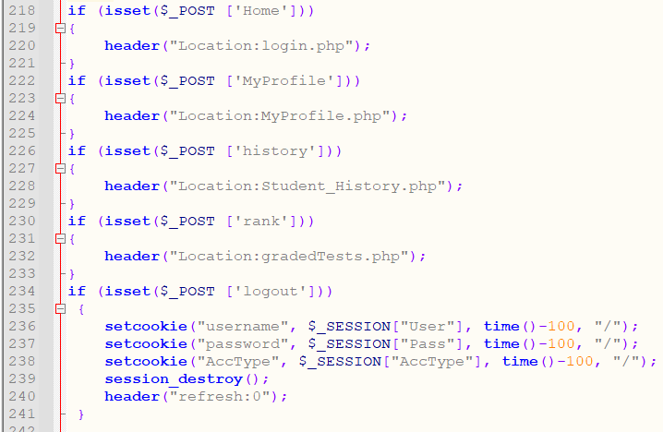

Figure Student.php line 218 to line 241

The isset function above uses $_POST to check which input type of submit with their respective names has been clicked. The input type with the name ‘logout’ will then destroy the session using session_destroy function on line 329 and will clear all cookies as seen on line 236-238. The page will then be refreshed.



Figure Student.php line 243 to line 250

The query on line 243-244 as shown above uses the SELECT statement to get the User ID, the users first name and their program by using the variable $_SESSION[‘User’] which is the username that was passed from the login page when the user logged in. It is the save into their respective variables $Uid(User_ID), $name(fname) and $Prog(prog_ID) as a string.



Figure Student.php line 275 to line 277

The user’s first name and program are displayed as shown above.

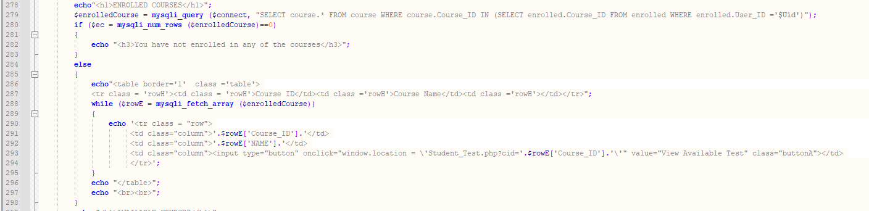

Figure Student.php line 278 to line 298

The mysqli_query function on line 279, performs a check against the database in the enrolled table with the variable $Uid that was created before to check if that variable exist in the enrolled table. It is then saved into a variable $enrolledCourses as a string. The if statement will then perform a check which uses the mysqli_num_rows function using the variable $enrolledCourses to return the number of rows result set identifier returned by mysqli_query() and if the number of rows is equal to 0, the following message on line 282 is displayed.

The else statement is for the if statement on line 280, which display all the courses they have enrolled in in a table using the similar method from the previous pages. The student can View Available Test for each course. Once clicked, the student will be redirected to Student_Test.php page and pass a query string ‘cid’ to that page.

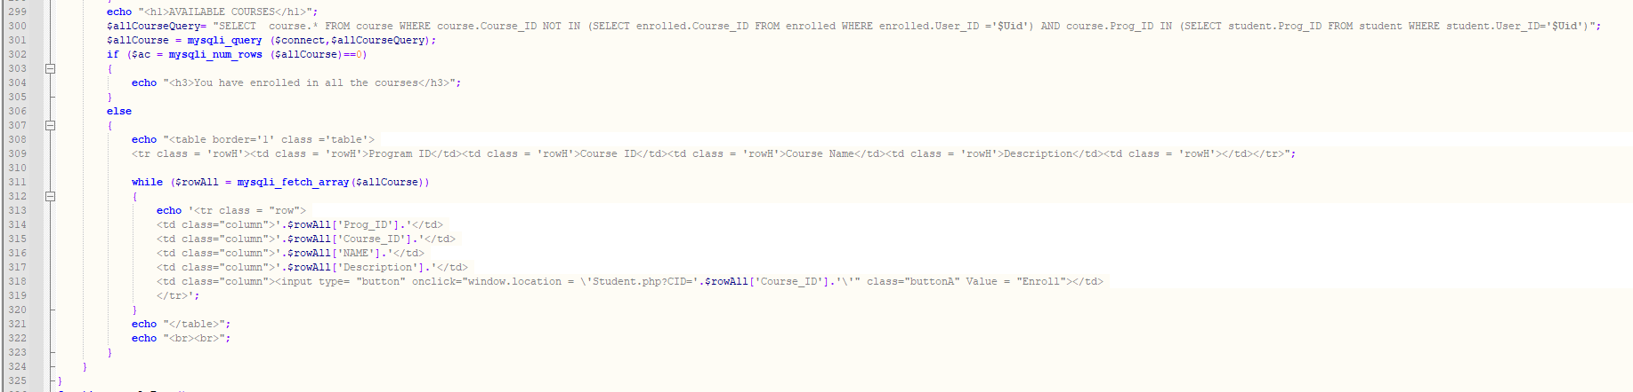

Figure Student.php line 299 to line 325

The query on line 300-301 as show above, performs a check against the database if there are any other courses that the student has yet been enrolled by the student. As you can see above, we used the NOT IN statement highlighted in red squares inside the SELECT statement to get the course ID that is not in the enrolled table in the database. The query is then saved into a variable $allCourse as a string. The if statement will then perform a check which uses the mysqli_num_rows function using the variable $allCourse which returns the number of rows using the result set identifier returned by mysqli_query() and if the number of rows is equal to 0, the following message on line 304 is displayed.

If the number of rows is not equal to 0, the else statement on line 306 above, will be triggered, which displays all the available course that the student has yet to enrolled in for the program that the student is registered in. On line 318 as highlighted in the red square, the student are able to enrol in the course that are available to them. Once clicked, the query string of ‘CID’ is sent to the same page and the isset function which uses $_REQUEST to get the value ‘CID’.



Figure Student.php line 251 to line 256

Once the isset function is triggered, the $_REQUEST[‘cid’] is save into a variable. Then we will ask the student to confirm the action of enrolling in the selected course with the variable $CourseID on line 254. If the student selected No as the page will then refresh back to the home page of the student using onClick function.

If the student clicks on Yes as highlighted in the green square, the query string ‘yes’ which contains the value of the requested ‘CID’ will be passed to the isset function which uses the $_REQUEST to get the input value ‘yes’ as shown below.

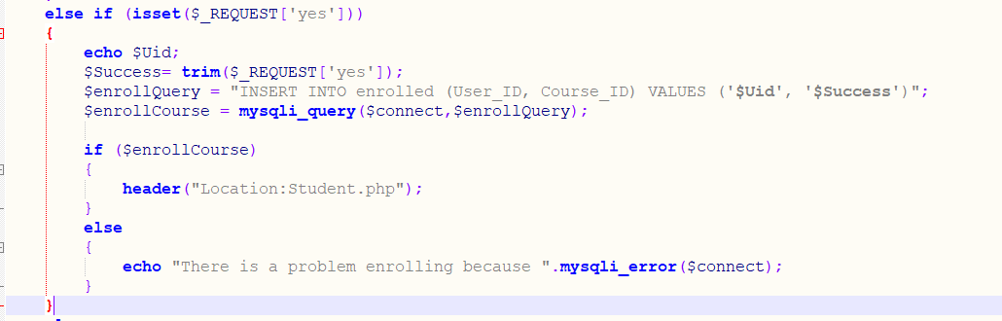

Figure else if statement for $_REQUEST ['yes']

The inser($sql) is used to insert the data into the enrolled table in the table with the variable $Uid which is the User ID and the $Success which is the variable used to save $_REQUEST[‘yes’] as a string. The if statement will perform a check if the insertion is successful. If it is the, the page will reload the to the same page and will the course that is student in enrolled in will be displays in Enrolled Course table. If the insertion is unsuccessful, the error message is the displayed using mysqli_error() function.

## 4.19 Student_History.php

In this page, the student will are able to view all test take by that student along with the details of the test such as Test ID, Test Name, Course ID, Date, Marks, Marks(%), Grade and whether they fail/ pass the test.



Figure Student_History.php line line 198 to line 199

We apply a search engine that allows student to search all the test using Course ID. Once the student enters the Course ID in the text box and clicked on the Search By Course ID button.

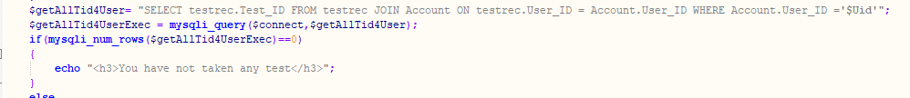

Figure query to get all test ID in Sudent_History.php

This query is used to get all the test id from the testrec table in the database using variable $Uid which means the students User ID to get all the test id taken by the student.



Figure Student_History.php line line 201 to line 203

The isset function which uses the $_POST to check if an input type of submit with the name ‘search’ has been clicked.

We use the mysqli_real_escape_string which escapes all special characters in a string which uses the $_POST with the input type of text with the name ‘searchcid’. We then save it into a variable $search and pass that variable into a string as a query.



Figure Student_History.php line line 219 to line 224

The query on line 219, is used to find if the test taken by the student by checking testrec table in the database. The query is then saved into the variable $sqEx. The if statement will the perform a check using mysqli_num_row to return the number of row using the result set identifier returned by mysqli_query() and if the number of rows is equal to 0, the message on line 223 is displayed. The else statement below will then be executed if the number of rows is not equal to 0.

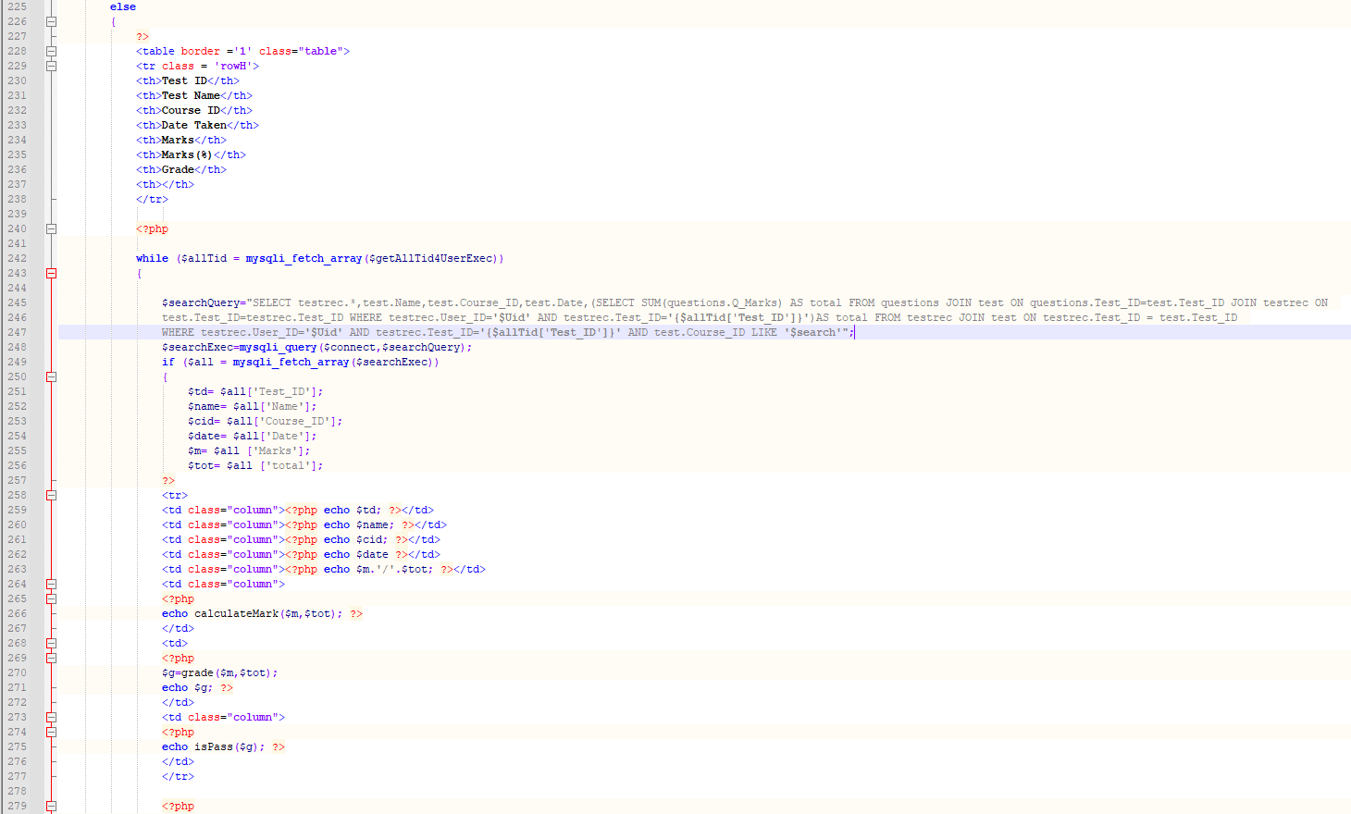

Figure Student_History.php line line 255 to line 279

If the course ID exist, it will the display all the records of the user such as Test ID, Test Name, Course ID, Date, Marks, Marks(%), Grade and whether they fail/ pass the test from testrec, test and questions in the database in which we used the query on line 245 to get all the records from multiple tables. The total marks of each test is save AS total in the query.

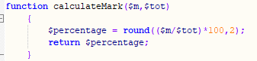

Figure function calculatemark in Student_History.php

The total and marks in the query is the passed to the function calculateMarks() as shown above, to calculate the percentage.

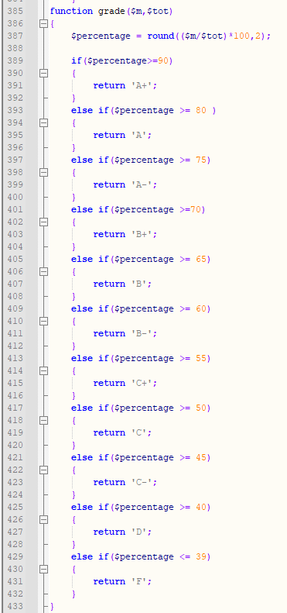

Figure Student_History.php line line 385 to line 432

The total set in the query is also used in the grade() to display the grade the student received in the test. And lastly the function isPass() is used to display whether the student fail/pass by passing in the grade into the function as show below.

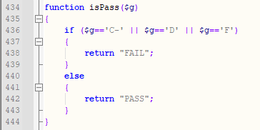

Figure Student_History.php line line 434 to line 444

If the search button is not clicked, the student is able to view all test taken for every course. We put the details of all the test taken into a function historyAll() and just call it in the else statement as shown below, where the search button have not been clicked. A similar query as above is used to get all the information of the test, marks and total from multiple tables from the database.

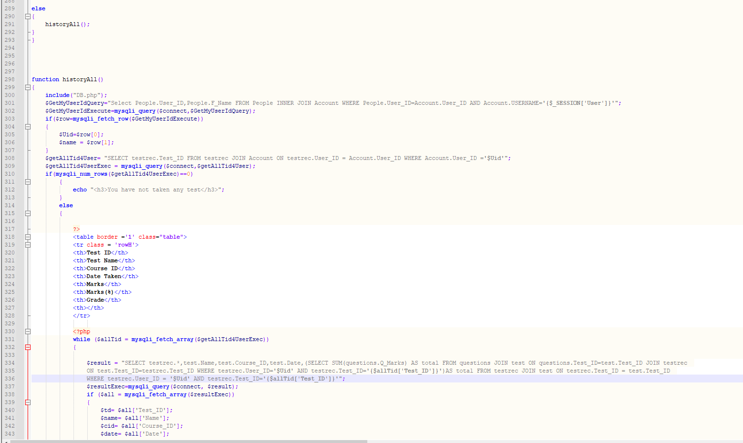

Figure Student_History.php line line 289 to line 343 function HistoryAll

## 4.20 Student_TakeTest.php

This page allows student to take the test from the available test for each course. When the use clicked on Take Test button in the Student_Test.php page, a query string of ‘tid’ is sent and passed to Student_TakeTest.php page.

Figure Student_TakeTest.php line 3



aaaaaaaaaaaaaaaaaaaaa

The form action above with method post and action to $_SERVER[‘PHP_SELF’] which means that the form will post to itself when data is submitted. The enctype=”multipart/form-data” to allow transfer of files such as images to the database. The red square shown above is where the $_REQUEST will get the input value of ‘tid’ which was passed from the Student_Test.php.



Figure Student_TakeTest.php line 143

The date_default_timezone_set function is used to get the current date and time with the Asia timezone and from the state of Kuala Lumpur.

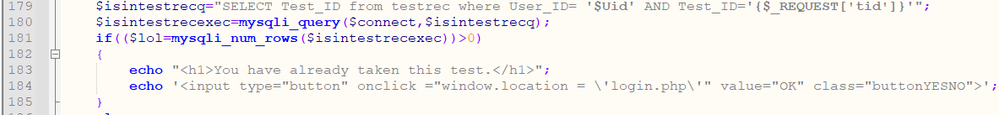

Figure Student_TakeTest.php line 179 to line 185

When the student clicked on the test they want to take, the query on line 179, will check if the User ID exist with the $_REQUEST[‘tid’] in the testrec table. The if statement on line 181, will then perform the check for the query above if there is any data in the testrec table the message on line 183 will be displayed and if the button ‘OK’ is clicked it will redirect user to the home page of the student.

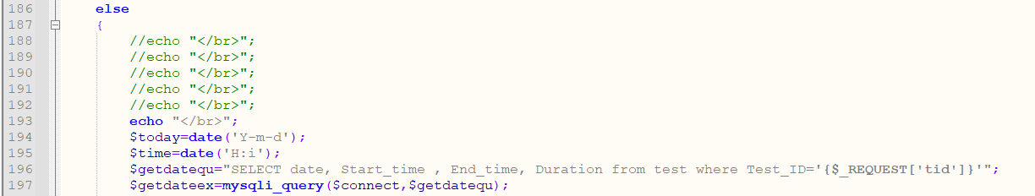

Figure Student_TakeTest.php line 186 to line 195

The else statement is for the if statement on line 181, if the student have not taken the test, the date function for the current date with the format (‘Y-m-d’) is saved to a variable $today as a string. The same goes to the current time where using the data function with the format (‘H:i’) is saved to a variable $time.

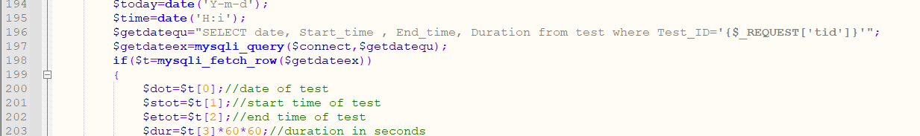

Figure Student_TakeTest.php line 194 to line 203



Figure Student_TakeTest.php line 204 to line 208

Next, the query on line 196, retrieves the start time, end time, and duration from the test table in the database where the test id is sent from a query string using $_REQUEST method. The if statement on line 198, will fetch the data from the database using the query and saved in their respective variables.

Next the if statement on line 204 will check if the date of the test is before the current date, and if it is the following message on line 206-207 will be displayed to the student. Note that the variable $dot and $today which contain the date of the test and the current date respectively is converted to unix time stamp using strototime function.



Figure Student_TakeTest.php line 209 to line 213

The else if statement will then perform a check if the current date passed the date of the test using the same method as stated above. If it is, the following message on lime 211-212 will be shown to the user.

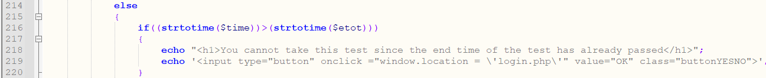

Figure Student_TakeTest.php line 214 to line 220

The else statement on line 214, is triggered when the if statement on line 204 is done performing a check. Then if statement on line 216, will then perform a check for the variable variable $time and $etot which contain the time of the test and the current times respectively is converted to unix time stamp using strototime function. If the time of the current time is more than the end time of the test, the message on line 218-219 will be displayed to the student.



Figure Student_TakeTest.php line 221 to line 225

The else if statement above on line 221, will then check if the current time is before the start time of the test, the following message on line 223-224 will be displayed to the user.

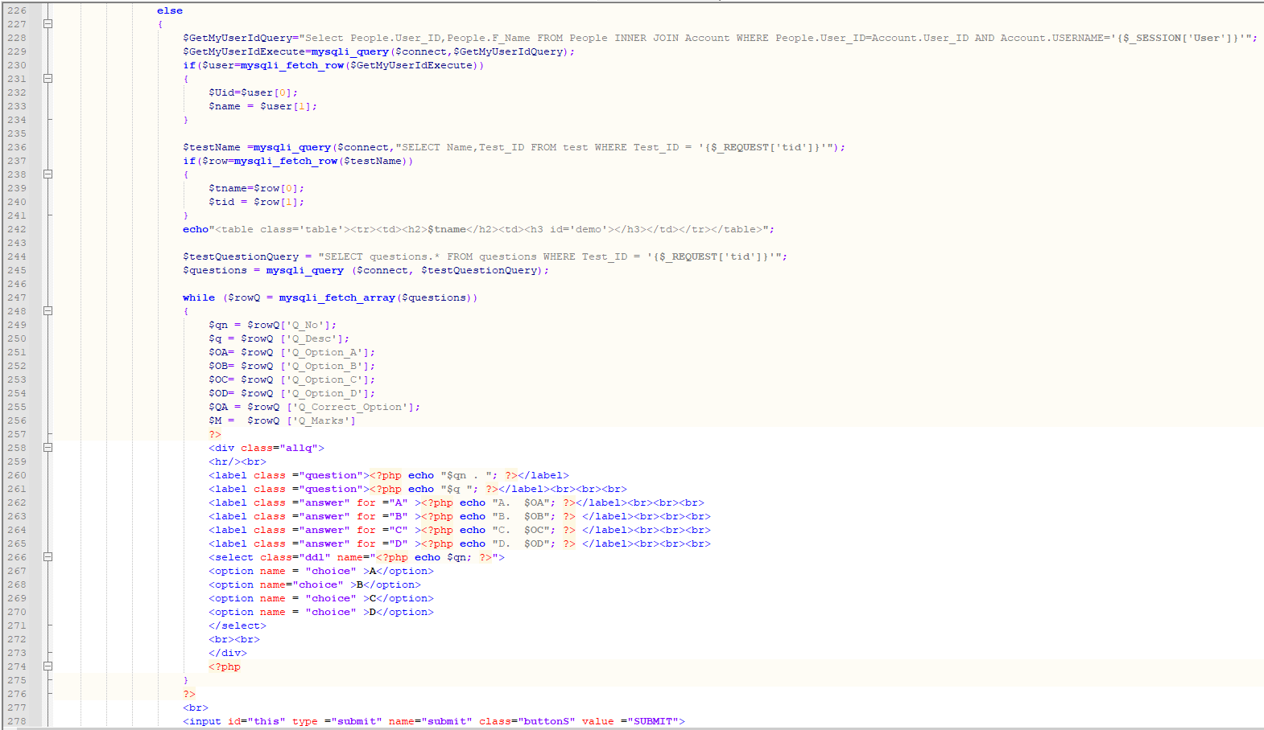

Figure Student_TakeTest.php line 226 to line 278

The else statement shown above on line 226, is only triggered if all checking done previously is passed. The query on line 236 in the highlighted green square will then retrieves the name of the test and the test id from the test table in the database where the test id is sent from a query string using $_REQUEST method.

The query on line 244 highlighted in the yellow square will retrieve all the questions, all the options, correct answer, and marks where the test id is sent from a query string using $_REQUEST method.

We also used a time counter which is displayed alongside the test name on line 242 in the highlighted red square above. As you can see the test name and the live counter is displayed in table using the variable $tname which the test name and the live counter next to the name with the element with the id= ‘demo’ which was created from the script that will be shown later and explained below. Note that the element with the id= ‘demo’ will only be triggered if the user has not yet click on the submit button on line 276 and the countdown is equal to 0.

The query on line 283 as show below is to retrieve the total of question number from the test table where the test id is sent from a query string using $_REQUEST method. The query is then saved to a variable $s as a string.

If the user, click on the submit button before the countdown is up the following isset function which uses the $_POST with the input type of value with the name ‘submit’ will be triggered.

In that isset function, a for loop is used that set $i as the question number which is set to 1 as the question number start from number 1. In the for loop, another isset function with the input type of value ‘$i’ will then check and gets all the choice selected by the user in the from the dropdown list. The loop will then break when it reaches the end of the question number $s.

The isset function which uses the $_POST with the input type of text with the name ‘$i’ will be triggered and will perform a check if the choice selected == correct option that is retrieved using the query on line 297-298 from question table from the database. If the selected answer is equal to the correct option, the marks will be added. Then the INSERT statement will then insert the marks to the testrec table. If the insertion is successful an alert message will be displayed using a script as to show the total marks the student will get and inform the student that the marks have been updated.

Figure Student_TakeTest.php isset 283 and after submit is clicked

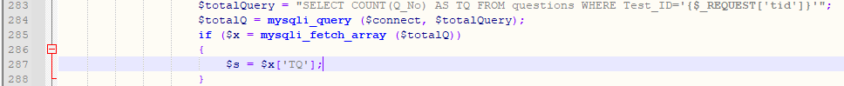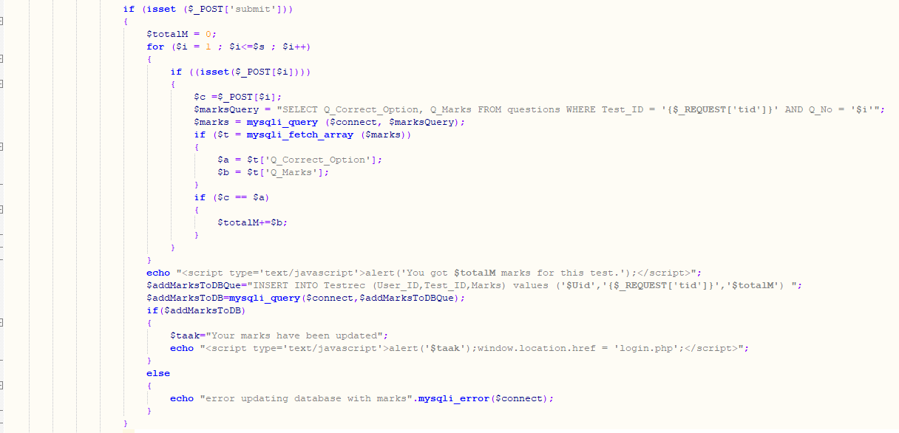

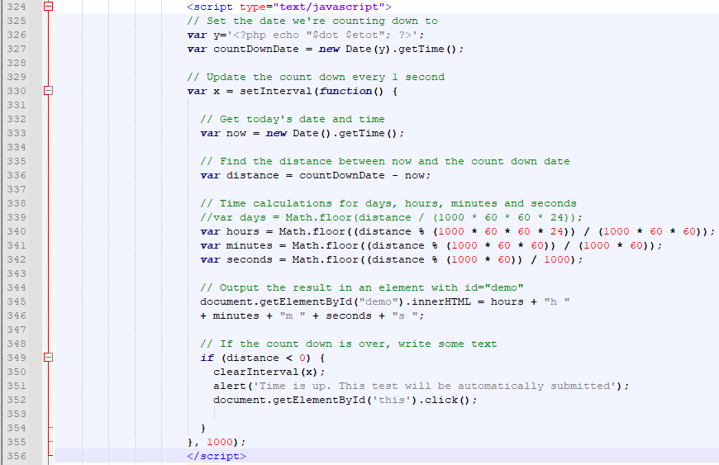

Figure Student_TakeTest.php line 342 to line 356 (script to show live timer for test)

In the script, we set the date and time that the test is counting down to by calling the variable $dot and $etot which is the date of the test and end time of the test respectively into a variable ‘y’. We then save the date and get the current time to the variable countDownDate.

Next, the highlighted yellow square above using the function setInterval which set the interval to 1 second when counting down. The current date and time using new date() and getTime() is then saved to a variable ‘now’. The blue square highlighted above, is used to find the distance to by subtracting the variable countDownDate and the variable now which is then saved to the variable distance.

Next, the highlighted in the purple square will then convert the distance which is unix time stamp of the variable distance to hours minutes and seconds. Next, the converted hours, minutes and time is save into the document.getElementById() method returns the element that has the ID attribute of ‘demo’ which is being called on line 242 (HTML DOM getElementById() Method, 2021). When the countdown ends an alert will be displayed with the message as shown in the script in the highlighted grey square above.

## 4.21 Student_Test.php

This page allows user to view all the available test for a certain course. The student will be redirected to this when the View Available Test is clicked from the student’s home page and a query string of ‘cid’ is passed to Student_Test.php page.



Figure Student_Test.php line 2

The form action above with method post and action to $_SERVER[‘PHP_SELF’] which means that the form will post to itself when data is submitted.

The $_REQUEST will get the input value of ‘cid’ which was passed from the Student.php.

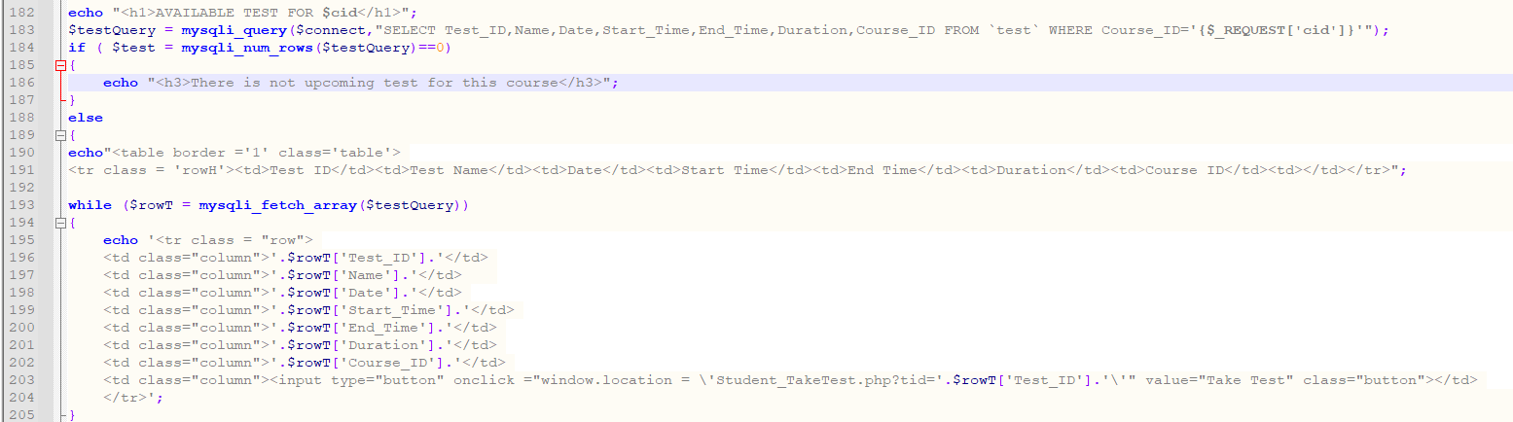

Figure Student_Test.php line 182 to line 205

The query on line 183 above, uses the SELECT statement to retrieve the data from the test table in the database with $_REQUEST will get the input value of ‘cid’. The if statement on line 184, will perform a check using mysqli_num_rows to return the number of row using the result set identifier returned by mysqli_query() (PHP mysqli_num_rows() Function, 2021) and if the number of rows is equal to 0, the message on line 186 is displayed. The else statement on line 188, is for when the number of rows is not equal to 0, it will then fetch the data from the test table using mysqli_fetch_array function. The data which is all the available test for a certain course id is then displayed in a table in the while loop.

## 4.22 StudentRecords.php

This page allows the Admin to view a certain students information, the course where the student in enrolled in and the test taken by the student with the marks. The Admin will be redirected to this page from the Admins home page where the View Records is clicked from the All Currently Registered Student table of a certain student. The query string ‘UID’ is passed to this page from the home page.



Figure StudentRecords.php line 1

The form action above with method post and action to $_SERVER[‘PHP_SELF’] which means that the form will post to itself when data is submitted.

The $_REQUEST will get the input value of ‘UID’ which was passed from the AdminHome.php.

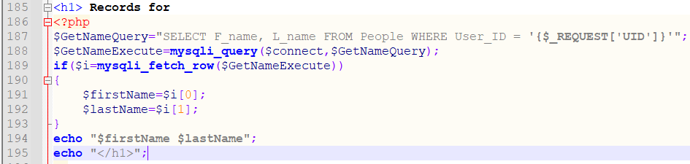

Figure Student_Test.php line 185 to line 195

First, the query on line 187-188 will retrieve the data for the first name and last name from the People table in the database using the SELECT statement with $_REQUEST method that will get the input value of ‘UID’. The if statement will the fetch the data using mysqli_fetch_row which fetches one row from a result-set and returns it as an enumerated array (PHP mysqli fetch_row() Function, 2021) with that requested User ID. The data is then saved as a string to their respective variables $firstName(fname) and $lastName(lname). It will then be used to display on the first line in the page as show from line 185-194.

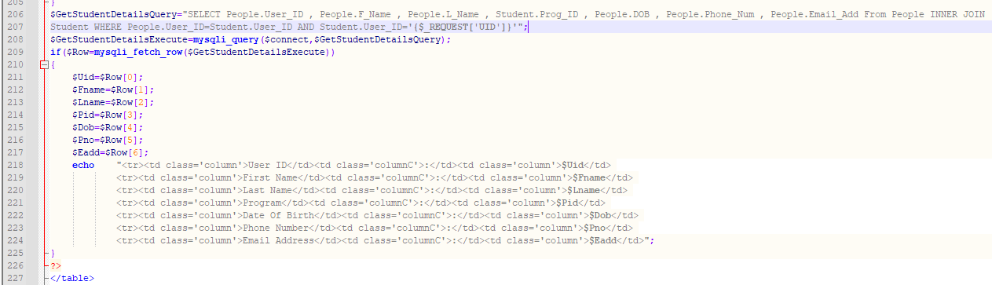

Figure Student_Test.php line 206 to line 227

Next, all the details of the user is retrieved using the SELECT statement and using INNER JOIN selects records that have matching values (SQL INNER JOIN Keyword, 2021) in 2 tables which are the People table that retrieves the User Id, first name, last name, date of birth, phone number, email and from the students table that retrieves the program id using the $_REQUEST method that will get the input value of ‘UID’.

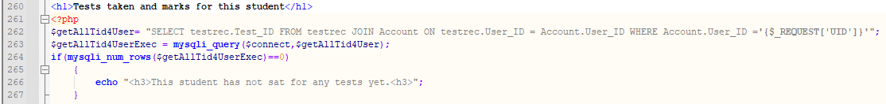

Figure Student_Test.php line 260 to line 267

The query above on line 262, will retrieve the data from the testrec table in the database the $_REQUEST method that will get the input value of ‘UID’. Then the if statement will check if there is any data using mysqli_num_rows and if there is none, the message on line 266 will be displayed.

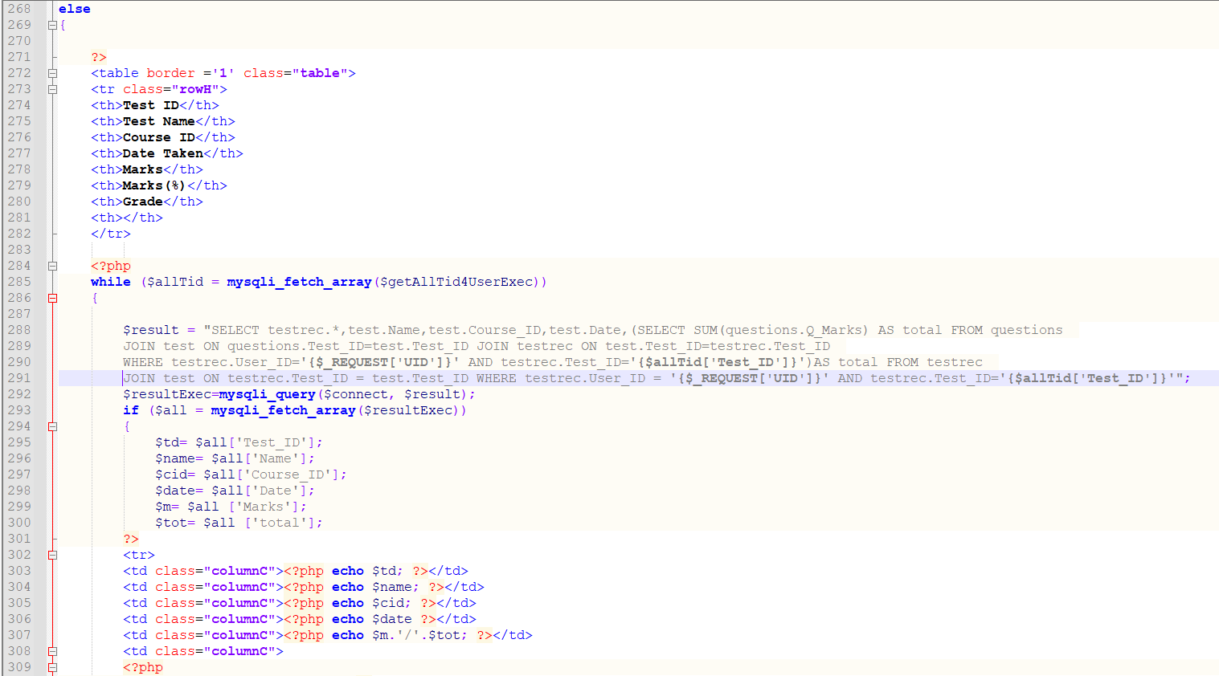

Figure Student_Test.php line 268 to line 309

If there is any data, it will then be outputted into a table using the while using the exact same method, query and functions as stated and explained on Student_History.php.

## 4.23 teacherHome.php

This page allows Teacher to view all the course they are currently teaching in.

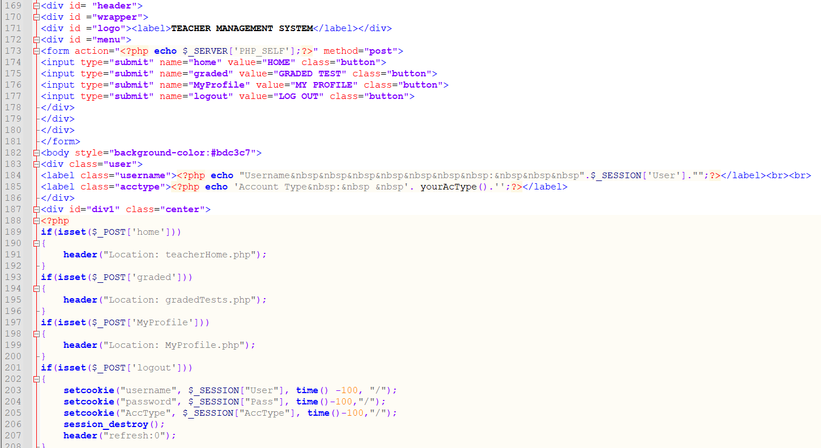

Figure teacherHome.php line 169 to line 208

The label that shows the Teacher Management is shown and the buttons that are available for the teacher to click on.

Line 189-208, are the isset functions which uses the $_POST method that has the input value of the respective button.

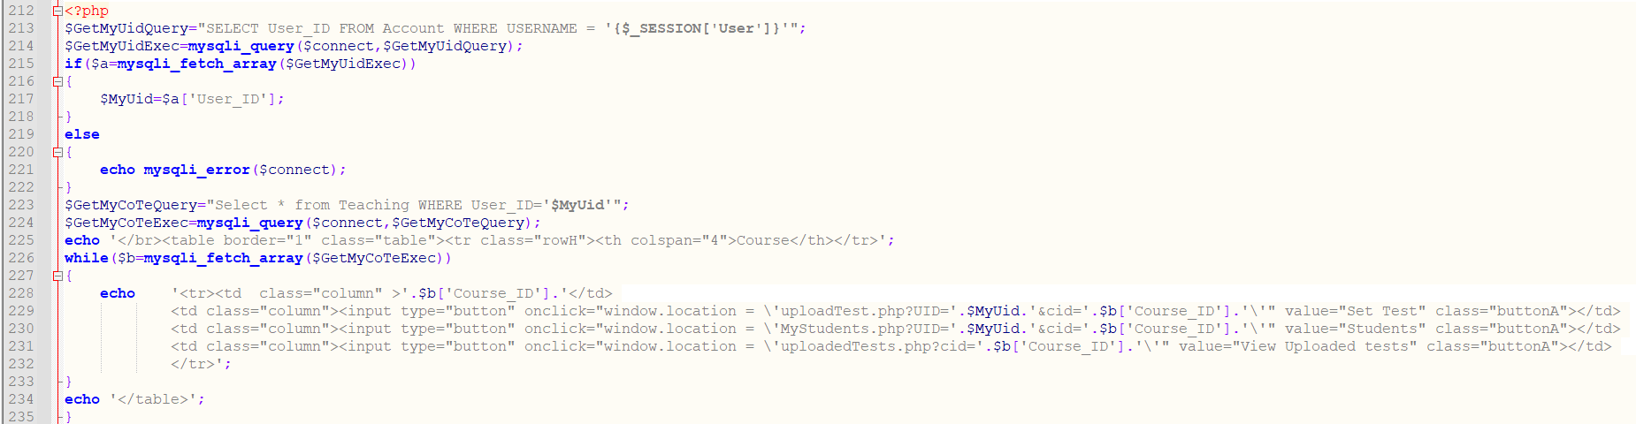

Figure teacherHome.php line 212 to line 235

The query on line 213, will retrieve the User ID from the Account table using the $_SESSION with the value of ‘User’ which is the username.

On line 223, is the query that uses the SELECT statement which retrieve the all the data from the teaching table in the database where the teacher is currently teaching in. The output is display in the table using the while loop which is a similar method where we are displaying information in a table in other pages.

Each row for each course has 3 buttons in the same row that redirects the teacher to the respective pages with their respective query string using the onClick function.

## 4.24 TestAndMarksByCourse.php

This page allows the teacher to view all the details of the test taken by a certain student along with their mark and grades. The teacher will be redirected to this page from the MyStudent.php page where the teacher will click on the Test and Marks button of a certain student.

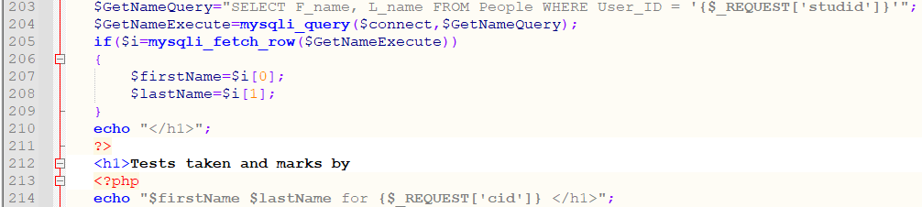

Figure TestAndMarksByCourse.php line 203 to line 214

First, the query on line 203-204 will retrieve the data for the first name and last name from the People table in the database using the SELECT statement with $_REQUEST method that will get the input value of ‘studid’. The if statement will the fetch the data using mysqli_fetch_row which fetches one row from a result-set and returns it as an enumerated array (PHP mysqli fetch_row() Function, 2021) with that requested User ID. The data is then saved as a string to their respective variables $firstName(fname) and $lastName(lname). It will then be used to display on the first line in the page as show from line 212-214.

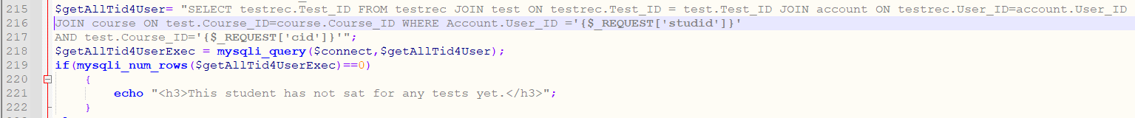

Figure TestAndMarksByCourse.php line 215 to line 222

The query above on line 215, will retrieve the data from the testrec, test and account table in the database using the JOIN and with the $_REQUEST method that will get the input value of ‘studid’. Then the if statement will check if there is any data using mysqli_num_rows and if there is none, the message on line 221 will be displayed.

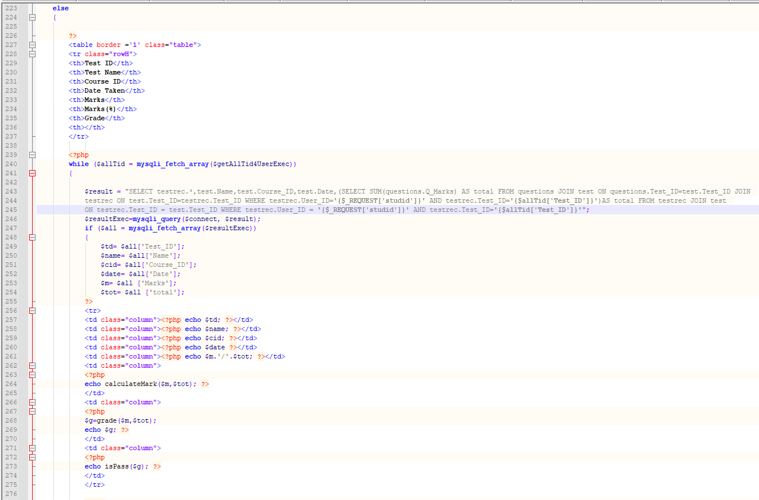

Figure TestAndMarksByCourse.php line 223 to line 276

If there is any data, it will then be outputted into a table using the while using the exact same method, query and functions as stated and explained on Student_History.php and StudentRecords.php.

## 4.25 uploadTest.php

This page allows the teacher to set a test for the courses he/she is currently teaching in. When the Set Test button is clicked the teacher will be redirected to this page and passing in a query string of ‘cid’.



Figure uploadTest.php form action

The form action above with method post and action to $_SERVER[‘PHP_SELF’] which means that the form will post to itself when data is submitted. The $_REQUEST will get the input value of ‘UID’ and ‘cid’ which was passed from the teacherHome.php when the teacher click on Set Test button.

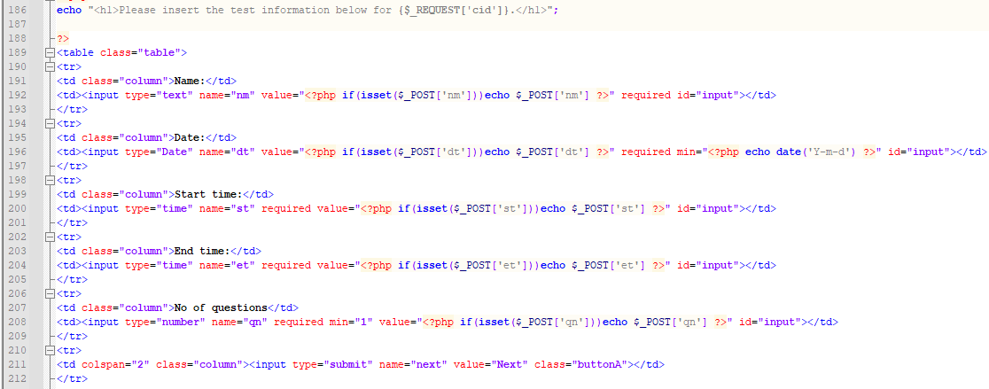

Figure uploadTest.php line 189 to line 212

A form will be displayed that allows the teacher to enter the test details such as Name, Date, Start Time, End Time and no of questions for that test.

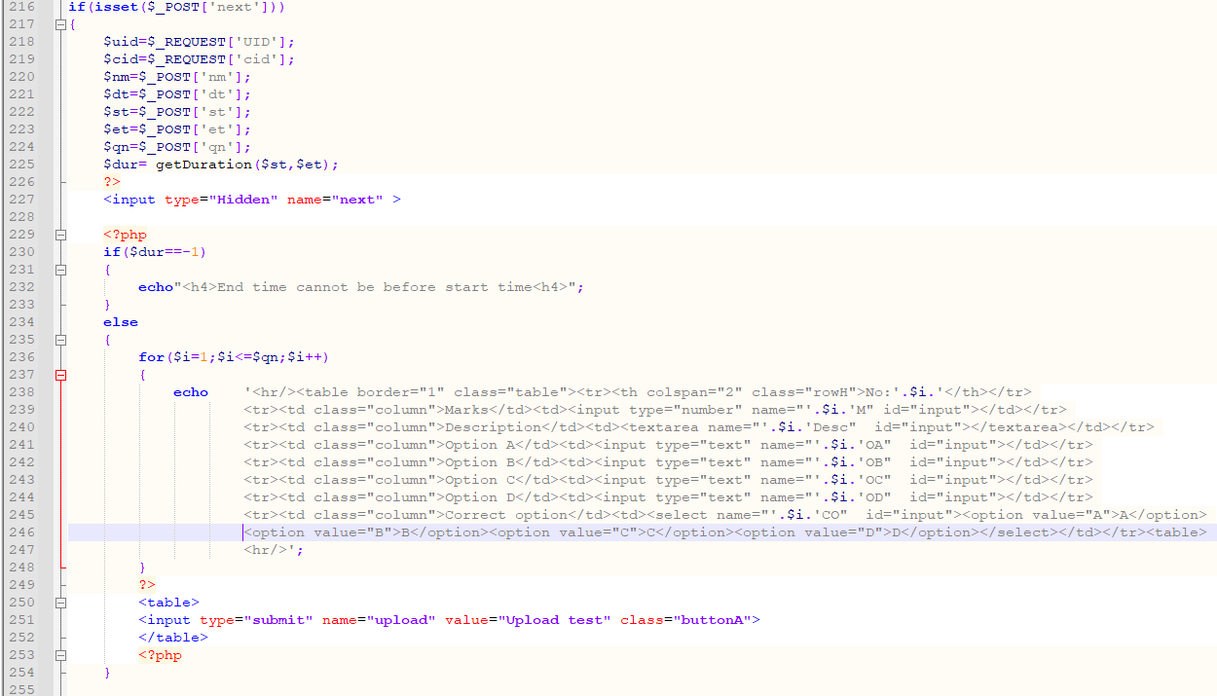

Figure uploadTest.php line 216 to line 255

Once the details are filled in, and the Next button is clicked and the isset function which used $_POST with the input value name ‘next’ will be triggered and will perform the necessary checks and validations. As seen on line 230, an if statement is used to check if the duration between start time and end time is equal to -1, meaning that the end time is less that the start time. If end time is less than the start time the message on line 232 is displayed. The else statement will be performed if the if statement on line 230 is passed. Therefore, a form will be displayed according to the number of questions the teacher entered in the previous form before clicking ‘Next’ by using a for loop on line 236. For example, if the teacher enter no of question is 5, there will be 5 forms for 5 questions will be displayed and will allows user to enter the questions, marks, possible options, and the correct option for each question.

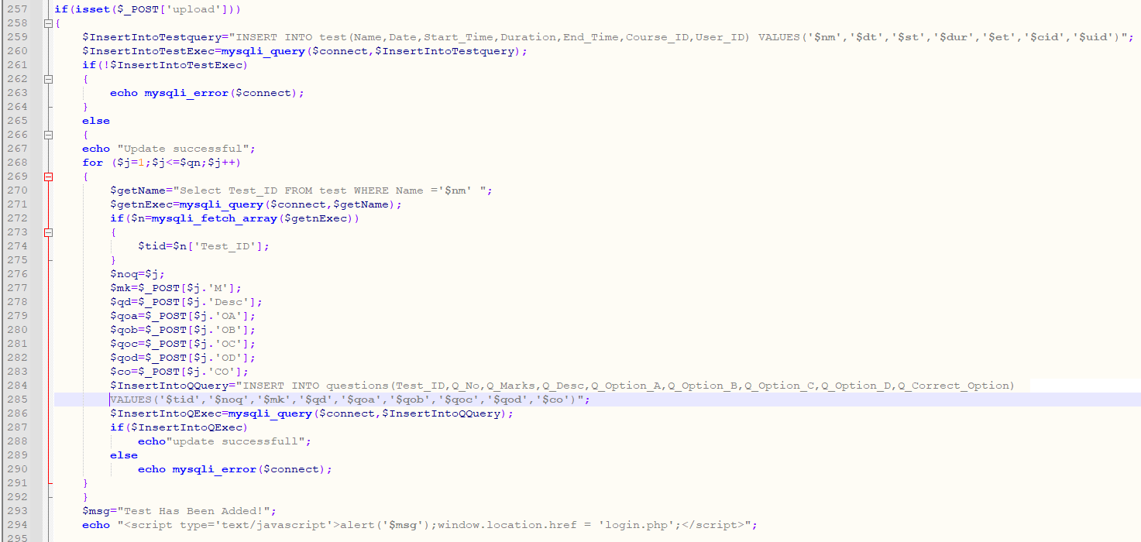

Figure uploadTest.php line 257 to line 295

Once the teacher enter all the details of each question, the button ‘Upload Test’ will be clicked and the isset function which uses the $_POST with the input value name ‘upload’ will be triggered. The INSERT query will then be used to insert all the form data for the details of the test and if the insertion is unsuccessful an error message on line 253 will be displayed which uses the mysqli_error() function. If the insertion is successful, the message on line 267 will be displayed and another INSERT query will be used to insert the details of each question using the for loop. If the insertion is successful, the message an alert message using script will be displayed to show that Test Has been Added successfully.

## 4.26 uploadedTests.php

This page allows the teacher to view all the test that has been created for a certain course they are currently teaching. The teacher will be redirected to this page when the teacher click on the “View Uploaded Test” button on teacherHome.php page which a query string of ‘cid’ is passed to this page.

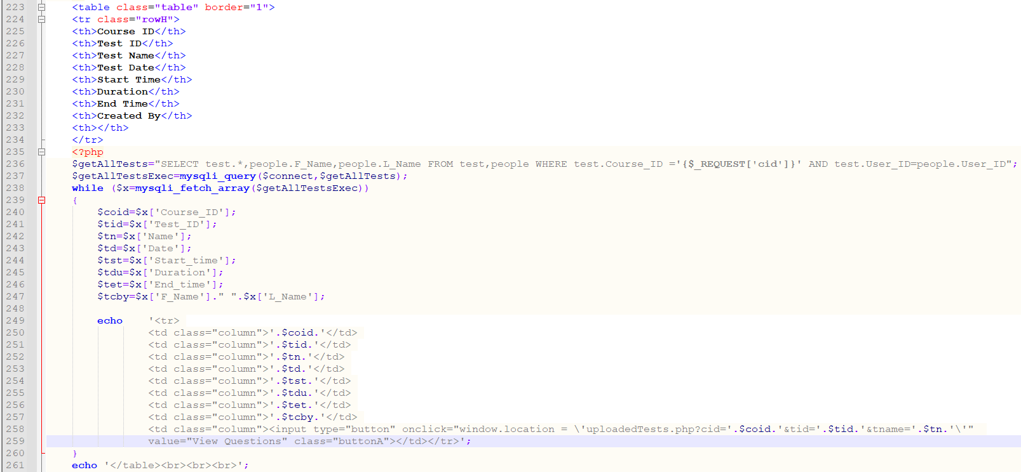

Figure uploadedTests.php Line 223 to line 261

The query on line 236, retrieves all the test and the name of the user that created the test for a certain course using $_REQUEST which uses the input value name ‘cid’. The data is then displayed in table which a similar method that is used in most of the pages. In each row for each test, a “View Questions” button is available for the teacher to view the questions of a certain test that has been uploaded.

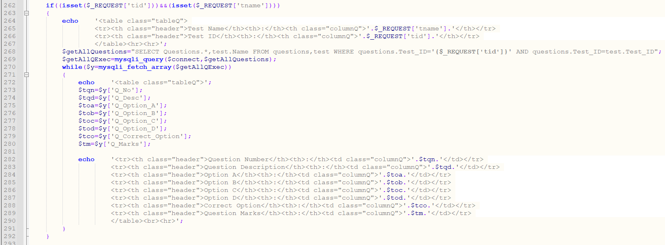

Figure uploadedTests.php Line 262 to line 293

Once the button “View Questions” is clicked the isset function() which uses the $_REQUEST method to get the value of the query string that was passed from the onlick function. The query on line 268, is used to retrieve all the questions, marks of each question and the correct option of a certain test. The question and their details is then fetch from the questions table and is displayed in a while loop which is also a similar method being used in some of the pages above.

# 5.0 Screenshots of system

## 5.1 Admin

### 5.1.1 Home page

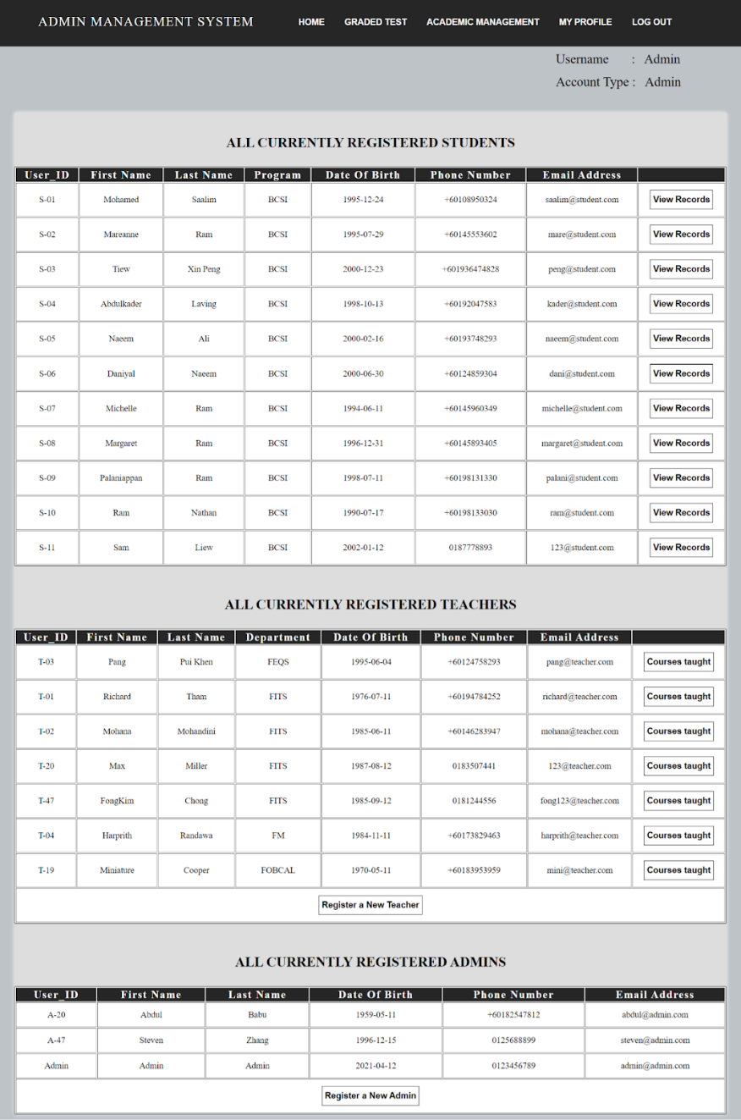

Figure Admin Home Page

#### 5.1.1.1 Student Records page

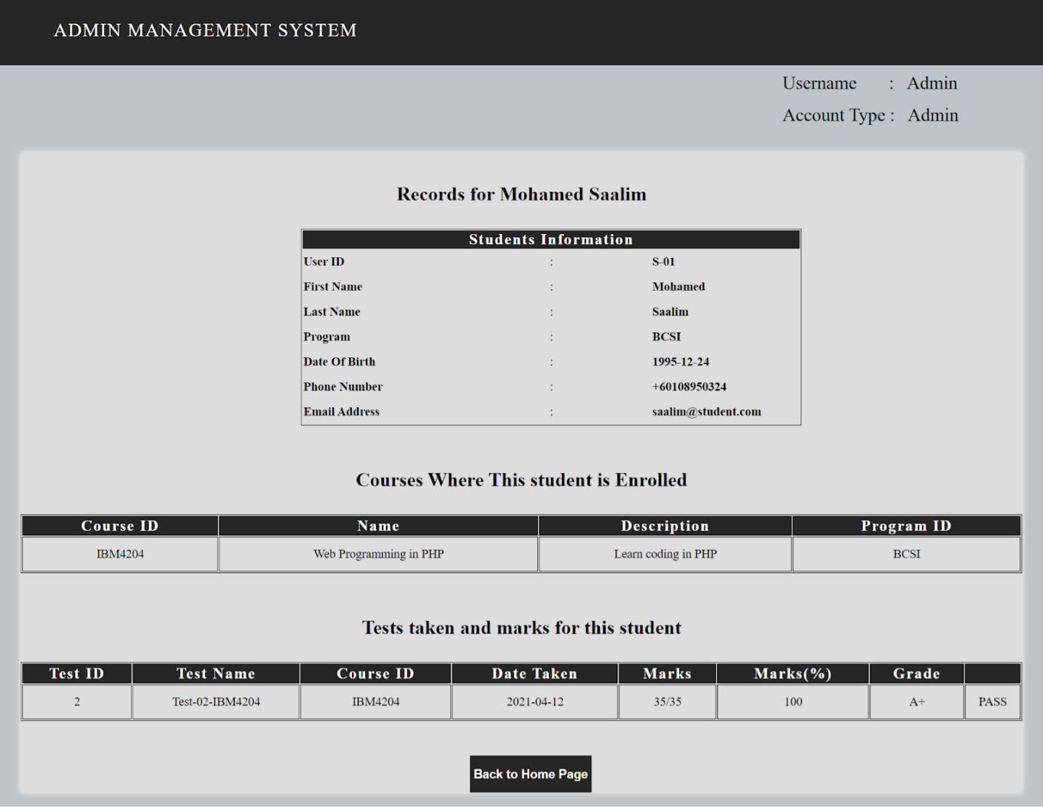

Figure Student records page

#### 5.1.1.2 Courses Taught By Teacher page

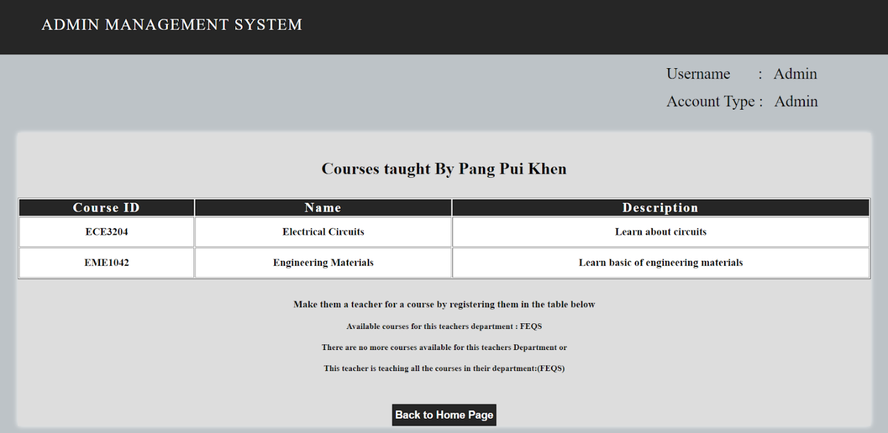

Figure Courses taught by teacher page

#### 5.1.1.3 Register New Teacher page

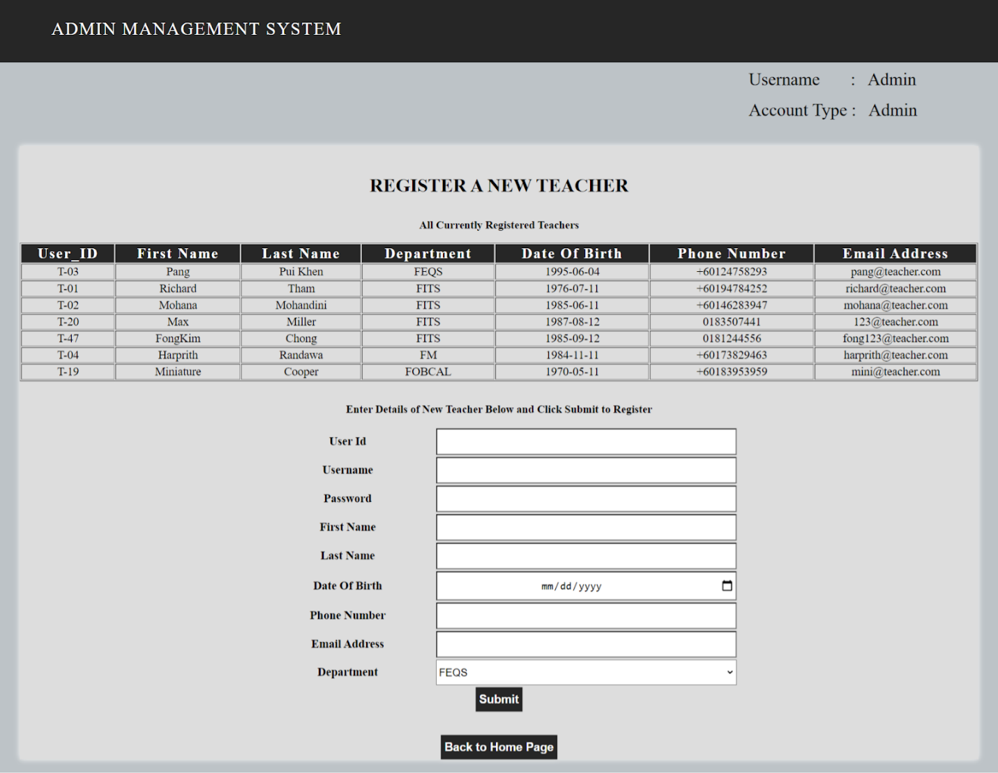

Figure Register new teacher page

#### 5.1.1.4 Register New Admin page

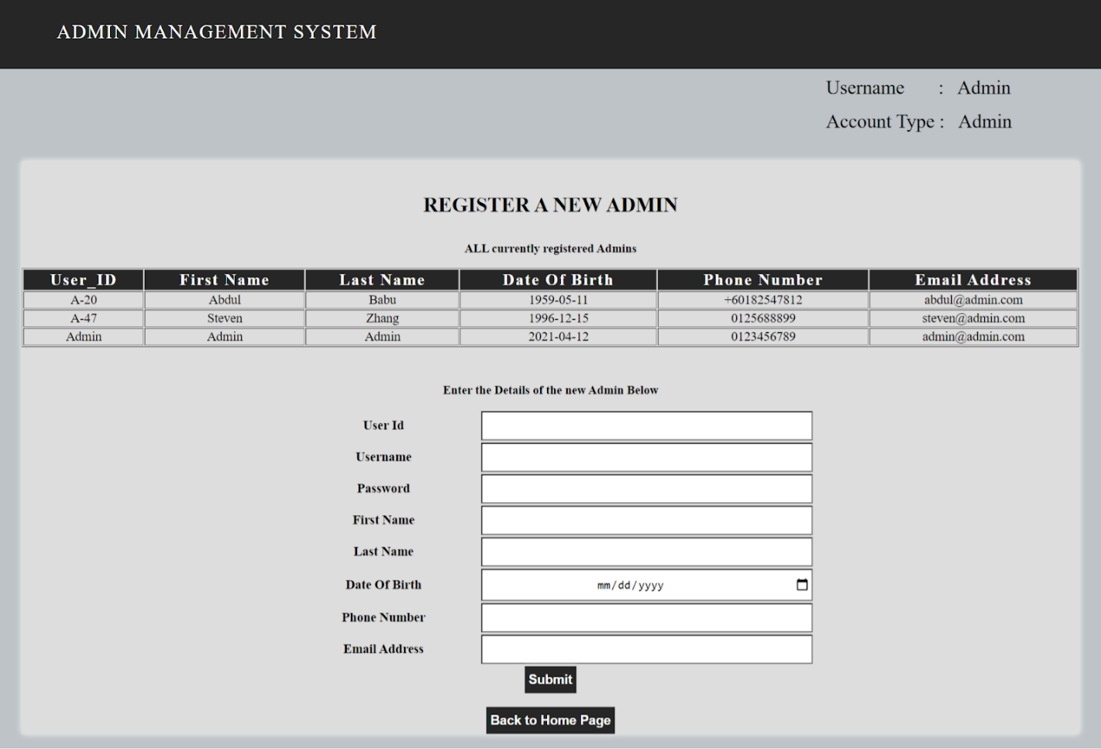

Figure Register new admin page

### 5.1.2 Graded Test page

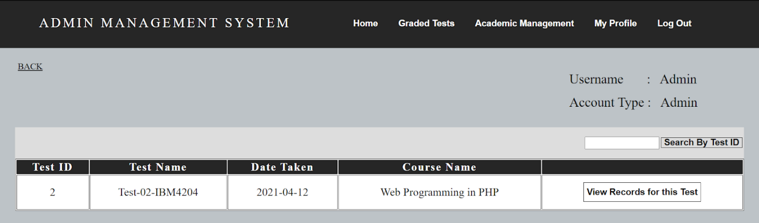

Figure graded tests page

#### 5.1.2.1 Records of Test page

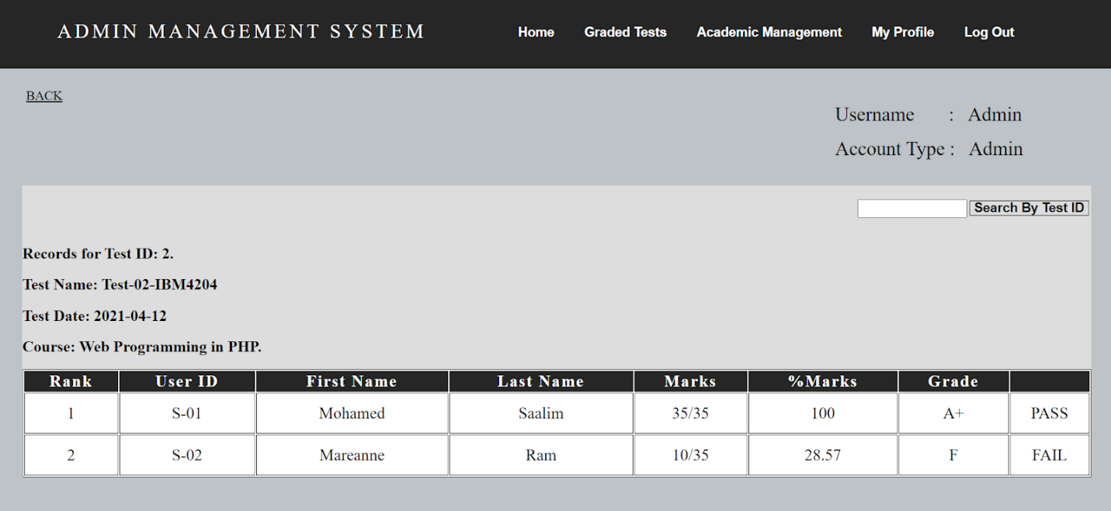

Figure records of test page

### 5.1.3 Academic Management page

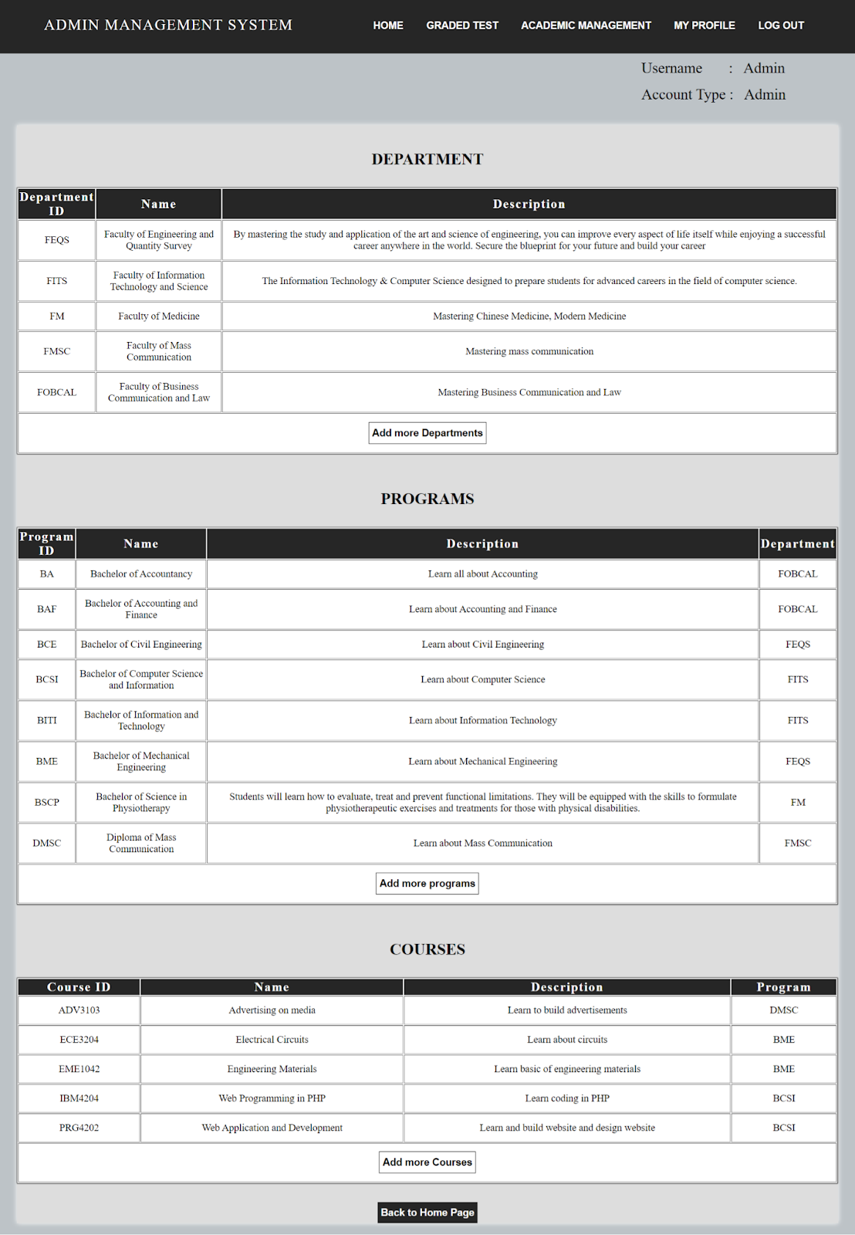

Figure Academic department page

#### 5.1.3.1 Add departments page.

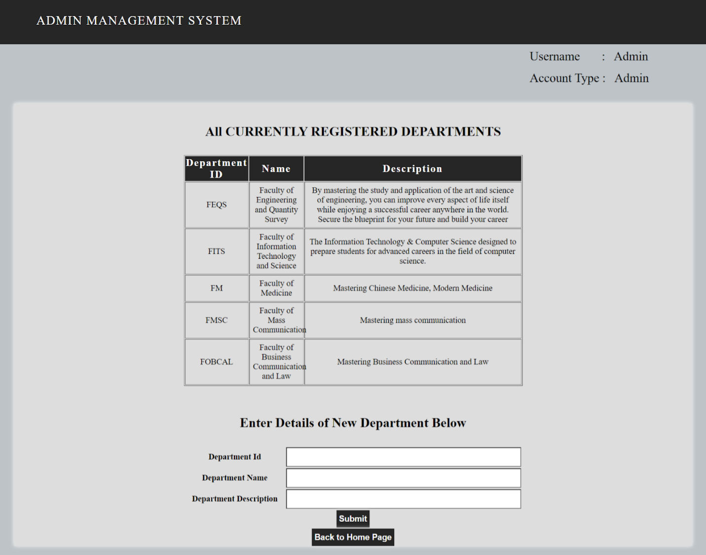

Figure Add department page

#### 5.1.3.2 Add programs page

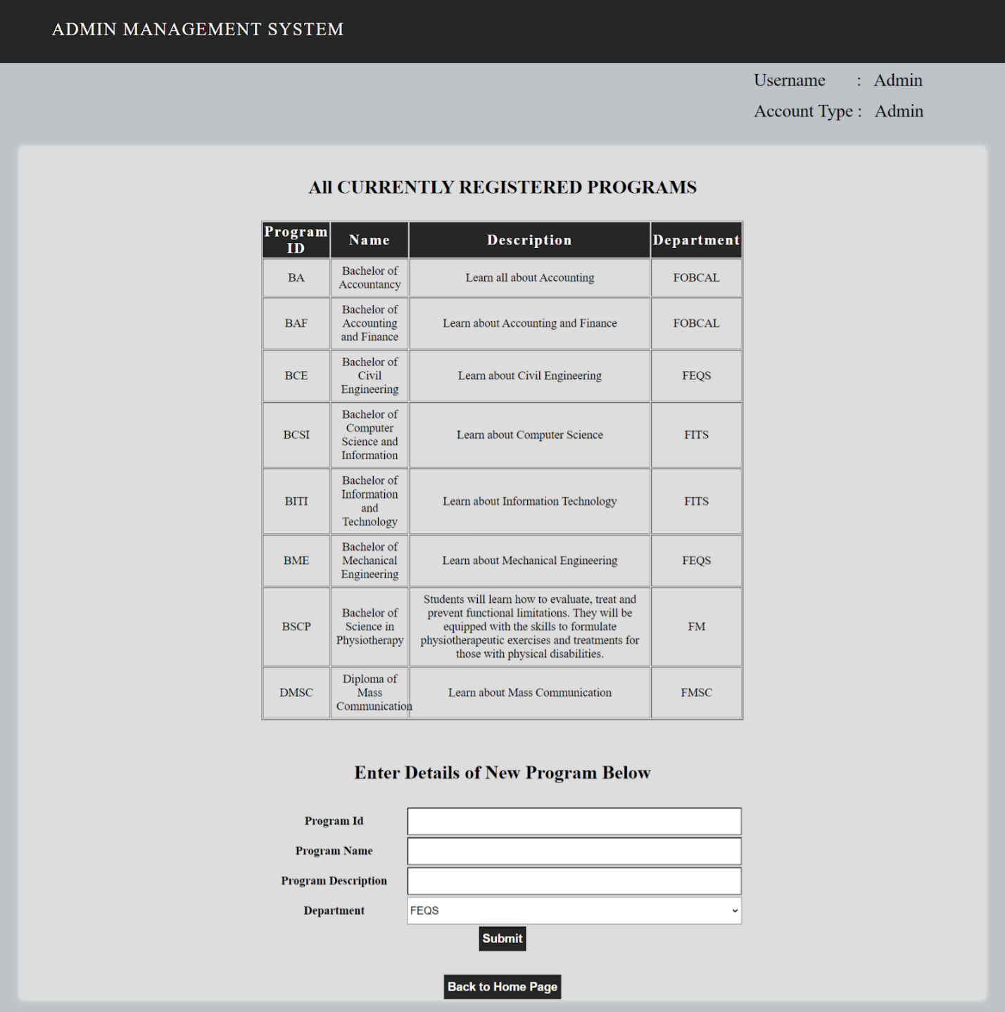

Figure Add program page

#### 5.1.3.3 Add courses page

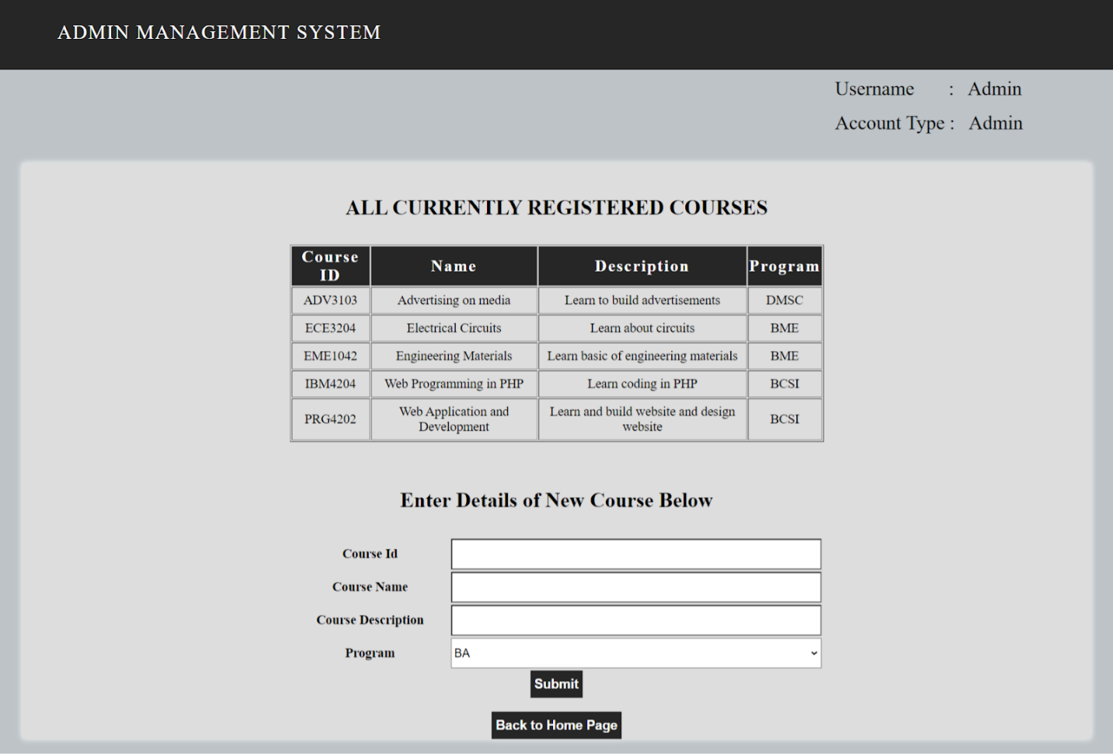

Figure Add Course page

## 5.2 Teacher

### 5.2.1 Home page

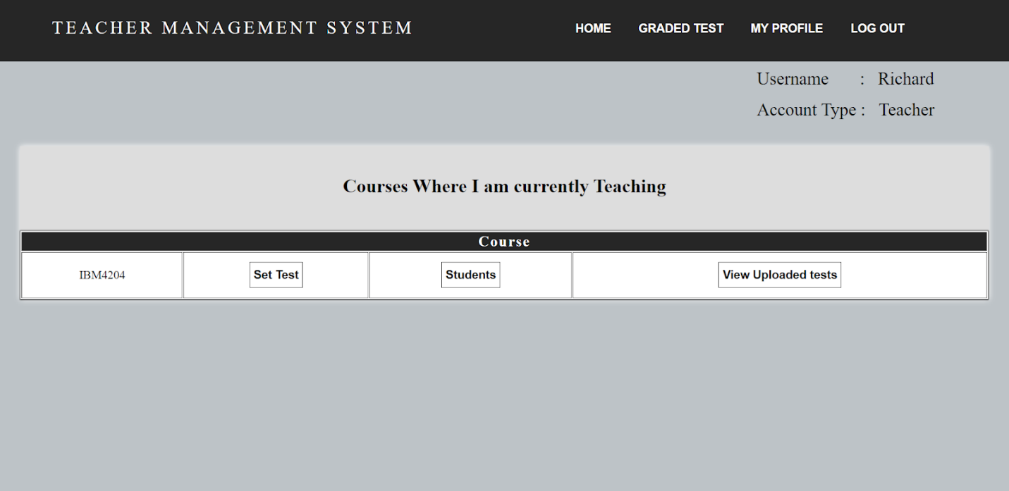

Figure Teacher Home Page

#### 5.2.1.1 Set Test page

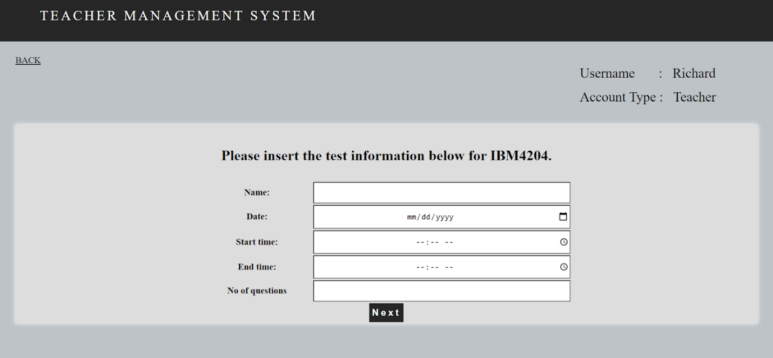

Figure Set Test page

#### 5.2.1.2 List Of Students Enrolled In Course page

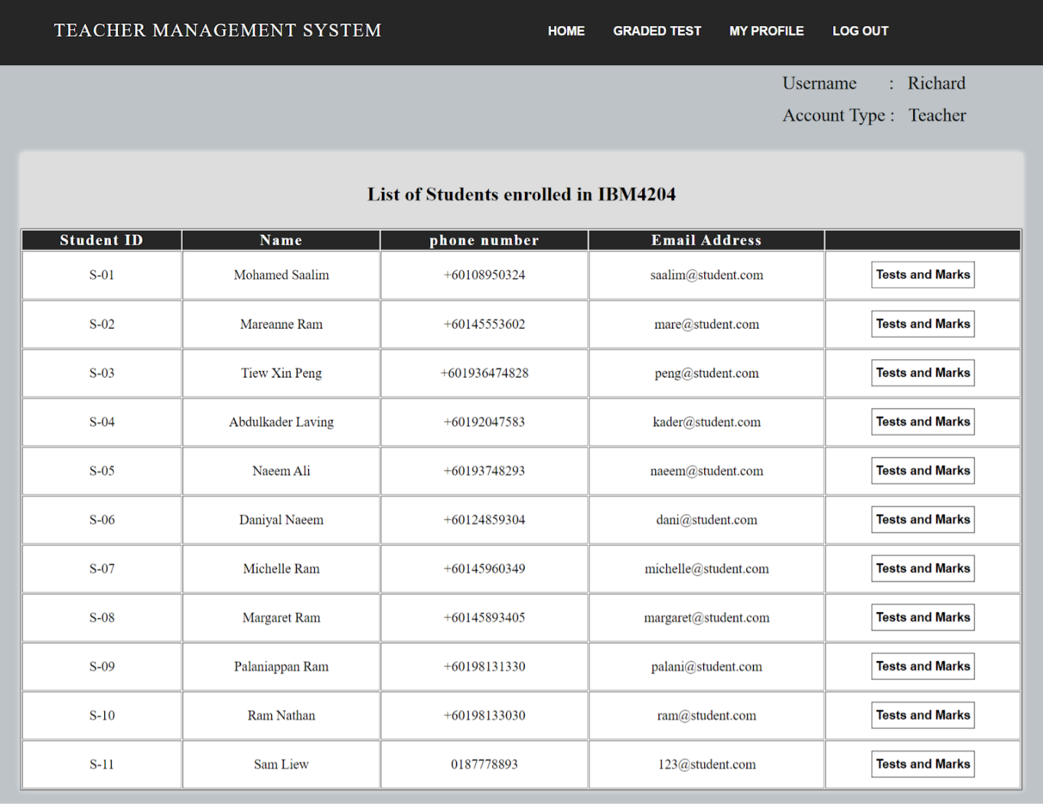

Figure List of students enrolled in course page

#### 5.2.1.3 Test And Marks By Student page

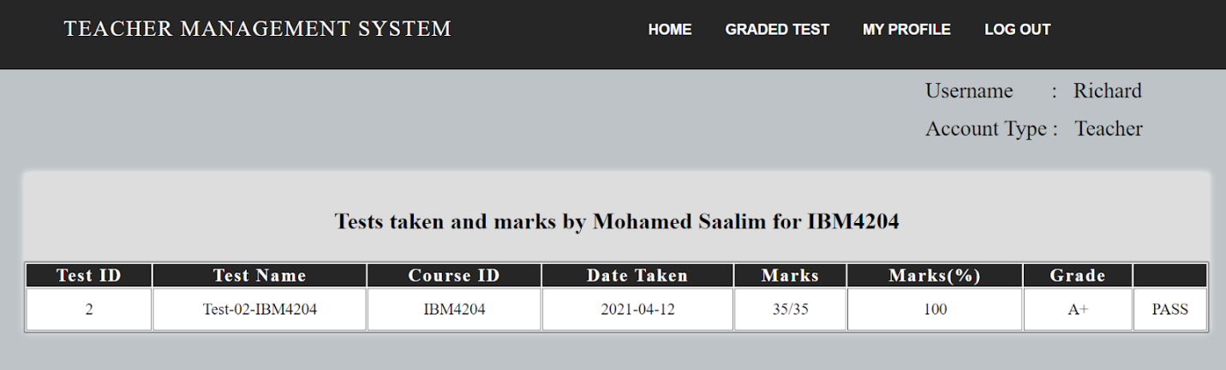

Figure Tests and amrks by student page

#### 5.2.1.4 Uploaded Tests page

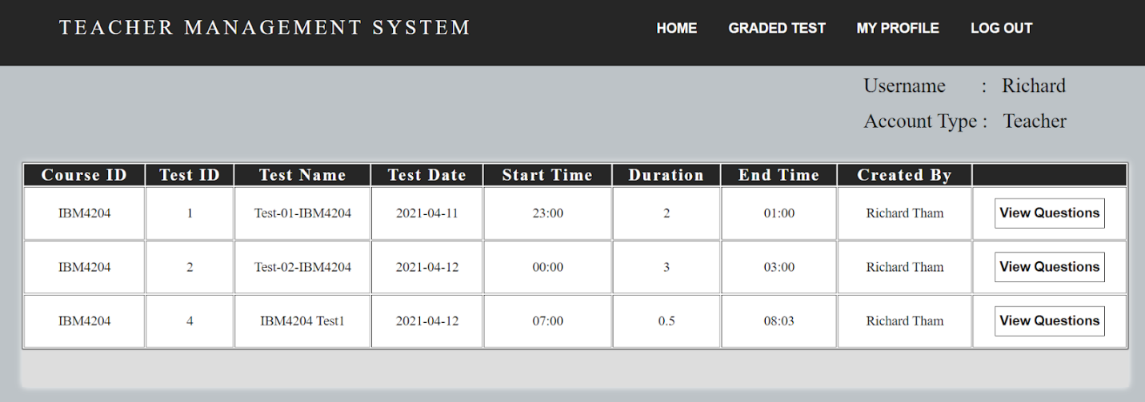

Figure Uplaoded tests page

### 5.2.2 Graded Test page

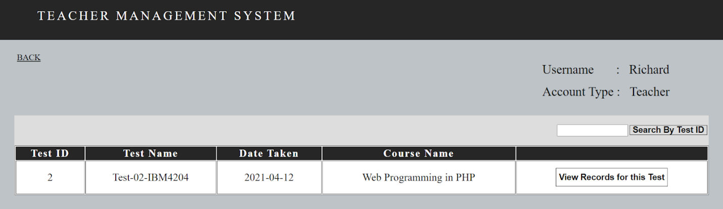

Figure Graded tests page

#### 5.2.2.1 Records For Test page

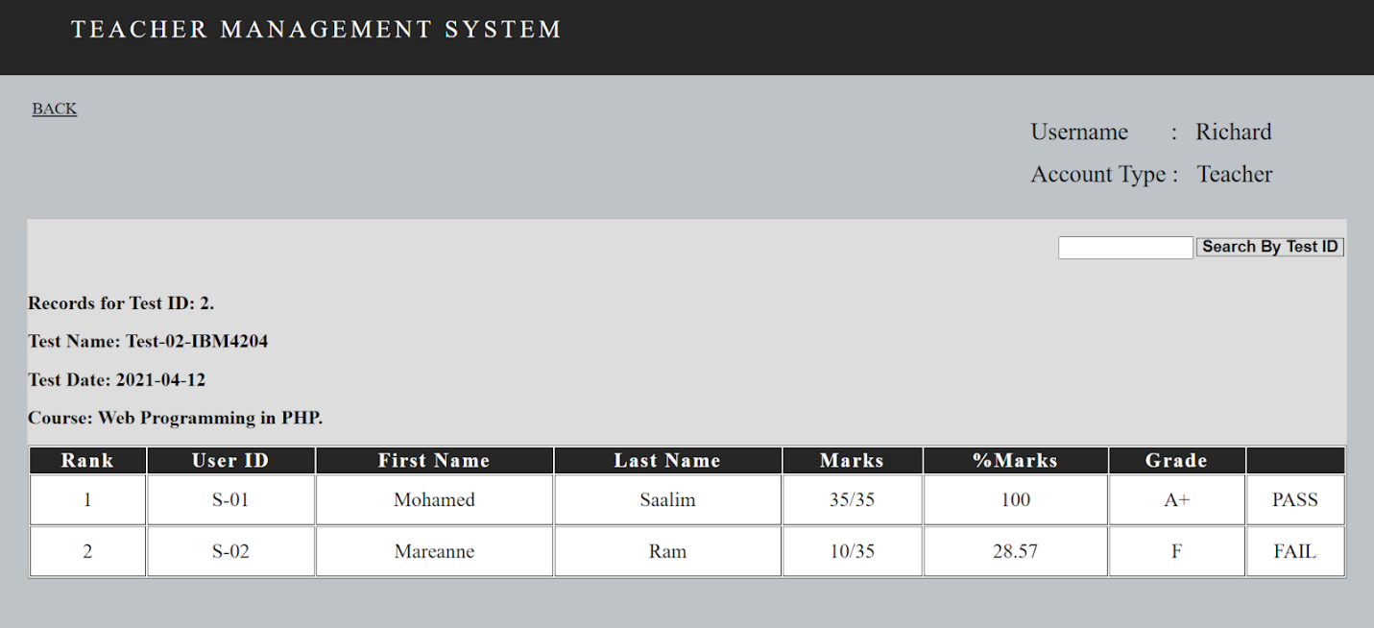

Figure records for test page

## 5.3 Student

### 5.3.1 Home page

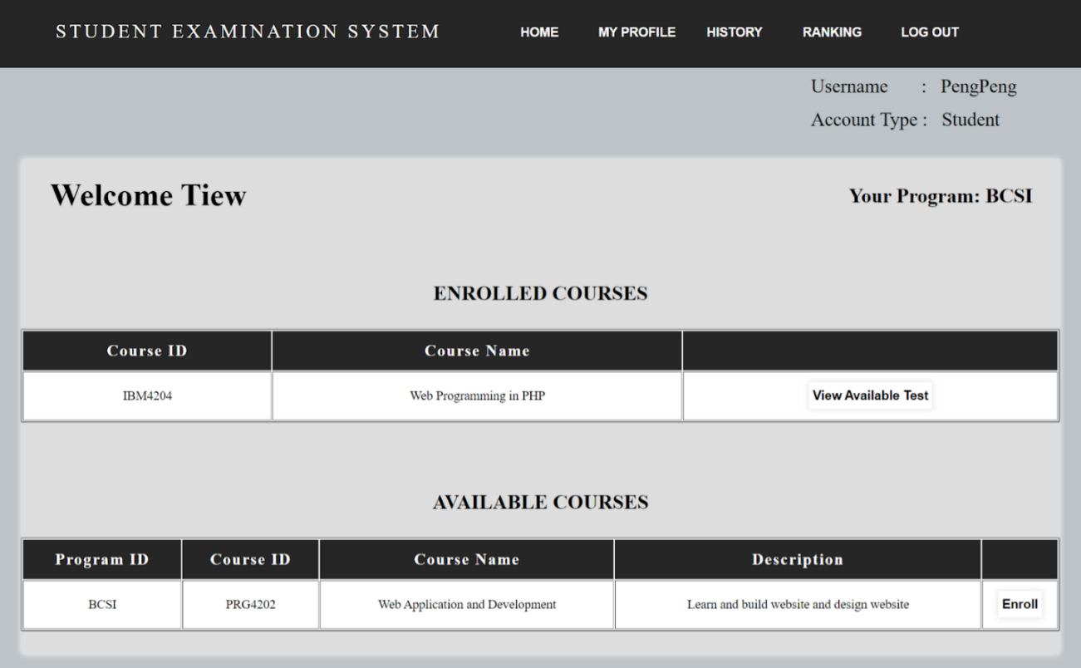

Figure Student Home page

#### 5.3.1.1 Available Test page

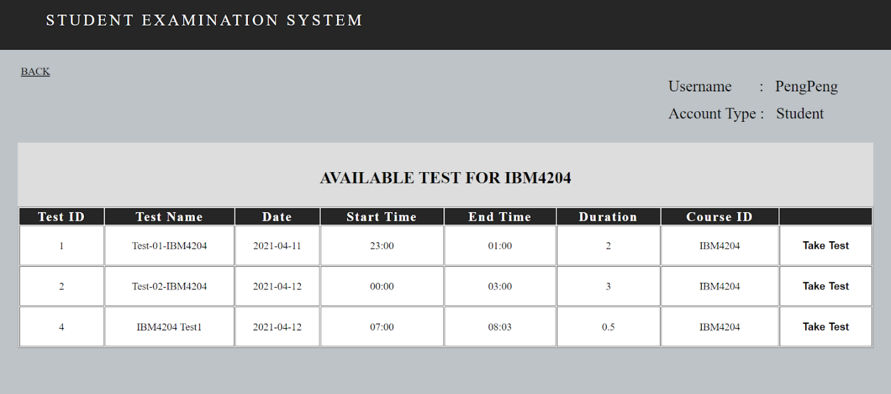

Figure Available test page

#### 5.3.1.2 Take Test page

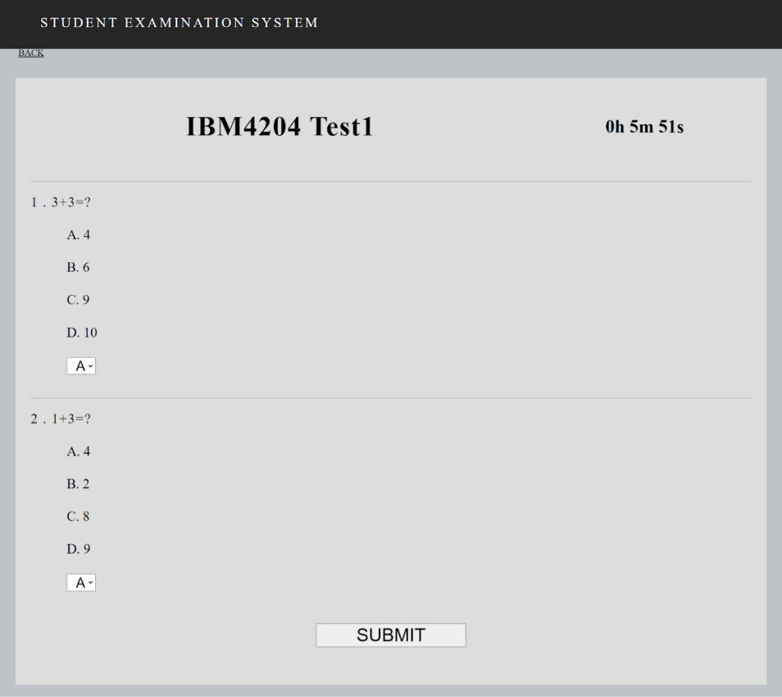

Figure Take test page

#### 5.3.1.3 Enroll Course page

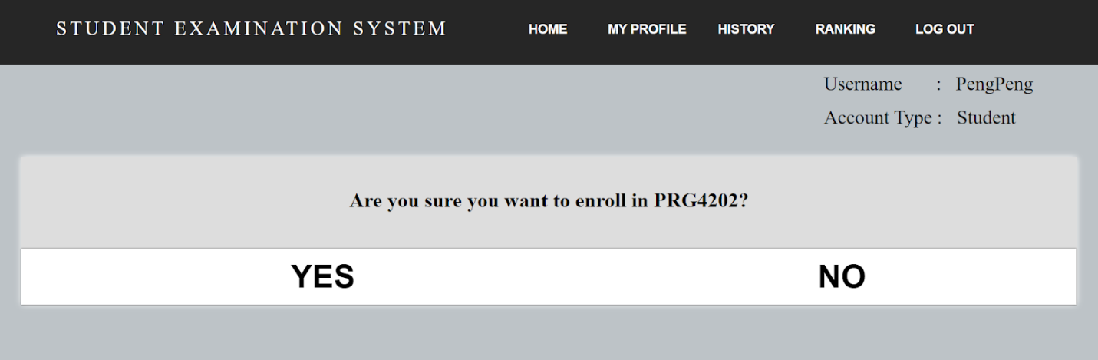

Figure enroll to course page

#### 5.3.2 History page

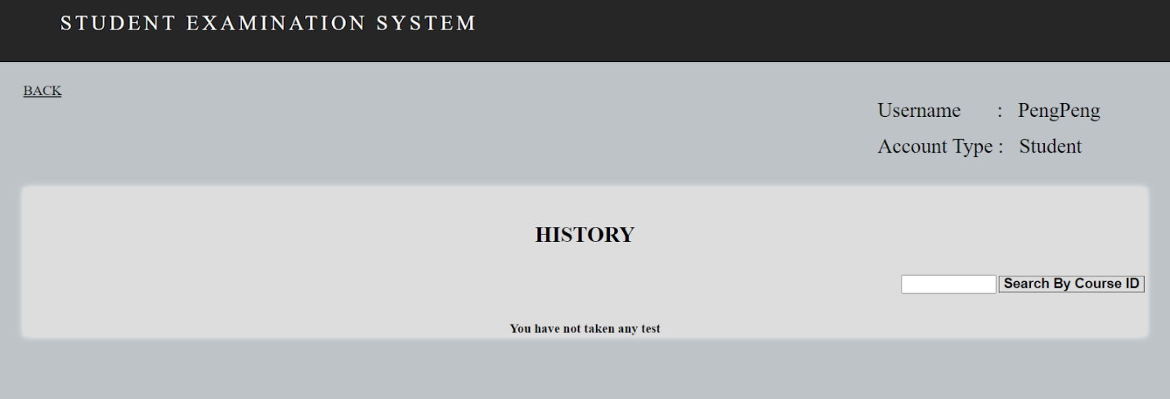

Figure History page

### 5.3.2 Ranking page

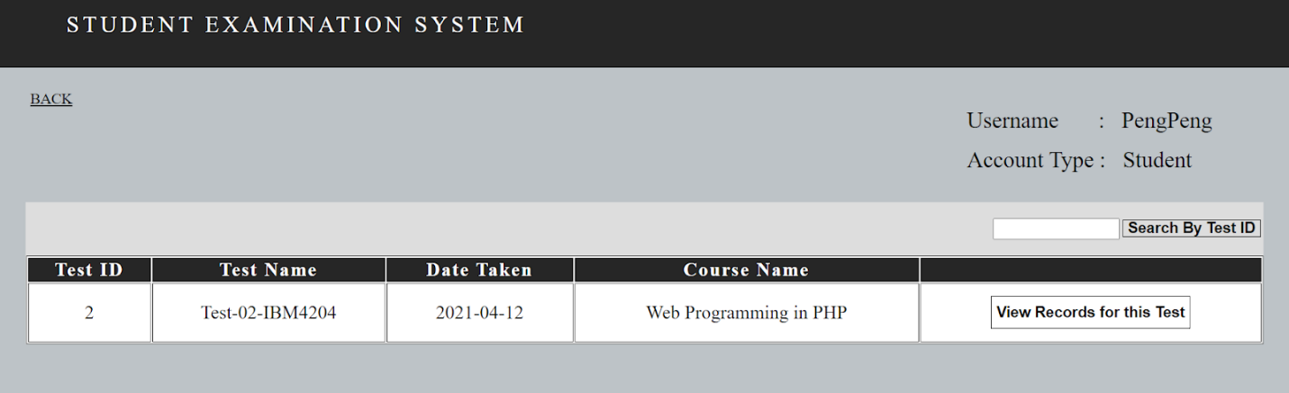

Figure Ranking page

#### 5.3.2.1 Records For Test page

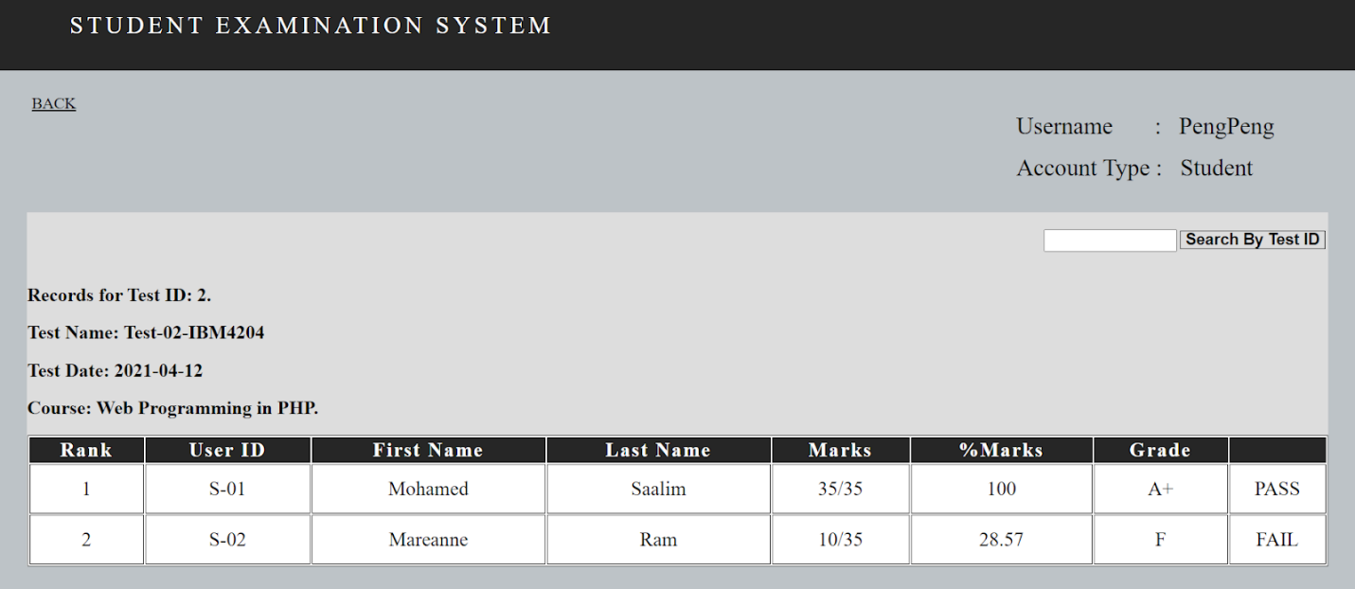

Figure Records for test page



Figure set test page



Figure Set questions page

## 5.4 All

### 5.4.1 My Profile page

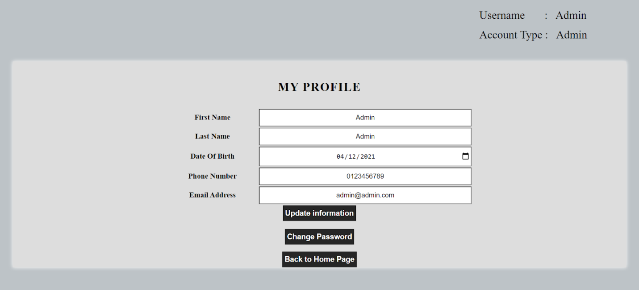

Figure My profile page

### 5.4.2 Change New Password form

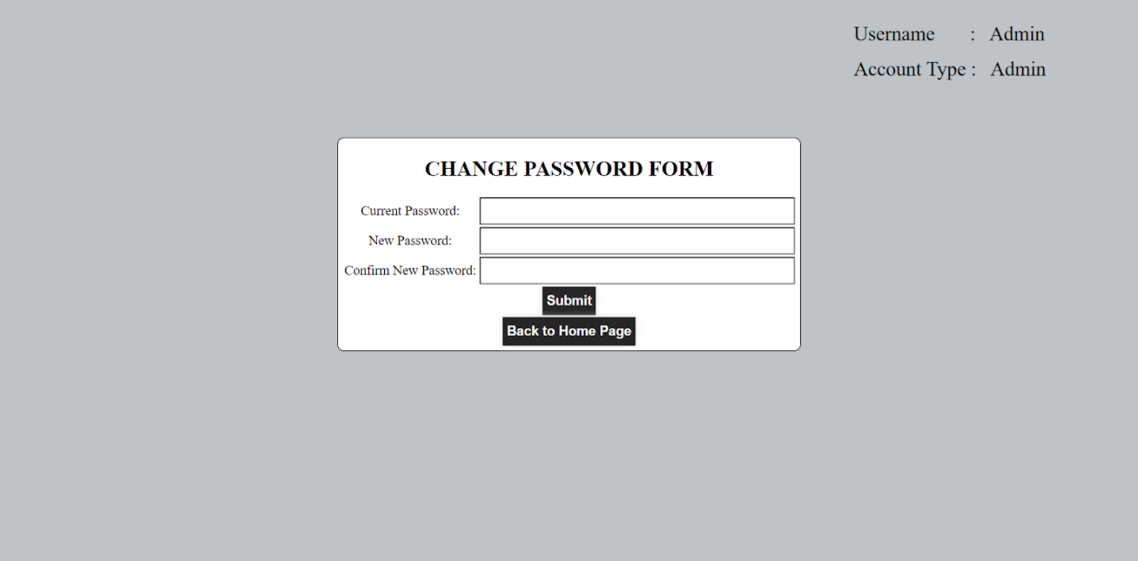

Figure change password page

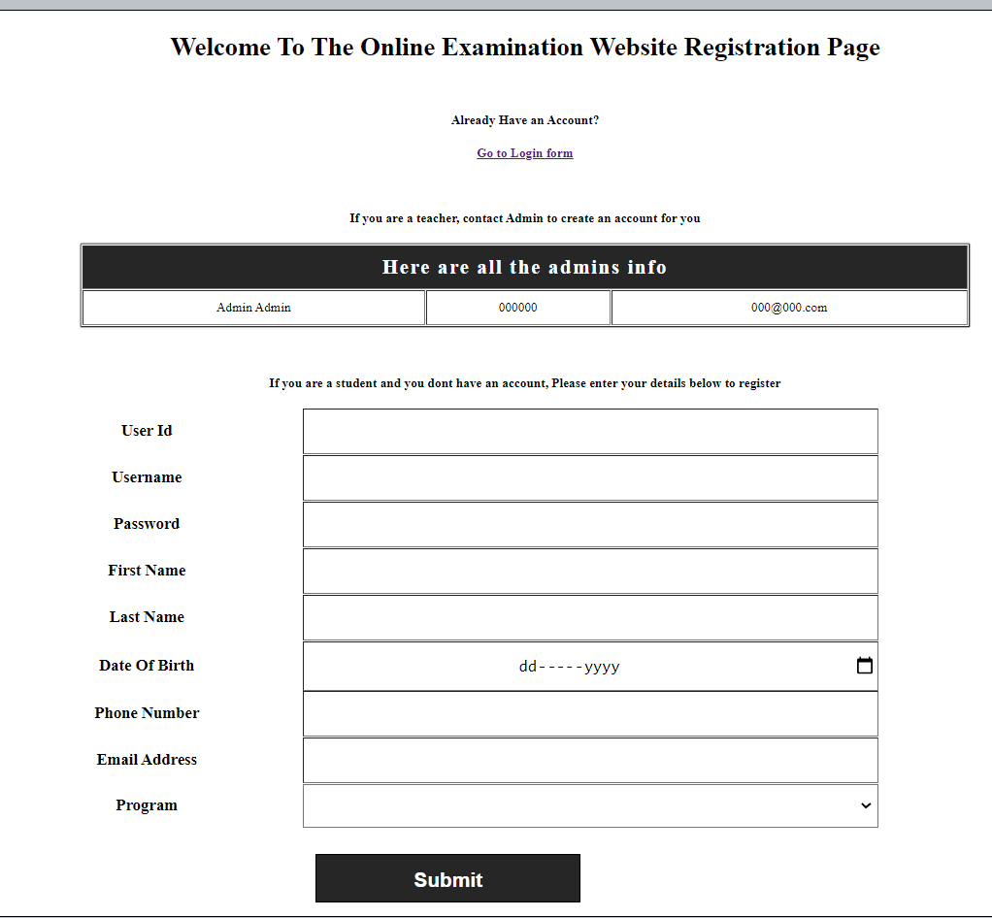

Figure registration page

# 6.0 Individual Contribution and Self Reflection

## 6.1 Mohamed Saalim Individual contribution

**Self-Contribution Form**

**Name: Mohamed Saalim A Kaderdina ID: I19016856**

1. **Description of Self Contributions**

|  |  |  |
| --- | --- | --- |
| **Task#** | **Tasks assigned** | **Remarks** |
| 1 | Group Leader | Lead the group Successfully |
| 2 | AcMan.php(Accedemic management page allowing admin to add depatments, programs,courses) | Completed |
| 3 | AddCor.php(Admin uses to add courses) | Completed |
| 4 | AddDept.php(Admin uses to add Departments) | Completed |
| 5 | AddProg.php(Admin uses to add departments) | Completed |
| 6 | Admin Home(Homepage for admin) | Completed |
| 7 | AdminRegNewTeach(Admin uses to register new teacher by department) | Completed |
| 8 | DB.php(used to create the database) | Completed |
| 9 | gradedTests.php(Used to view marks and ranking of students for each test) | Completed |
| 10 | Myprofile.php(used by all users to edit their profile) | Completed |
| 11 | MyStudents.php(used by teacher to keep track of their students) | Completed |
| 12 | RegNewAdmin.php(Admin uses to register new teacher) | Completed |
| 13 | uploadtest.php(used by teacher to upload test) | Completed |
| 14 | uploadedTests.php(used by teacher to view tests uploaded) | Completed |
| 15 | Helped all my group members to complete their assigned parts for the assignment. | Completed |

1. **Lesson learned by completing this assignment (NOT LESS THAN 200 words):**

|  |
| --- |
| I learnt that it is important to manage all the group members as a team leader. I learnt that each member might not be as efficient or successful at completing their assigned tasks however it is up to me as the leader to make sure that I have assigned tasks to each member and I have to make sure that each member’s task is within their capability to complete. And I learnt that I have to make sure that if my members cannot complete their part, it is up to me as the leader to step in and help them complete their part. |
| I learnt the importance of time management, as this assignment was very compacted with many other assignments that I had from other courses. |
| I learnt that an online system that is made to allow different categories of people to work together is very complex and requires deep thought on many levels, such as database creation, interface design, backend design and a lot more. |
| After completing the assignment, I realized that there are many better ways to do backend coding such as using Object Oriented Design which allows for easy scalability. This would be helpful if the system required additional features in the future. |
| I learnt the importance of thorough testing of the system to make sure all the parts are working properly. I learnt that many things can go wrong during system integration when different people are working on different parts of the system. Therefore, it is important to perform testing and to make sure to fix any bugs or issues found during testing. |
| The main takeaway for me is to choose my group members wisely. Some of my group members were pretty much useless and next time ill be wiser at choosing better group members |

1. **Self-Evaluation from lowest 0 mark to highest 10 mark. Justify your evaluation.**

|  |
| --- |
| Self-evaluation (0-10): 10 |
| Justification: I completed all my parts and I also helped each member to complete their part. I also added additional functionality to the system. |

**Student’s Signature: (**saalim**)**

*[Office Use]*

**Lecturer’s comment:**

|  |
| --- |
|  |
|  |
|  |
|  |

## 6.2 Mareanne Ram Individual contribution

**Self-Contribution Form**

**Name: Mareanne Ram ID: I19017521**

1. **Description of Self Contributions**

|  |  |  |
| --- | --- | --- |
| **Task#** | **Tasks assigned** | **Remarks** |
| 1 | **Student.php**  (Allow students to view and enroll in available course of their program and view all currently enrolled courses) | COMPLETED |
| 2 | **Student_Test.php**  (allowing Student to view all available test for the course they currently enrolled in) | COMPLETED |
| 3 | **Student_TakeTest.php**  (allowing Student to take test for a certain course) | COMPLETED with help from group leader. |
| 4 | **Student_History.php**  (allowing Student view all the test taken by him/her) | COMPLETED |
| 5 | **Coding Explanation 4.15- 4.26** | COMPLETED |
| 6 | **Reflection Report on TM Workshop** | COMPLETED |

1. **Lesson learned by completing this assignment (NOT LESS THAN 200 words):**

|  |
| --- |
| What I learned from this assignment is how it is important for everyone to work together as a group and how important it is to complete the given task within a given time in order complete this assignment. But we have overcome this problem by having meetings continuously until the completion of the whole project.  By doing this assignment, I have also learned how important it is the use of session_start() as it is the key that allows user to move across multiple page in the system. Besides that, I have also learned how to use sessions to save users information to be used in other web pages. I also learned and understand how to use cookies that store the users data into the computer and can be used to keep users logged in until logged out or after a time period of 1 month.  In terms of technical and skills I have learned to use the queries for different syntax such as INNER JOIN which combine 2 or more tables that has the matching values and JOIN combine rows from 2 or more tables into the query. I have also learned how to retrieve data from the database by applying 2 queries into 1 to retrieve a certain data. I also learn to use the SQL functions such as Count and SUM to get the total marks of each test in my php page. I also learned how to use the  if(isset) functions to perform check of a certain variable and using $_REQUEST and $_POST method. I have also learned how to implement script for the live counter in Student_TakeTest.php with the help of my group leader. Not only that, I also learned how to apply the date function that is used the same page make sure that a certain test cannot be taken is before and after the date or time set by a teacher.    For the report, I have learned how to explain the coding in each php page and ultimately adding more knowledge regarding the implementation of each code. |

1. **Self-Evaluation from lowest 0 mark to highest 10 mark. Justify your evaluation.**

|  |
| --- |
| Self-evaluation (0-10): 10 |
| Justification: I believe I have completed my task properly and on time. I also believe that, I have written the report and explain the coding properly. |

**Student’s Signature: ( Mareanne )**

*[Office Use]*

**Lecturer’s comment:**

|  |
| --- |
|  |
|  |
|  |
|  |

## 6.3 Tiew Xin Peng Individual contribution

Name: TIEW Xin Peng**ID : ___I19017402_______**

**1.            Description of Self Contributions**

|  |  |  |
| --- | --- | --- |
| **Task#** | **Tasks assigned** | **Remarks** |
| 1. | teacherHome.php with help from Mohamed Saalim | COMPLETED |
| 2. | uploadTest.php with help from Mohamed Saalim | COMPLETED |
| 3. | ChangePass.php | COMPLETED |
| 4. | resetPassword.php | COMPLETED |
| 5. | Identify the features and function (report) | COMPLETED |
| 6. | Screenshots of system (report) | COMPLETED |

**2.       Lesson learned by completing this assignment (NOT LESS THAN 200 words):**

|  |
| --- |
| The parts that are allocated for me are php files “teacherHome.php”, “uploadTest.php”, “ChangePass.php” and “resetPassword.php”. I have encountered problems with my codes in both “teacherHome.php” and “uploadTest.php”, where I have no idea about how to set restrictions on pages, such as which type of accounts are only allowed to access a specific page. There is another problem I met, I have no clue on how to use the number of questions that was grabbed from the user and display the tables for enabling teachers to modify or insert details of questions according to the value obtained as previously mentioned. Since what I have completed does not make sense and work in a proper way, my group leader has helped me a lot with the parts that I did not do well. He also explained to me the parts that were changed and added.  In this assignment, I have learnt about how to apply user defined functions in php code, user defined function has provided more convenience because a particular function can be used multiple times in a same program. For our system, the function “yourAcType” is constructed in order to differentiate the account type of each user in pages, and this function is placed in most of the php files in our system. |

**3.       Self-Evaluation from lowest 0 mark to highest 10 mark. Justify your evaluation.**

|  |
| --- |
| **Self-evaluation (0-10): 7** |
| **Justification:** Although the tasks are completed on time, there are still improvements that can be done to my coding skills. |

**Student’s Signature:** (TIEW Xin Peng)

***[Office Use]***

**Lecturer’s comment:**

|  |
| --- |
|  |
|  |
|  |
|  |

## 6.4 Abdulkader Abubakar Laving Individual contribution

Name: Abdulkader Abubakar Laving**ID : ___I18014366_____**

**1.            Description of Self Contributions**

|  |  |  |
| --- | --- | --- |
| **Task#** | **Tasks assigned** | **Remarks** |
| 1. | login.php | COMPLETED |
| 6. | Skills and techniques used (report) | COMPLETED |

**2.       Lesson learned by completing this assignment (NOT LESS THAN 200 words):**

|  |
| --- |
| I encountered a great load of problems when doing my parts and nearly ended up causing a lot of problems for my group. My group leader Saalim assisted me in understanding the work and helped me to complete it where I managed to fall behind. This has been a very difficult project with a lot of work and that it was done thanks to the great work done by this group. A lot of research was conducted to understand what to write for the report. I tried my best to get as much authentic research material to use to write the parts I was assigned. Saalim once again assisted me in explaining what was needed in the report and then left me to work out how to get the task done. This has helped me appreciate my group a lot and it has given a new understanding of all my group members and I appreciate the opportunity I have been given to learn all the important lessons that are going to be very useful in the near future. It was a very difficult time and I nearly failed at completing my tasks but my group members managed to assist me and were very supportive when I needed it the most. |

**3.       Self-Evaluation from lowest 0 mark to highest 10 mark. Justify your evaluation.**

|  |
| --- |
| **Self-evaluation (0-10): 7** |
| **Justification:** There are a lot of improvements that is needed on my part all across the work that was done. |

**Student’s Signature:** (Abdulkader)

***[Office Use]***

**Lecturer’s comment:**

|  |
| --- |
|  |
|  |
|  |
|  |

## 6.5 Naeem Mamed Ali Individual contribution

Name: Naeem Mamed Ali**ID : ___I19017067_______**

**1.            Description of Self Contributions**

|  |  |  |
| --- | --- | --- |
| **Task#** | **Tasks assigned** | **Remarks** |
| 1. | Regitration.php | COMPLETED |
| 6. | Skills and techniques (report) | COMPLETED |

**2.       Lesson learned by completing this assignment (NOT LESS THAN 200 words):**

|  |
| --- |
| This assignment has given me many lessons and experiences. Since the classes are being conducted online and some of the group members are in different regions, we had to seek solutions to set this assignment on time. We had a lot of meetings so we could be all on the same page. With the present assignment, I had the encouragement to self-learn and online learning. With the help of my group members, I could also develop new skills and learn about more stuff that can help me in the future. This assignment was very useful for me because I could make use of what I've been learning from the past months. With this assignment I could learn how to work among a group, and to accept other people’s opinions and points of view. I also was able to learn that time management is very important, because of it I could work on this assignment and still manage to finish and present the other ones. Without further say I want to thank all the group members because all of them were able to complete the tasks given, it was very good to work with this group because we were able to communicate, help and divide tasks very easy and I hope that we can deliver a good assignment. |

**3.       Self-Evaluation from lowest 0 mark to highest 10 mark. Justify your evaluation.**

|  |
| --- |
| **Self-evaluation (0-10): 7** |
| **Justification:**. I feel that I could improve my skills and techniques . |

**Student’s Signature:** (Naeem Mamed Ali)

***[Office Use]***

**Lecturer’s comment:**

|  |
| --- |
|  |
|  |
|  |
|  |

# 7.0 Workshop Reflection Report

## 7.1 Mohamed Saalim Workshop Reflection Report

I learnt that TM R&D's strategic role is to bring new technology and innovation to the group. This helps to build the nation and the digital economy. The reason is to drive operational efficiency and to create new revenue opportunities. The main purpose is creating talent, bring forward the existing talent and to digitalize the nation. It is also a way to drive Malaysia into becoming a producing nation rather than a consuming one.

I learnt that the main reason for the open innovation in Tm is because of inefficient development strategies lead to many problems. Some of these problems were that products took a long time to market due to the long time taken to design the system API's. These Systems, so called API's need to be translated between multiple systems which leads to inefficiencies. Since everyone needs to pay for data and services, hoarding occurs which leads to increased upfront costs like hosting and subscription.

The open innovation Platform creates Business Rules and Linkages between systems therefore reducing inefficiencies and increasing innovation speed allowing for reusability of API's. The 3 key features of OIP are that it enables rapid creation of IoT and Digital Applications, it creates an Eco-System that enables collaboration by allowing data and service exchange. It also promotes speed and innovation through reusable API's. OIP is a multi-layered digital infrastructure that enables an ecosystem where the creation of new revenue streams is possible. The different layers of the OIP are digital services, service exchange platforms, service creation platform, data hub, data, and service hosting platform. They rapidly increase the speed of application development by reusing App components, OPI handles all the technology stack for digital applications including data, device and rules management and they also allow for 3rd party and individually developed digital assets through the OIP marketplace.

The key components of OIP are digital service creation, which is a platform for rapid development, they provide a data hub for managing application data assets, they also have a large catalogue of APIs which are reusable, and the catalogue is also constantly growing. There is built in security, service API brokerage and they allow monetization of individual solutions.

Internet of things also known as IoT, is a system of interrelated devices, machines, objects animals or people that have unique identifiers and the ability to transfer data over a network without requiring physical human to human or human to computer interaction. It enables automation, reduces costs, reduces waste, improves security, service delivery and most importantly transparency.

I learnt that IoT Systems have separate hardware and software components that come together to create the system. Basically, you need sensors that have connectivity through WIFI access points which then connects to the IoT platform through the gateway. The application side then can have back talk with the platform through Rest APIs that work on top of the HTTP and can send information back to sensors through the IoT platform Using connectivity protocols. If the connected devices can support HTTP layer four, they can host the data to the IoT platform. However, if the device is more resource constrained (limited computing power/storage etc.), then it would use MQTT which is message querying Trimetric data transfer.

## 7.2 Mareanne Ram Workshop Reflection Report

The talk is held by Mr. Yeoh Chun Yeow who is a Principal Researcher at Telekom R&D. The talk introduces us the concept of Internet of Things (IOT) and how it can be used to a part of our entry learning for the final year project. The talk explains on how to use the cloud IOT and interaction between the application of our devices towards the cloud IOT platform.

Firstly, I learned and was introduces about Telekom Malaysian (TM). I learned that Telekom Malaysia(TM),the main theme for them right now is enriching Humanity and Progressing Nations as TM is part of the national builder for the telecommunication infrastructure. The company’s strategic role is to bring new technology and innovation to the group and contributing to nation building and the digital economy. Their 3 main strategic roles are to act as an Enabler to drive operational efficiency and creating new revenue opportunities, a Catalyst to prepare the nation to drive the nation digital aspiration forward and lastly to act as a Creator to lead Malaysia to become a nation of producers, not consumers.

Next, from the talk I learned the Online Innovation Platform (IOP) is a digital multilayer architecture solution or digital platform to help the people to rapidly design their smart services especially on the Internet of Thing (IOT) cases. It also creates an ecosystem for the creation of new revenue opportunities. Besides that, IOP ensure and helps us to be on the same level or speed as the ongoing and growing innovation of technology. IOP helps the people to be on board to create and design their IOT services and to enter/retrieve their data to their devices. The main reason on why TM come up with the OIP is because of the inefficient strategies that leads to multiples problems such as the products take a long time to market due the delayed feedback about the services, highest cost dues to the upfront cost relating to hosting and subscription. Not only that, but the systems also that need to have API management layer which allows them to consolidate is desperate as it needed to translate between systems and the inefficiency and the inability to grow the application idea to production.

Furthermore, I learned what are the typical linkages between the digital appliances such as the waste management services, traffic management services and streetlight management services. Technically in our everyday life we go through there services. I learned that the linkage was messy at first, but it is solved by creating business rule and linkages between systems through IOP that allows the services to be centralised. The API management layers are reusing APP components which quicken the development of an application, provide exchanging services and data API’S, handling all the Technology Stack for Digital Application and get other data services.

Next, we were introduced to the component of IoT System which requires both hardware and the software components to form an IoT system. The basic components are sensors, connectivity, IoT Platform, and application. Other than that, the talk provides us information of how IoT is done and how it can be applied in our everyday devices such as television, fridge, computer etc. When everything is centralised using the IoT platform, it can the status and can detect the environment the devices are in. For example, a washing machine was not turned off when the owner is away, the machine can be remotely switch off.

From the talk I also learned briefly about the embedded system which is something I was not familiar with. I also learned about Postman which is a collaboration platform for API Development.

## 7.3 Tiew Xin Peng Workshop Reflection Report

I have gained some useful knowledge after I attended the workshop which was held today. For example, OIP, which stands for open innovation platform allows the connection between the problems that are delivered by problem owners to the platform full of diverse types of solutions in order to design smart services and Iot(Internet of things) use cases.

Iot, which stands for ‘Internet of things’, it is a giant network with connected devices. These devices gather and share data about how they are used and the environment in which they are operated, describes intelligent objects that are connected to the internet and each other with the help of sensor that embedded into the ‘things’ and network (wi-fi,LTE,LORA),  sensors are embedded into every physical device, these devices can be any electrical appliances, almost everything that we come across in day-to day life, and sensor continuously transfer data about the working state of the devices, and it can be explained as different types, for example, time sensor is embedded into a washing machine in order to help the device to differentiate and perform its tasks based on the appropriate time that is gathered from user as a input, Iot provides a common platform for devices to place the data, and translate the data into a common language for all the devices to communicate with each other, by doing so, IOT will be managed to transfer the data between physical device such as air conditioning, fridge to the applications that can be installed in any electronic devices (phone, tablet, smart watch). Finally, the result is shared with other devices for better user experience and improving efficiency.

Suppose there is a scenario which represents the roles and importance of IOT, in the manufacturing industry, all the machines have sensors attached, the sensor will be in charge of sending the information regarding the health of the machine to the manufacturer to identify the problem immediately if there is any issue. Products in the industry have a barcode attached which contains the details of the product, enabling the manufacturer to identify the place that product is distributed, next the products are parceled and sent to different retailers, retailers have a barcode reader to track the details of each product. For other examples, smart watch is tracking our daily activities, and we can always refer to our information, as one of the voice assistants, Siri has provided much more convenience by answering to our questions according to our statements, and we are able to get the proper solution from the voice assistant without picking up or turn on our smart devices.

With the help of IOT, the time spent for performing a task is decreased as they are all replaced by connection between the physical devices and smart devices. IOT provides the ability of enhanced monitoring and convenience, means that we will be able to control a particular device without controlling it physically but remotely and automatically and advancing the way we live by using the application from smart devices anywhere and anytime.

## 7.4 Abdulkader Abubakar Laving Workshop Reflection Report

The workshop has been very enlightening in that I have learnt a lot and it has been an amazing experience. I learnt about a lot of things I had merely read about in my free time or may not even have heard of before this day. Some of the things that I learnt are such as open innovation platform or OIP that is used to establish a connection between problems from problem owners to a platform bursting with a large amount of different types of solutions which would allow for smart design services and other use cases. We also were given a better understanding of the internet of things which is a network of connected devices that allow for the gathering and sharing of data across the network. Sensors are used to connect the physical devices to each other. The sensors are used to send out data without stop. The data that is transferred is about the state of the device when it is working. This can be explained in multiple different ways such as a time sensor in a microwave can help the device complete its task based on the time which is acquired from the input of the user. The data is than processed and translated into a language better understood by the connected devices which allow for communication to occur. Through this the internet of things can allow the data to be transferred from one device to another in a home setting for example it would be a fridge could communicate with the smartphone devices or a smart home system. This would assist in having more efficiently working devices.

The devices we use can be made to be a lot more efficient through the internet of things thus making our lives easier. This allows for less time performing tedious tasks. Easier understanding of how to use the device and a better time learning the intricacies of how they work. The sensors embedded in the physical devices can send the user with messages of the health of the device which would allow the user to know when the device was having problems functioning as it should and allow them the chance to have it fixed before it becomes more than a minor inconvenience. The sensors can also send a notification to the manufacturers who would arrive to solve the problem before the user even realized that there was a problem on their device. This allows for a faster service and can help the user bypass a major inconvenience of calling the manufacturers up. Siri is an important example of how much convenience it has brought about in that it answers our questions according to the processes statements that we are feeding to our device and provides a suitable answer. It can also improve the use of the device for disabled individuals who may be unable to move or see. This allows the user to be able to make calls or send messages without the use of touch and simply through the use of their voice.

IOT or the internet of things has made life easier and convenient through the connection between devices thus improving efficiency all around. This means that we can even control devices without being in contact with the actual device and this can help to improve the way of living using smart devices anywhere and at any time.

## 7.5 Naeem Mamed Ali Workshop Reflection Report

For this workshop, I could learn and gain many experiences that I can take in the future. This workshop was very clarifying and touched subjects that I was not interested in before, some of the topics that I could learn was OIP also known as the Open innovation platform. This platform is used to establish a connection from problem owners to this platform that is filled with a large number of solutions that allow smart design services and other cases. We also could learn that data that is transferred is about the state of the device when it is working, that sensors are used to send data without stopping we also could learn that IoT is a network that connects devices that allows data gathering and sharing across the network. We could learn that sensors are used to connect physical devices one to another. As an example, a washing machine with a time sensor can help the device to complete all his task based on the time that was assigned to it to perform the task. The data inserted there can be processed and translated and sent to the other connected devices that allow communication to occur. IoT allows data to be transferred from one device to another in a home setting, as an example, all smart devices in a house can communicate with each other, and since that communication is established we can know what is working properly and what is not. From this workshop, I could understand that IoT came to make our life’s easier and came up intending to facilitate our life. With IoT we save a lot of time, we can easily understand what was given to us, and we can easily discover how everything works and is connected. The sensors used in physical devices can send messages to other devices demonstrating that it has a problem and this is very easy to detect and solve a problem. By IoT, I could discover that it came t make our life easier and show us that connected devices can be very easy and efficient on our daily basis. Nowadays we have lots of devices that help us to keep track of our daily basis, we have smartwatches that connects with our cellphones, we have smart bands that connect with watches, earphones, and cellphones, we have voice assistants that help us to know and to perform a task only with our voice, for example, Alexa Is a smart device controlled by voice command, it answers and keeps you updated about everything that you should know. On the other hand, we have Siri that has provided a very good convenience by replying to our questions according to what we are asking her, and we were able to get good feedback from the voice assistant without even touch our smart devices. With IoT e can see that it comes to change our lives, to make them easier and simpler, in my point of view in a couple of years it will be used and known by every person, because we know that technology is the future.

# 8.0 Conclusion

In conclusion, this assignment has tested our ability to create a fully functioning system that allows different users to perform certain tasks. It is safe to say that we have managed to achieve all the requirements if not exceeded them. We managed to create a system that allows students teachers and admins to work together to allowing admins the ability to successfully administrate the system, view and maintain the system, view students’ records, tests and marks and allow teachers to successfully set tests and view students marks, grades and rankings and most importantly allow students to sit for tests remotely without having to be present at location.

Like any system, our system needs improvement. Given more time, we would have added more validation and checking. We would also have added additional functionality, such as allowing teachers to teach courses by posting videos or live conferences with students, we could also have made the system look better by working on the css properties. Another improvement would have been to allow users to chat with each other for example allowing students to communicate with their respective teachers. However, all these improvements can only be achieved given enough time.

We are happy to say that we have achieved success in meeting all the requirements set out by the lecturer.

# 9.0 References

W3schools.com. 2021. *PHP mysqli_num_rows() Function*. [online] Available at: <https://www.w3schools.com/php/func_mysqli_num_rows.asp> [Accessed 12 April 2021].

W3schools.com. 2021. *PHP mysqli real_escape_string() Function*. [online] Available at: <https://www.w3schools.com/php/func_mysqli_real_escape_string.asp> [Accessed 12 April 2021].

W3schools.com. 2021. *PHP mysqli fetch_array() Function*. [online] Available at: <https://www.w3schools.com/php/func_mysqli_fetch_array.asp> [Accessed 12 April 2021].

W3schools.com. 2021. *HTML DOM getElementById() Method*. [online] Available at: <https://www.w3schools.com/jsref/met_document_getelementbyid.asp> [Accessed 12 April 2021].

W3schools.com. 2021. *PHP mysqli fetch_row() Function*. [online] Available at: <https://www.w3schools.com/php/func_mysqli_fetch_row.asp> [Accessed 12 April 2021].

W3schools.com. 2021. *SQL INNER JOIN Keyword*. [online] Available at: <https://www.w3schools.com/sql/sql_join_inner.asp> [Accessed 12 April 2021].

W3schools.com. 2021. *PHP mysqli error() Function*. [online] Available at: <https://www.w3schools.com/php/func_mysqli_error.asp> [Accessed 12 April 2021].

Php.net. 2021. *PHP: date_default_timezone_set - Manual*. [online] Available at: <https://www.php.net/manual/en/function.date-default-timezone-set.php> [Accessed 12 April 2021].

Php.net. 2021. *PHP: header - Manual*. [online] Available at: <https://www.php.net/manual/en/function.header.php> [Accessed 12 April 2021].

bar, P. and Omi, H., 2021. *PHP header(Location: ...): Force URL change in address bar*. [online] Stack Overflow. Available at: <https://stackoverflow.com/questions/7467330/php-headerlocation-force-url-change-in-address-bar> [Accessed 12 April 2021].

W3schools.com. 2021. *PHP include and require*. [online] Available at: <https://www.w3schools.com/php/php_includes.asp> [Accessed 12 April 2021].

condition, h. and Alpha, T., 2021. *how to destroy a cookie by php condition*. [online] Stack Overflow. Available at: <https://stackoverflow.com/questions/12043578/how-to-destroy-a-cookie-by-php-condition> [Accessed 12 April 2021].

Php.net. 2021. *PHP: setcookie - Manual*. [online] Available at: <https://www.php.net/manual/en/function.setcookie.php> [Accessed 12 April 2021].

W3schools.com. 2021. *PHP Sessions*. [online] Available at: <https://www.w3schools.com/php/php_sessions.asp> [Accessed 12 April 2021].

Php.net. 2021. *PHP: session_start - Manual*. [online] Available at: <https://www.php.net/manual/en/function.session-start.php> [Accessed 12 April 2021].

W3schools.com. 2021. *PHP mysqli real_escape_string() Function*. [online] Available at: <https://www.w3schools.com/php/func_mysqli_real_escape_string.asp> [Accessed 12 April 2021].

Php.net. 2021. *PHP: mysql_real_escape_string - Manual*. [online] Available at: <https://www.php.net/manual/en/function.mysql-real-escape-string.php> [Accessed 12 April 2021].

W3schools.com. 2021. *PHP trim() Function*. [online] Available at: <https://www.w3schools.com/php/func_string_trim.asp> [Accessed 12 April 2021].

W3schools.com. 2021. *PHP mysqli fetch_row() Function*. [online] Available at: <https://www.w3schools.com/php/func_mysqli_fetch_row.asp> [Accessed 12 April 2021].

GeeksforGeeks. 2021. *PHP | mysqli_fetch_array() Function - GeeksforGeeks*. [online] Available at: <https://www.geeksforgeeks.org/php-mysqli_fetch_array-function/#:~:text=The%20mysqli_fetch_array()%20function%20is,a%20numeric%20array%20or%20both.> [Accessed 12 April 2021].

Tutorialspoint.com. 2021. *PHP - Function MySQLi Fetch Array - Tutorialspoint*. [online] Available at: <https://www.tutorialspoint.com/php/php_mysqli_fetch_array.htm> [Accessed 12 April 2021].

Php.net. 2021. *PHP: mysqli_result::fetch_array - Manual*. [online] Available at: <https://www.php.net/manual/en/mysqli-result.fetch-array.php> [Accessed 12 April 2021].

W3schools.com. 2021. *PHP mysqli_num_rows() Function*. [online] Available at: <https://www.w3schools.com/php/func_mysqli_num_rows.asp> [Accessed 12 April 2021].

GeeksforGeeks. 2021. *PHP | mysqli_num_rows() Function - GeeksforGeeks*. [online] Available at: <https://www.geeksforgeeks.org/php-mysqli_num_rows-function/> [Accessed 12 April 2021].

Php.net. 2021. *PHP: mysqli_result::$num_rows - Manual*. [online] Available at: <https://www.php.net/manual/en/mysqli-result.num-rows.php> [Accessed 12 April 2021].

Php.net. 2021. *PHP: mysqli::query - Manual*. [online] Available at: <https://www.php.net/manual/en/mysqli.query.php> [Accessed 12 April 2021].